Wilbraham Primary School

Class Teacher – Temporary (2 terms) – 2 days per week. MPS 1 – UPS3 – Monday and Tuesday in class
We are looking to appoint a classroom teacher to cover maternity leave from January 2026 for 2 terms. The position is for 2 days a week working in Year 3. Would you like the opportunity to join an already strong school team within a unique school community.

Wilbraham Primary School is an exciting and vibrant three form entry Primary School in Fallowfield Manchester. With nearly 600 pupils and over 100 staff the school serves a diverse community from many different cultures. The school prides itself in delivering a rich curriculum with a wealth of enrichment activities being made available to the children. We expect our children to be resourceful, reciprocal, resilient and reflective.

You will find our pupils friendly, well-behaved and very eager to learn. We have active and supportive local governors, staff and parents/carers, with the additional benefit of the support of a local, small, experienced MAT. There is effective collaboration and partnership within the Trust and local primary Heads’ forum and a strong commitment to continuing professional development.

To be successful you will have to be an outstanding practitioner with a willingness to learn, develop and adapt to the needs of the children in your class. We are looking for an excellent communicator who can further strengthen existing positive relationships with staff, pupils, parents/carers and families.

We are a member of The Aspire Multi Academy Trust and offer a mutually supportive ethos with excellent opportunities for professional development. We are proud to be a Disability Confident Committed Employer, we strongly encourage applications from all persons with a known disability. We aim to ensure a fully inclusive and accessible recruitment process.

As a trust we are committed to safeguarding and promoting the welfare of our children. For all shortlisted candidates reference checks and online searches will be completed prior to interview. All successful candidates are subject to satisfactory references, medical checks, right to work in the UK and safeguarding checks (including enhanced DBS checks)

Visits to the school are strongly encouraged and welcomed. To arrange a visit with the Principal, please Andrew Marchant at a.marchant@wilbrahamprimary.com

For an application form, please go to the staff area on our website www.aspireeducationaltrust.co.uk or email admin@wilbrahamprimary.com
Opportunity to visit the school for a tour Call to arrange – 0161 2243900
Closing Date: Friday 14 November 2025
Shortlisting: Friday 14 November 2025
Start Date: January 2026
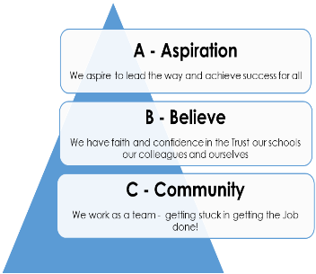
Please return applications to: admin@wilbrahamprimary.com

