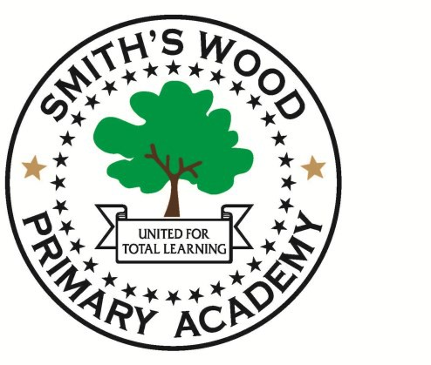
Dear candidate,

Thank you for showing an interest in the position of Class Teacher at Smith`s Wood Primary Academy.

Smith`s Wood Primary Academy is a large primary school in the north of Solihull. The school was built in 2009 and has been transformed to create a totally unique learning
environment. We have 460 pupils aged 3-11, organised into 2-3 classes per year group. This means that in many parts of the school, we offer class sizes of 20, alongside
additional TA support. In many year groups we have added further teaching staff in core subjects to make group sizes even smaller.

Now is an exciting time to join Smith`s Wood Primary Academy. In May 2017, the school was judged as “outstanding” by Ofsted. This reflected the huge effort made by staff to raise levels of attainment and progress and provide opportunities that make Smith`s Wood 'More Than A School'.

We have a keen and enthusiastic staff who embrace risk taking and new initiatives. The quality of teaching is high and the school also benefits from an impressive array of
additional support staff. We are now recruiting for staff for September 2021.

As a standalone academy, we have the flexibility and independence to innovate.
You will need to be an imaginative, creative person. You will need to be an organised individual, able to work cooperatively with others. Most importantly, you will need the drive, determination and stamina to succeed to ensure that every child in your class can reach their full potential.

If you would like to see for yourself what the school can offer, please book a visit via the school office or contact me directly. (s48dgivens@smithswoodpri.solihull.sch.uk).

Regards,

Danielle Givens (Head Teacher, Smith`s Wood Primary Academy)

Smith’s Wood Primary Academy has a responsibility for and is committed to safeguarding and promoting the welfare of children, young people and vulnerable groups

