Additional information
Visits strongly recommended—this is a totally unique school.
Applications must be received by 12.00pm on 12/05/21 Applications (using the Solihull MBC application form)
may be sent electronically
(office@smithswoodpri.solihull.sch.uk) or be sent as a hard copy.

In the “other information” section, candidates should ex- plain why they wish to work at Smith`s Wood Primary Academy.

Please ensure reference details are fully complete.
(including email addresses) .

Candidates selected for interview will be informed with- in 48 hours of the closing date.
An enhanced DBS clearance is required for this position. Smith’s Wood Primary Academy has a responsibility for, and is committed to, safeguarding and promoting the welfare of children, young people and vulnerable groups.

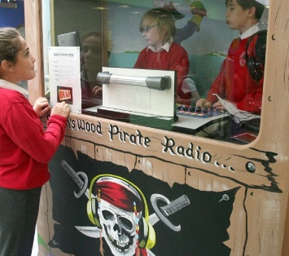
Candidates are advised to make their application stand out; imagination and creativity is actively encouraged.

The post is advertised as either a KS1, KS2 or FKS posi- tion and can be offered on a part time, or full time basis; the strongest candidate will be selected. The position is advertised as a one year contract in the first instance.
Applications are welcome from both experienced teachers and NQTs.

