

Juniper Hill School
Class Teacher
Candidate’s Pack

We are seeking an outstanding, experienced teacher to join our Juniper Team from September 2026. The role is a permanent full-time post.

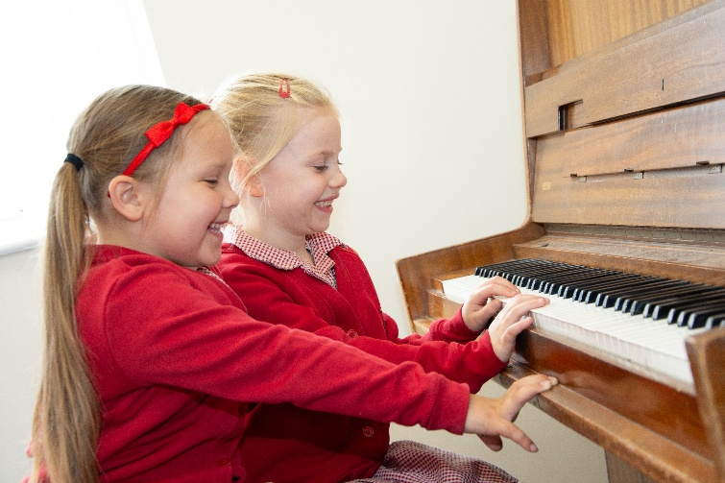
Welcome from Claire Garnett, Headteacher

Thank you for your interest in this role; we are delighted that you are considering joining our Juniper team.
We are looking for someone to take up post in September 2026 and are open to hearing from candidates who would ideally like to work in Key Stage 2, but welcome applications from experienced outstanding Key Stage 1 teachers.

Juniper is a great place to work, the Juniper Team are kind, caring and supportive of each other. We will provide you with the professional training and support to thrive in our school.
Our children are delightful, they work hard and enjoy coming to school. The school has an active Governing Body and interested, supportive families.
Myself or a member of the leadership team would welcome the opportunity to show you around before you apply, please contact the school office.
Juniper is a successful school, where we live our vision of empowering everyone in our community to have the courage to make a difference in the world. Join us and make a difference in our children’s lives.
Claire Garnett

The Juniper Way
The Juniper Team have a defined and consistent way of working underpinned by our school motto of Kindness, Enjoyment, Achievement; we call it The Juniper Way. It informs how we all act and behave, which shapes our culture. It helps us express the ambition we have for our school, children and wider community. At the heart of what we do are the relationships we invest in and nurture.
Kindness
- I invest in my own self-care to be the best version of myself I can be.
- I show kindness to myself.
- I care about people in the Juniper Community and speak to them respectfully.
- I give my time to all members of the Juniper Team to support them as best as I can.
- I choose my language carefully.
- I recognise when I’ve made a mistake, I’m not afraid to say sorry.
- I thank people and give honest feedback. I praise readily, I make people feel good.
- I am able to slow down and connect to how I am feeling.
- I am honest, I behave with integrity, I build trust and show with empathy.
Enjoyment
- I have a positive, optimistic outlook.
- I enjoy being with the children.
- I laugh and show a sense of humour.
- I am present when I am talking to others.
- I display confidence and credibility.
- I enjoy my role on the Juniper Team.
- I take advice and consult with others.
- I enjoy reading and learning.
- I am inquisitive. I share my ideas that may benefit Juniper.
- I promote a culture of inclusivity and value diversity.
Achievement
- I begin each day with a sense of renewed confidence.
- I invest time understanding others and develop positive relationships.
- I am enthusiastic about working at Juniper.
- I am reflective; I’m aware of my own strengths and weaknesses and am committed to my own personal growth.
- I remain calm in a crisis, and look for creative ways to solve problems.
- I am approachable, fair and open minded.
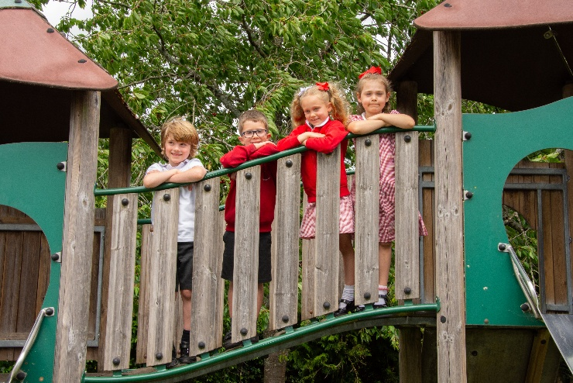
- I see the learning in every situation.
- I am determined and never give up.
- I have the confidence to take risks.
- I go the extra mile for the Juniper Community.
- I have a strong sense of commitment to the children, staff, parents and governors at Juniper.

Class Teacher Role
Our motto, vision and values are embedded in all we do. It is important that you share Juniper’s vision and values and subscribe to the Juniper Way.
What we are looking for
We are looking for a committed, understanding, caring, teacher. A teacher who puts relationships at the heart of their teaching. We are looking for someone who is keen to learn and develop and is committed to their own professional development.
You will have a very good understanding of SEND and are passionate about supporting our disadvantaged and SEND pupils. We value diversity and you will be expected to support our SMSC & D (Spiritual, Moral, Social, Cultural and Diversity) provision.
You will be keen to learn and open minded to try new ideas. At Juniper we use the Read Write Inc approach to teach phonics, from Year 1 we use the ‘I’m a Clever Writer’ approach to teach English. We also use Kagan Structures in our classrooms to create learning environments that are rich in cooperation and engagement. All of our children have Forest School lessons in our School Orchard.
We value everyone in our school. You will need to be warm, caring and supportive of everyone in our community.
Our commitment to you
We care about your wellbeing and will be considerate of your workload. We will provide full training and support including the opportunity to receive Kagan Training and Forest School Leader training. We have two classes in each year group, our year group teams share planning and support each other.

Training and professional development are highly valued at Juniper. You will benefit from all the training opportunities we provide.

Job Description
Main Purpose
- To fulfil the professional responsibilities of a teacher, as set out in the School Teachers’ Pay and Conditions Document.
- Meet the expectations set out in the Teacher’s Standards (for ECTs, by the end of the ECT period).
Duties and Responsibilities
Teaching
- Plan and teach well-structured lessons to assigned classes, following the school’s plans, curriculum and schemes of work.
- Assess, monitor, record and report on the learning needs, progress and achievements of assigned pupils, making accurate and productive use of assessment.
- Adapt teaching to respond to the strengths and needs of pupils, especially SEN and Pupil Premium.
- Set high expectations which inspire, motivate and challenge pupils.
- Promote good progress and outcomes by pupils.
- Demonstrate good subject and curriculum knowledge.
- Participate in arrangements for preparing pupils for external tests, if appropriate.
Whole-school Organisation, Strategy and Development
- Contribute to the development, implementation and evaluation of the school’s policies, practices and procedures, so as to support the school’s values and vision.
- Make a positive contribution to the wider life and ethos of the school.
- Work with others on curriculum and pupil development to secure co-ordinated outcomes.
- For more experienced teaching staff, e.g. UP, support the Leadership Team implement the SDP and drive whole school initiatives.
Health, Safety, Safeguarding and Discipline
- Promote the safety and wellbeing of pupils, follow all safeguarding policies and procedures. This includes keeping up to date with mandatory training.
- Maintain good order and discipline among pupils, managing behaviour effectively to ensure a good and safe learning environment.
Professional Development
- Take part in the school’s appraisal procedures.
- Take part in further training and development in order to improve own teaching.
- Where appropriate, take part in the appraisal and professional development of others.

Communication
- Communicate effectively with pupils, parents and carers.
- Communicate and collaborate with other Juniper stakeholders, e.g. Governors, PTA, etc.
Working with Colleagues and other Relevant Professionals
- Collaborate and work with colleagues and other relevant professionals within and beyond the school.
- Develop effective professional relationships with colleagues.
Personal and Professional Conduct
- Uphold public trust in the profession and maintain high standards of ethics and behaviour, within and outside school.
- Have proper and professional regard for the ethos, policies and practices of the school, and maintain high standards of attendance and punctuality.
- Understand and act within statutory frameworks setting out their professional duties and responsibilities.
Management of Staff and Resources
- Direct and supervise support staff assigned to them and, where appropriate, other teachers.
- Contribute to the recruitment and professional development of other teachers and support staff, if appropriate.
- Deploy resources delegated to them.

The teacher will be required to safeguard and promote the welfare of children and young people, and follow school policies and the staff code of conduct.

Person Specification
Criteria | Qualities
Qualifications and experience | - Qualified teacher status  - Degree  - Successful teaching experience  - Ability / Interest in leading a curriculum subject
Skills and knowledge | - Knowledge of the National Curriculum / EYFS Currciulum  - Knowledge of effective teaching and learning strategies  - A good understanding of how children learn  - Ability to adapt teaching to meet pupils’ needs  - Ability to build effective working relationships with pupils  - Knowledge of guidance and requirements around safeguarding children  - Knowledge of effective behaviour management strategies  - Good computing skills, particularly using computing to support learning
Personal qualities | - A commitment to getting the best outcomes for all pupils and promoting the ethos and values of the school  - High expectations for children’s attainment and progress  - Ability to work under pressure and prioritise effectively  - Commitment to maintaining confidentiality at all times  - Commitment to safeguarding and equality  - Positive, enthusiastic attitude  - Ability to work well with others and become part of the Juniper Team.  - Committed to professional development
How to Apply
If you would like any more information, or wish to arrange a visit or have an informal conversation with our Headteacher or member of the leadership team, please contact our school business manager, Luisa Davis, on sbm@juniper.school
To apply for this role, please complete the Buckinghamshire application form and submit it along with a personal statement explaining why you are the right candidate for this role. Applications should be sent to Luisa Davis on sbm@juniper.school
Closing date: Wednesday 22nd April at 9am 2026
Interviews: Wednesday 29th April 2026
Start Date: 1st September 2026


