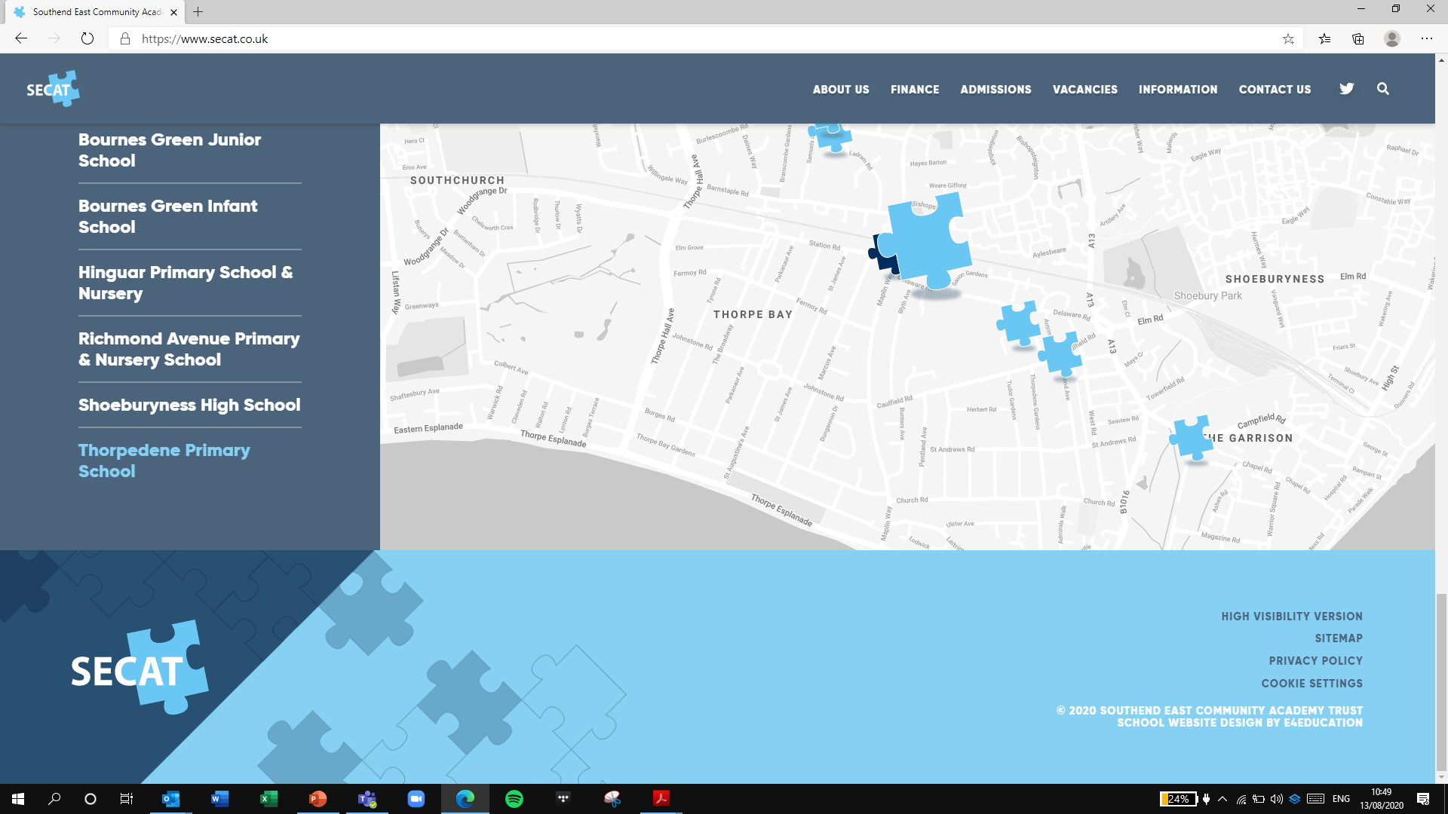
Building strong schools
Building strong partnerships
Building strong communities
SOUTHEND EAST COMMUNITY ACADEMY TRUST

Thank you for your interest in the Class Teacher position at Thorpedene Primary School & Nursery.

Please visit our online recruitment platform via www.secat.co.uk to complete the online application process.

We look forward to receiving your application.

