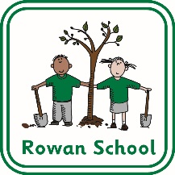
Building a secure foundation for learning and life.

At Rowan School our aims are for everyone to:

- feel safe and happy

- have high self esteem

- celebrate the efforts and achievements of themselves and others

- feel comfortable trying new experiences

- have a sense of excitement, vision and purpose in their lives

- learn and begin to put into practice values of healthy living

- develop communication and social skills that access participation in their communities

- develop independence

- enjoy lifelong learning

- achieve their full potential

- make a positive contribution to society

- appreciate and value differences

Building a secure foundation for learning and life.

We believe success will be achieved through:

- being valued and respected for our individual qualities, capabilities and contributions

- being encouraged to have a positive attitude to lifelong learning and to make progress towards and beyond agreed targets

- offering high quality and carefully planned learning experiences to meet individual needs

- having opportunities for shared learning and social activities with our peers both in and out of school

- creating a safe, happy and supportive environment that promotes respect and understanding of other races religions and lifestyles, and encourages sensitivity to the needs of others to nurture all

- working co-operatively and in partnership with parents and carers, professionals and others in the wider community

- furthering the process of inclusion wherever appropriate and practicable

- acknowledging and celebrating effort and achievement

