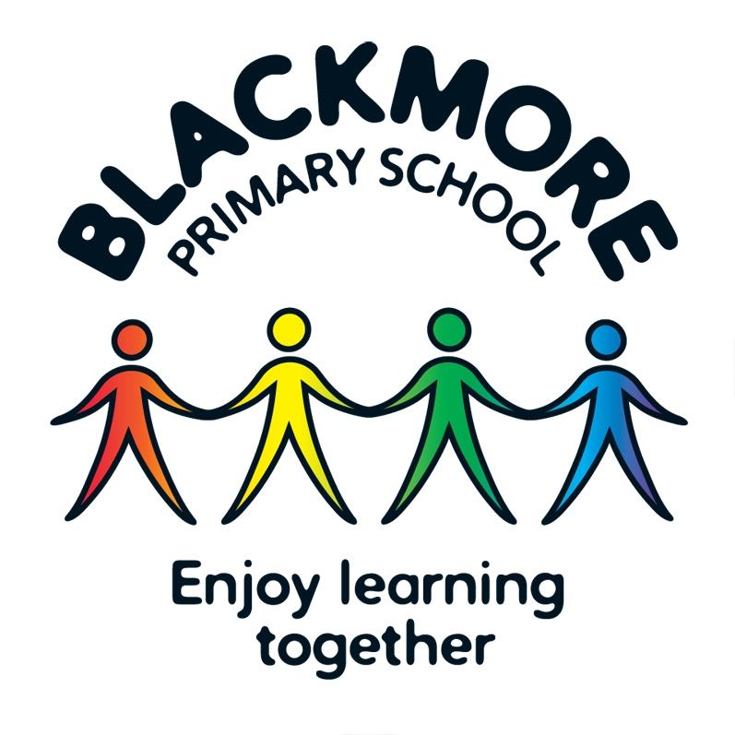
Person Specification for Classroom Teacher

 | ESSENTIAL | DESIRABLE
QUALIFICATIONS | Qualified Teacher Status and appropriate degree
EXPERIENCE | - Proven ability to be an outstanding classroom teacher  - Working effectively in a team | - Proven record of effective  subject leadership
PROFESSIONAL  KNOWLEDGE,  UNDERSTANDING  AND SKILLS | - Know what constitutes quality and high  standards in learning and teaching  - Understanding of inclusion and strategies for engaging all learners  - Appropriate and successful relationships with children  - Understanding of safeguarding procedures in a primary school  - Achieving and sustaining high  standards  - Effective organisational skills  - Ability to work well with parents and carers  - Understanding how the learning environment supports high standards  - Using a positive approach to  promote learning and excellent  behaviour strategies  - Confident and competent user of  ICT | - A good knowledge of specialist areas  - Subject Leadership experience
CURRICULUM | - The implementation of the National Curriculum  - An understanding of cross curriculum learning and teaching which motivates children | - An understanding of how the curriculum supports the ethos and values of a school'.
PROFESSIONAL  VALUES | - High expectations of everyone  - Learning should be fun  - Commitment to practical learning  - Willingness to use variety of  teaching strategies to engage and motivate all learners  - Commitment to the personal welfare and safeguarding of children  - Primary age teaching experience | - Support for an enriched  curriculum through out of  hours learning and  educational visits
PERSONAL  QUALITIES | - Passionate about Learning and  Teaching  - Displays warmth, care and  sensitivity in dealing with children  - Open minded, self-evaluative and  adaptable to changing  circumstances and new ideas  - Able to enthuse and reflect upon  experience  - Willingness to be involved in the  wider life of the school  - Ability to work flexibly  - Ability to prioritise  - Good interpersonal and communication skills  - When all the above fail, to maintain good sense of humour, a willingness to learn and the will to continue to strive for excellence | - Insight into what is important in our school  - Brings personal interests  and enthusiasms to the  school community  - Go the extra mile!
Above all, you need to like children, to want the very best for them and be prepared to put their needs first. You recognise the importance of educating the whole child, including all learners and achieving high standards, within a creative, broad and innovative curriculum.

