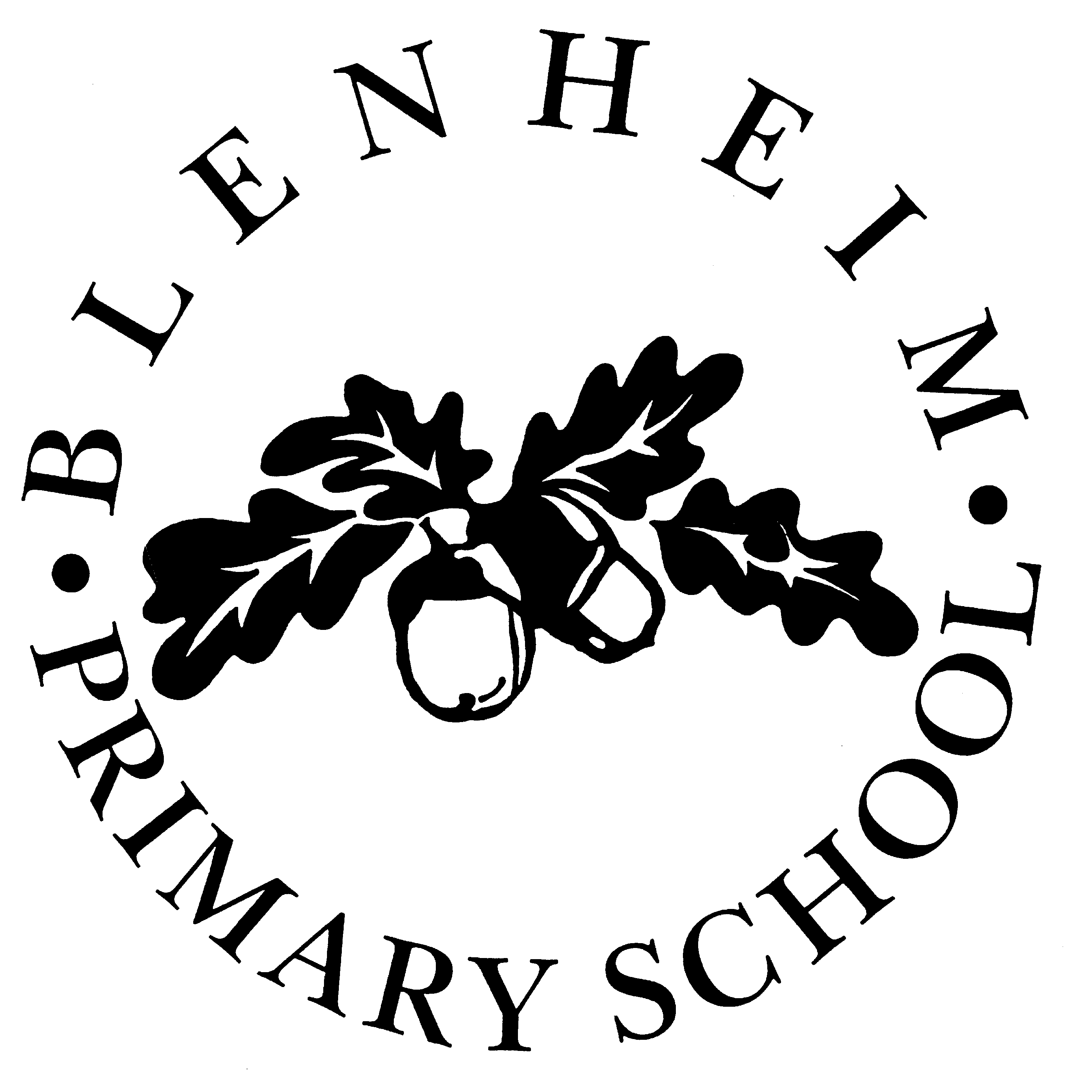
Blenheim Primary School
Lofthouse Place
Leeds LS2 9EX

Head Teacher: Mrs M. Duffy
Tel: 0113 2930808

2026

Dear Applicant,

Thank you for your interest in the post of Teacher at Blenheim Primary School. We are a successful two form entry school and are looking for teachers who can continue the excellent work of the school and maintain our Outstanding Ofsted grade. Please state your preferred key stage or age range when applying.
This is a fixed term role in the first instance, but will be looked at going forward. It requires a loyal, dedicated individual who is prepared to go the extra mile in order to achieve the very best for our children.

Please find enclosed some further information about the school, a job description and person specification. Application forms are to be returned to the school no later than Monday 20th April at 9am. Short listing will take place that day and successful applicants will be informed by either telephone or email. If you do not hear from us by 24th April, please assume you have been unsuccessful.

Our school is committed to safeguarding and promoting the welfare of children and expects all staff and volunteers to share this commitment. The successful candidate will be subject to an enhanced DBS disclosure. Please note that previous employment references MUST be from the most senior person in the organisation and should include your most recent employer.

We promote diversity and want a workforce which reflects the population of Leeds.

Applicants are invited to a tour of the school with the Headteacher at 9am or 4pm on Wednesday 1st April. Please telephone the school to book an appointment.

I hope you are interested in this position at Blenheim Primary School and look forward to receiving your application form.

Yours sincerely,

Mo Duffy
Headteacher
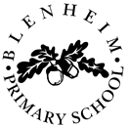

Profile of the School

Blenheim Primary School is a two-form entry inner city school near the University of Leeds. It is situated in pleasant grounds, having a large field and ample playgrounds. There are four buildings: the main school (housing years 4, 5 and 6); the new building (housing Reception, year 1, 2 and 3); the nursery building and the bungalow (which has been converted to school use).

Blenheim Primary has a very varied ethnic mix of pupils and staff working together harmoniously. A high percentage of pupils arrive with little or no English. One main reason for this is a proportion of their parents are international students attending the university. As the students are here for a limited length of time before returning to their country of origin, this creates a high turnover of pupils through the year (28% mobility).

One of the school’s strengths is the welcoming nature of pupils and staff when helping our many new arrivals to settle in. The school aims to foster a caring environment where pupils are expected to reach and maintain a high standard of both behaviour and academic achievement. Our children are very well-behaved. On entry ,children are generally well below age related expectations but leave us well above.

We are a hard-working, committed and enthusiastic team who work cohesively with governors, parents and the community. Staff and pupil relationships are exemplary.

Currently there are 464 pupils on roll and our numbers are rising. This includes a 39-place nursery which offers fully flexible provision; currently 52 children are enrolled part-time. 36% of pupils are entitled to free school meals – a high proportion compared to the 15% average nationally. 46% of children who attend the school live in an area classed as being amongst the 10% most deprived in England, with 68% living in an area classed as being amongst the 20% most deprived in England. At present there are 16% on the school’s register of special needs; this figure is in line with the national average. But there is a very high number of children with complex needs: 19 have individual full or part-time support. For 81% of children in school, English is an additional language and there are 52 other languages spoken. 92% of children are BAME which adds to the rich cultural diversity of the school.

Please take a look at our website to learn more about the school: https://www.blenheimprimaryschool.com/

