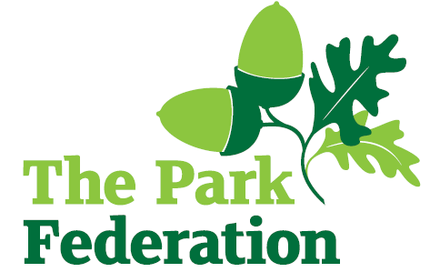
Class Teacher

Salary (actual): £21,933 - £47,839
Grade: UNQ - UPS
Hours: Full time
Contract: Permanent
Start: September 2024

Montem is a warm and vibrant multi-cultural primary school based in Slough.

We are seeking to appoint enthusiastic professionals, who has high expectations of themselves and their pupils and is committed to improving the lives of our children.

Our partnership with The Park Federation Academy Trust means there are a host of professional development opportunities that will further your own skills, knowledge and expertise.

We are looking for an individual who:
- has experience of supporting young people;
- is proactive, positive, calm and flexible;
- has high expectations of themselves and the children they work with;
- has excellent communication, organisational and interpersonal skills;
- is committed to working as part of a team;
- is resilient.

For the right candidate, we will offer
- extensive support and CPD;
- the opportunity to work with other professional colleagues across the Multi-Academy Trust;
- a welcoming school, with friendly, enthusiastic and supportive staff team;
- an ambitious and dynamic Senior Leadership Team;
- a dedicated Governing Body;
- supportive parents and children who are keen to learn;
- an employee assistance programme (EAP).

We warmly welcome candidates coming to visit the school prior to application; please contact the school to arrange. Please visit the school website for an application pack. We do not accept CV’s.

Closing Date: As and when we receive successful applications.

The school is committed to safeguarding and promoting the welfare of children and young people and expect all staff and volunteers to share this commitment. The successful applicant will be required to undertake an Enhance DBS Check with a check of the BDS Barred List.

