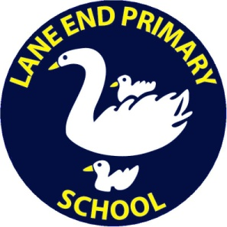
LANE END PRIMARY SCHOOL

PERSON SPECIFICATION

 | Essential |  | Desirable
Qualifications | - Must hold at least GCSE English and maths Grade C or above  - Qualified Teacher Status |  | - Evidence of continuous INSET and commitment to further professional development  - Forest school qualification
Experience | - Successful primary school teaching experience  - Successful experience of working within EYFS |  | - Experience of working in partnership with parents
Knowledge & Understanding | The applicant must have knowledge and understanding of:  - The theory and practice needed to provide effectively for the needs of all children  - A range of appropriate strategies for learning and teaching, including use of ICT and behaviour management  - The monitoring, assessment, recording and reporting of pupil’s progress – including use of platforms such as Tapestry  - Confident using Microsoft Office and Teams |  | In addition, the applicant might also have knowledge and understanding of:  - Preparation and administration of statutory National Curriculum tests such as the phonics screening check  - A secure knowledge and understanding of phonics to develop Early Reading  - An understanding of supporting young children with a range of special educational needs
Skills & Abilities | The applicant will be able to:  - Commit to the school’s safeguarding procedures and policy  - Teach creatively to inspire and challenge all pupils  - Relate to and motivate pupils well  - Demonstrate good classroom management  - Create a stimulating. purposeful and effective learning environment  - Contribute positively to and promote the school’s mission statement, aims and ethos  - Work well within and contribute to team development  - Establish and develop good relationships with parents, governors and the wider community  - Seek advice and support where necessary  - Be supportive of and promote equality and diversity  - A reflective practitioner committed to personal development | - Offer an extracurricular activity  - A willingness to lead a curriculum subject
Personal Characteristics | - Enthusiastic  - Works well in a team  - Has flexibility, sensitivity and understanding  - Organised

