
CLASS TEACHER APPLICATION PACK

CLASS TEACHER APPLICATION PACK

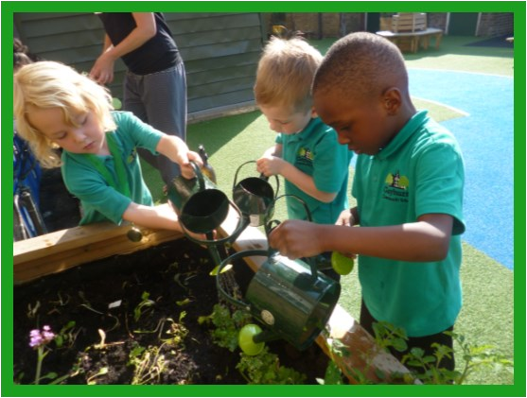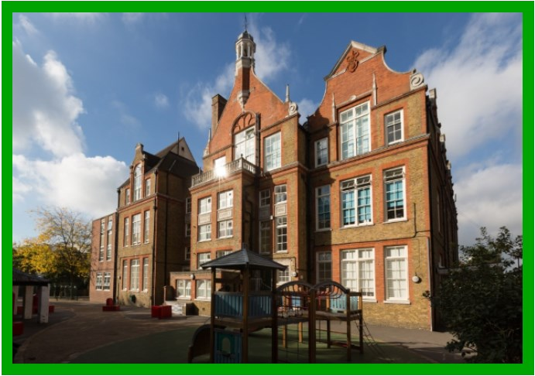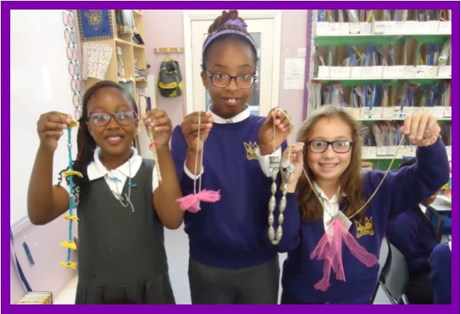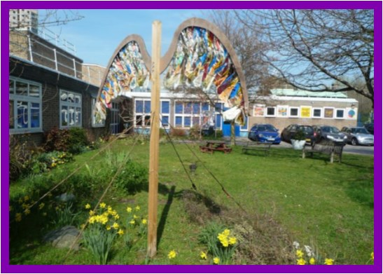
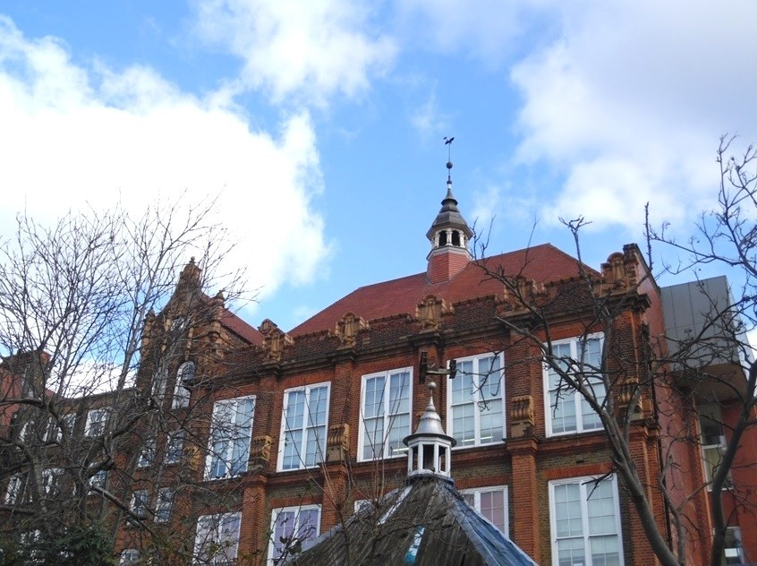
LEARNING EDUCATION ARTS PARTNERSHIP FEDERATION OF KINGSMEAD, GAYHURST AND MANDEVILLE PRIMARY SCHOOLS





Welcome!
CONTENTS

 What do we offer?

What are we looking for?

How to apply

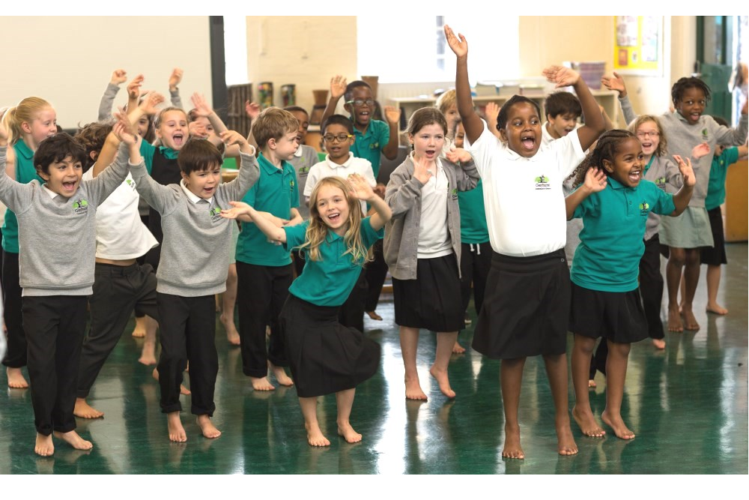 Job description & person specification
Kingsmead Primary School | Gayhurst Community School | Mandeville Primary School
Kingsmead Way | Gayhurst Road | Oswald Street
London E9 5PP | London E8 3EN | London E5 OBT
0208 985 5779 | 0207 254 6138 | 0208 986 5249
admin@kingsmead.hackney.sch.uk  www.kingsmead.hackney.sch.uk | admin@gayhurst.hackney.sch.uk  www.gayhurst.hackney.sch.uk | mdvoffice@mandeville.hackney.sch.uk  www.mandeville.hackney.sch.uk

Dear Applicant,

Thank you for your interest for the position of Class Teacher at the LEAP Federation. LEAP stands for Learning Education Arts Partnership which demonstrates the emphasis on learning of a broad and balanced curriculum, it is also a play on the River LEA which connects our school sites.

I hope that you will find this information pack helpful. If after reading this you have any questions, we would be happy to answer these.
Please visit the websites of each of our schools for additional individual information. We also encourage visits to our schools if you have not visited before.
Come and see our creative curriculum in action and meet the friendly, happy, school staff.

The London Borough of Hackney is a vibrant, diverse and rewarding place to teach with outstanding results and outcomes for pupils.

Our schools reach communities across London Fields, Homerton and Lower Clapton in Hackney with over 1,200 pupils on roll. All three schools are within easy transport links into and out of Central London. We aim to ensure that every child succeeds to the best of their ability and receives a broad and balanced education which fosters a love of learning for life. We have developed a brand new curriculum called the LEAP empowerment curriculum where many of the units are written and designed by our school leaders to ensure that what we teach gives all children the knowledge of history, geography and world politics that has led us all to this community we live and work in.
We are committed to continuous improvement and developing a sense of shared purpose and belonging across the whole community.
Between the schools we have won many awards including the Mayor’s Award for music provision and Arts Mark Platinum by the Arts Council. We have won Beacon Cycling school awards, School of the Region and Gold and Silver awards f rom TfL for our work promoting sustainable travel.

The schools are very well resourced with a dedicated art gallery #TAG at Gayhurst, dance studio, chickens, our very own cooking school in the award winning Hackney School of Food which features a large productive vegetable garden where all LEAP children get to grow, harvest and cook meals. !
Our healthy tasty free to staff school lunches cooked by highly respected chefs have won national acclaim and staff regularly feedback that this and other staff wellbeing initiatives make all the difference to their daily work.

We lead the Hackney Teaching & Schools Alliance (www.hackneytsa.org.uk) which is an alliance of 15 other primary and secondary schools in Hackney and have designed a career pathway from Teacher apprenticeship , through ECT training, second and third year development programme, middle leaders, senior leaders and new Headteachers. We are always looking out for future leaders among our new recruits. Our focus on continuing professional development means we have a low staff turnover and high standards of teaching and learning throughout. Many of our staff deliver training both locally and nationally and we have 6 dedicated Specialist Leaders of Education and a National Leader of Education who design and deliver bespoke training for all our staff.

We are looking to recruit self-motivated and ambitious class teachers who are inspirational and will work to develop outstanding teaching and learning, driving up standards so as to enable all pupils to make excellent progress and maximise their potential. This is a great and unique opportunity to join a supportive and collegial team to drive our vision for our schools where children are at the centre of all we do, and to join a dynamic forward thinking setting.

If you would like to come and be part of our diverse and talented staff team and help to really make a difference to children’s lives, then our federation could be the place for you.



CLASS TEACHER APPLICATION

Why work with us?

High quality Specialist Leaders of Education as mentors.
The HTSA career pathway supports all staff to develop to their full potential
with the highest quality staff training available.
Staff benefits such as cycle to work scheme, childcare vouchers, massage sessions, training residential, international trips including in this year alone trips to Finland, Spain and Germany.
Our amazing support staff ensure that you are able to concentrate on teaching and not all the other things that can add to your work load.
Inner London weighting making a difference to your pay and you will be on the highest pay scales available to teachers across the country. As a Class Teacher you will begin on a salary of at least £32,157.00 (Main Scale point 1) in inner London. As you rise up the pay ranges, you could earn m much more.
Our schools now have more freedom to develop their own pay policies to attract and retain the teachers that have the greatest impact on their pupils’ learning. So what you are paid will be linked to performance and not length of service-meaning you can increase your salary faster than ever before.

We are looking for teachers who:

- Are self-reflective and have the desire to be the best they can
- Have a professional attitude, are great role models and really want to make a difference for Hackney children
- Are a great innovators who want to work with others to create exciting new learning adventures for children
- Are well informed and have a great subject knowledge
- Are ambitious for themselves and their children and want to be school leaders of the future

We are committed to safeguarding and promoting the welfare of children and young people and expect all staff and volunteers to share this commitment.
A DBS at enhanced level will be required. We welcome applications from all sections of the community, regardless of gender, race, religion, disability, sexual orientation or age

HOW TO APPLY

1. Read the job description and person specification carefully

2. Complete the application form either electronically or print and complete by hand

3. Ensure supporting statement relates to the competencies outlined in the person specification

4. Email your completed application to Joanna Makaruk at:
JMakaruk@gayhurst.hackney.sch.uk
Closing date for applications:
Monday,18th April 2022 at 5pm

Interview Date:

Week commencing 25th April 2022

We are committed to safeguarding and promoting the welfare of children and young people and expect all staff and volunteers to share this commitment. The successful candidate will be subject to clear reference checks and a DBS at enhanced level. We welcome applications from all sections of the community, regardless of gender, race, religion, disability, sexual orientation or age.

Should you have any queries or would like to arrange to visit our schools please contact Joanna Makaruk at:
JMakaruk@gayhurst.hackney.sch.uk

We look forward to receiving your application!

CLASS TEACHER JOB DESCRIPTION

Grade: MPS

Main activities & responsibilities:

The current School Teachers’ Pay and Conditions document describes duties which are required to be undertaken by teachers in the course of their employment. In addition certain particular duties are reasonably required to be exercised, and completed in a satisfactory manner. It is the contractual duty of the post holder to ensure that his/her professional duties are discharged effectively.

Essential Qualifications

- Educated to degree level
- Qualified teacher status
Experience

Will have had some experience of teaching in a multicultural inner city environment, ideally in more than one year group.

Particular Specific Responsibilities

- The postholder is responsible to their line manager for his/her duties, responsibilities and teaching tasks.
- The postholder will interact on a professional level with all colleagues and establish and maintain good working relationships which will promote the development and effective delivery of the school curriculum and maximise children’s achievement.
- The postholder will be responsible for the supervision of the work of support staff and any students who may be on teaching practice or work placement.
- The postholder undertakes the teaching of the pupils in his/her class and the associated pastoral and administrative duties in respect of those pupils as well as the general responsibilities in the school as agreed with the Headteacher.
- Possibility of TLR for experienced teachers
Other Responsibilities

In addition to undertake such duties of a similar nature as may be reasonably directed by the Headteacher from time to time.
The duties and responsibilities of the post may vary from time to time according to the changing needs of the school.

CLASS TEACHER PERSON SPECIFICATION

- To be flexible and versatile in attending to the needs and requirements of children
- Excellent organisational skills, ability to meet time-related deadlines and ability to prioritise.
- Ability to work under pressure and on own initiative.
- Ability to develop interpersonal relationships with children and staff.
- Identify underperformance in pupils and take appropriate action to rectify.
- Supervision of children in an assertive but fair and reasonable manner.
- To be able to praise, encourage and develop potential of children to raise attainment.
- Teaching all pupils in your class according to their educational needs and acknowledging that every lesson counts.
- Creating a well ordered and secure environment that will ensure the educational well-being of individual children within the group.
- Making effective use of ICT to enhance learning and teaching.
- Undertaking careful planning and delivery of the curriculum.
- Ensuring careful and ongoing assessment of the pupils learning to inform further planning.
- Ensuring that the curriculum is differentiated to mean that tasks and activities are matched to the ability of the children and henceforth allowing them to make progress at the right pace and level.
- Completing all assessments and records as determined by school policy in a timely fashion.
- Working with school leaders to track the progress of individual children and intervene where pupils are not making progress.
- Working with school leaders to complete and teach individual pupil plans where pupils have specific needs. (IEPs)
- Ensuring that equal opportunities are implemented in the classroom and throughout the school.
- Developing and maintaining positive relationship with parents, which involve them actively in the classroom and in the learning process.
- Participating in planning and staff meetings.
- Contributing to the whole school ethos by taking a leading role in display particularly in own classroom and designated whole school areas as agreed with the Headteacher.
- Contributing towards the development of the school and implementation of whole school policies.
- Contributing and co-operating with other staff and professional agencies as appropriate to the needs of the children.
- Undertaking in-service training for further development as a teacher.
- Undertaking other duties, which may be reasonably assigned by the Headteacher to ensure the smooth running of the school.
