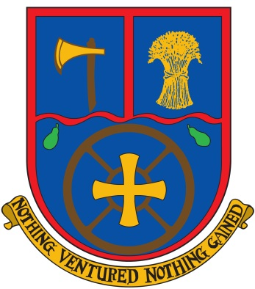**Aldermaston C.E. Primary School**

Wasing Lane, Aldermaston, Berkshire, RG7 4LX

Tel: 0118 9713362

Text: 0118 3240216

Email: [enquiries@aldermaston.w-berks.sch.uk](mailto:enquiries@aldermaston.w-berks.sch.uk)

Website: [www.aldermaston.org.uk](http://www.aldermaston.org.uk)

Mrs. M Higgs - Headteacher

Oxford Diocese Logo

**Class teacher required for Spring and Summer Terms 2022**

**Full Time Main Scale (Fixed term contract – 2 terms)**

We’re looking for a great teacher to join our warm and friendly team. You will be working part time as a whole class teacher and on the remaining days you will be delivering high quality interventions to identified groups of children.

**Our ideal candidate would be:**

* Creative, enthusiastic and caring with high expectations for all of our children – both academically and socially
* Innovative and interested in further professional development
* Sympathetic to the school’s Christian foundation and ethos

**Our children are ready to learn. We have a beautiful setting, a lovely learning environment with great facilities and fantastic support from the wider community. We are committed to providing good quality CPD opportunities and personalised development.**

Visits warmly welcomed. For more details and an application form please call or email (details above).

The school is committed to safeguarding and promoting the welfare of children and expects all staff and volunteers to share this commitment. The successful applicant will be required to undertake an enhanced DBS check.

Closing date: Friday, 12th November 2021

Interview date: w/c 15th November 2021