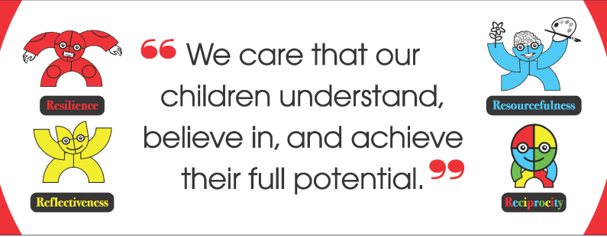

Application Pack

Allenton Community Primary School
Brookhouse Street
Allenton
Derby DE24 9BB

Telephone: (01332) 701144
Headteacher: Jon Fordham
Email: admin@allenton.derby.sch.uk

Friday 19th November 2021
Dear Candidate,

Thank you for expressing an interest in the post of class teacher.

You will find in this pack, information about our school, person specification and a job description for this post. Application forms are found on the Transform Trust website http://www.transformtrust.co.uk/vacancies.

You are most welcome to visit the school before applying; please contact Lucy Savory, School Office Manager, on the above number or email address to make an appointment.

This is a very exciting time for Allenton Community Primary School as we work towards our journey to outstanding and improving outcomes for the children of Allenton.

We are a friendly, welcoming school and our team are all dedicated and hardworking. We are looking for an outstanding, reflective practitioner who is eager to share best practice, who values teamwork and collaborative working to join our committed staff. We believe in better outcomes for our children and we achieve this through quality teaching and a lively curriculum.

Benefits we can offer successful candidates include:
- Close links with schools in which to share and disseminate good practice
- Joining a forward thinking and outward facing school with excellent support from Transform Teaching School Alliance and our Trust.
- Bespoke CPD tailored to the needs of successful candidates
- Access to excellent courses delivered through TTSA
- Teacher Networks to support your growth as a member of the school team
- If an NQT, development in line with the new Early career framework
- An excellent team ethos and wonderful children!

Safer recruitment measures include rigorous checking information you supply about yourself in your application e.g. verifying employment history and qualifications and references, enhanced Criminal Records Bureau check and assessment of your suitability in light of safeguarding and promoting the welfare of children and young people.

Before completing your application, look carefully at the job description/person specification and include any evidence you can about how you would be suitable for this particular post. Please note that both references will be taken up, and that you will be required to produce certificates, if you are called for interview, to validate your qualifications.

The closing date for applications is 1pm, 3/12/2021. We will aim to be in contact with the successful candidates after short listing in order to prepare for interviews which will be held on 7/12/21.

I look forward to receiving your application.

Yours sincerely

Jon Fordham

Mr. Jon Fordham
Headteacher

Our Learning SuperHeroes!

Special Points of interest
- ACPS is located near the centre of Derby.

- We have extensive school grounds.

- We are a two form entry school with over 400 pupils.

- We have a significant number of pupil premium and strive to improve life chances for these children in our school community.

- We have 34 languages spoken in school.

- Developing learning attitudes and raising aspirations is central to our ethos.

- Staff CPD is core to improvements in our school.

- Senior leaders have developed systems to reduce teacher workload.
A little bit about us
We are sited in the heart of the Allenton community with all the rewards and challenges that this brings. Many of the improvements made in school have been held up as models of good practice across Derby and beyond. Such strengths include use of Pupil premium, marking and feedback, teacher research and staff workload. Over the years we have developed our staff to become Specialist leaders of Education and currently have six SLEs in school that support staff and trainees a like in school and beyond.
We are an Academy with Transform Trust as our sponsor. This further opens CPD and promotion opportunities for staff to lead areas of interest across the trust and be a part of Trust wide improvement. Working with the Trust has also significantly increased the amount of schools we collaborate with.
We are a friendly, welcoming school and our team are all dedicated and hardworking. We care that children understand, believe in and achieve their full potential and look for like-minded able colleagues to join our excellent team.
In return for working at ACPS, we can offer you great team support, friendly staff and children, significant CPD opportunities and a commitment to support you at whatever stage of career you are in.

We look forward to meeting you.

Jon Fordham
Head teacher

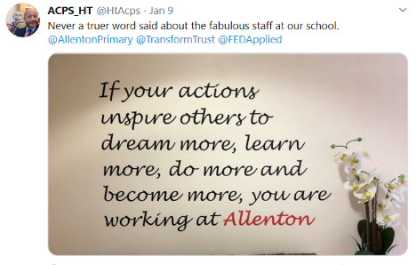

Check us out on Twitter.

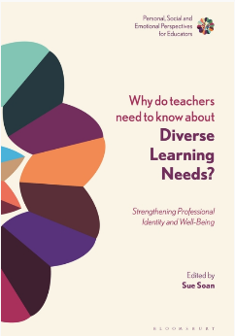
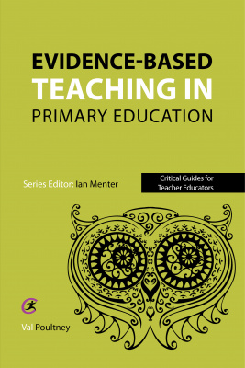
Read our chapter on Resilience in children and educators.

Read our book on research in education

JOB DESCRIPTION: CLASS TEACHER

AREAS OF RESPONSIBILITY AND KEY TASKS
A. PLANNING, TEACHING AND CLASS MANAGEMENT, TO:

Teach allocated pupils by planning their teaching to achieve progression of learning through:

- Identifying clear teaching objectives and specifying how they will be taught and assessed
- Setting tasks which challenge pupils and ensure high levels of interest
- Setting appropriate and demanding expectations
- Setting clear targets, building on prior attainment
- Identifying SEN or very able pupils
- Provide clear structures for lessons maintaining pace, motivation and challenge
- Make effective use of assessment and ensure coverage of programmes of study
- Ensure effective teaching and best use of available time
- Monitor and intervene to ensure sound learning and discipline
- Use a variety of teaching methods to:
1) Match appropriate to content, structure information, present a set of key ideas and use
appropriate vocabulary
2) Use effective questioning, listen carefully to pupils, give attention to errors and
misconceptions
3) Select appropriate learning resources and develop study skills through library, ICT, and
other sources
- Ensure pupils acquire and consolidate knowledge, skills and understanding appropriate to the subject taught
- Evaluate their own teaching critically to improve effectiveness
- Take account of pupils needs by providing structured learning opportunities which develop the areas of learning identified in national and local policies sand particularly the foundations for literacy and numeracy
- Encourage pupils to communicate about and record their learning, develop self control and independence, concentrate and persevere, and listen attentively
- Use a variety of teaching strategies which involve planned adult intervention and first-hand experience
- Manage parents and other adults as appropriate

B MONITORING, ASSESSMENT, RECORDING, AND REPORTING-TO:
- Assess how well learning objectives have been achieved and use them to improve specific aspects of teaching
- Mark and monitor pupils work, give constructive feedback and share targets as required
- Assess and record pupils progress systematically and keep records to check work is understood and completed, monitor strengths and weaknesses, inform panning and recognise the level at which the pupil is achieving
- Prepare and present informative reports to parents.

C OTHER PROFESSIONAL REQUIREMENTS- TO:
- Have a working knowledge of teachers’ professional duties and legal liabilities
- Operate at all times within the stated policies and practices of the school
- Establish effective working relationships and set a good example through their presentation and personal and professional conduct
- Endeavour to give every child the opportunity to reach their full potential and meet high expectations
- Contribute to the corporate life of the school through effective participation in meetings and management systems necessary to co-ordinate the management of the school
- Take responsibility for their own professional development and duties in relation to school policies and practices
- Establish and maintain effective working relationships with colleagues and parents
- Take on any additional responsibilities which might from time to time be determined

PERSON SPECIFICATION – Class Teacher

Keys:

E = essential; D = desirable; EB = evidence base;

A = application R = reference I = interview & task

 | Qualifications and experience | E | D | EB
1 | Qualified teacher status for primary phase | □ |  | A
2 | Experience of teaching in Key Stage 2 | □
3 | Experience of working in a diverse setting |  | □

 | Teaching and Learning | E | D | EB
1 | Ability to plan, implement and evaluate the curriculum in accordance with the educational needs of all children and the policies of the school and the requirements of the National Curriculum. | □ |  | A, R & I
2 | The ability to monitor, assess and record children’s learning effectively in accordance with school policies and the requirement of the National Curriculum. | □
3 | The ability to set up and maintain an attractive and purposeful learning environment which is relevant to the children’s needs and challenges their potential. | □
4 | The ability to communicate relevant information effectively to other staff members, parents, governors and other agencies and liaise effectively. | □
5 | The ability to utilise appropriate strategies for managing children’s behaviour in order to maximise their learning | □
6 | Perform as a model practitioner especially in Literacy topics; coaching others to develop practice, research new initiatives and disseminate to whole staff. | □
7 | Good ICT Skills and experience of using ICT to support teaching and learning across the curriculum | □
8 | A good understanding of inclusion issues, including EAL, SEN, G&T, gender issues etc. | □
9 | Knowledge of the current legislation and legal requirements and the ability to use this knowledge in efficient curriculum practice. |  | □
10 | An understanding of the role of monitoring to improve the quality of teaching and learning | □
11 | Ability to work well with colleagues and maintain good relationships with pupils | □
12 | A commitment to personal professional development and supporting the development of a professional learning community within the school. | □
13 | An interest in how children learn and develop. | □

 | Safeguarding and Equal Opportunities | E | D | EB
1 | Ability to form and maintain appropriate relationships and personal boundaries with children and young people | □ |  | A, R & I
2 | Understanding of and willingness to promote the Council’s Equal Opportunities Policies and the ability to implement these in the classroom. | □

