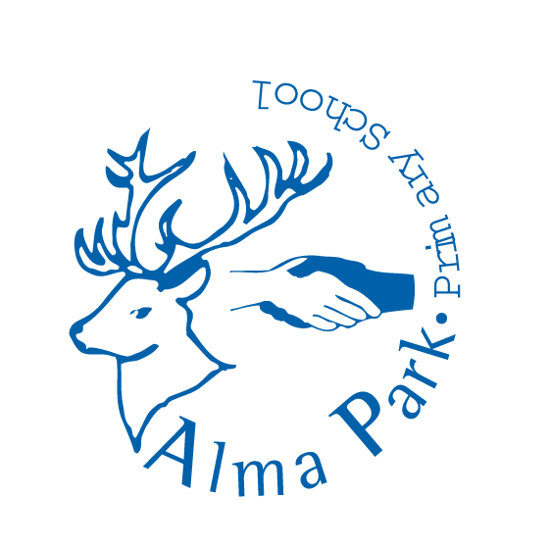
Alma Park Primary School
Job Description Main Scale Teacher

Core Behaviours:
- Demonstrate personal integrity, loyalty, discretion and professionalism at all times and in all situations; inspiring trust and confidence in pupils, colleagues, parents, carers and governors
- Actively celebrate diversity and promote equality at all times and in all situations
- Actively promote and engage in all school policies and practices
- Seek every opportunity to support and celebrate our unique Hearing Deaf Needs provision; securing the best outcomes for deaf children at Alma Park.
Core Purpose:
Teachers at Alma Park will be expected to support National, City Council and School priorities and carry out the full range of professional duties of a teacher as set out in the School Teachers’ Pay and Conditions Act and DfE Teachers’ Standards. They are accountable to the Headteacher through the Assistant Headteacher for the relevant Key Stage and will support the continuing improvement of the school through:

- Promoting and enabling good and outstanding achievement and provision
- Promoting effective teaching, learning and high standards of behaviour, which sustains improvement in the development of all pupils
- Communicating to pupils, parents, staff and the wider community the school’s high expectations and the inclusive philosophy that all pupils can succeed
- Promoting the school’s inclusive approaches to raise the quality of provision and ensure achievement for every child
- Supporting a curriculum area

Achievement, Teaching and Learning:
- Deliver creative teaching that secures high standards of learning, access and engagement
- Create and maintain a climate that secures good and promotes outstanding teaching, high standards of achievement and good behaviour
- Publish and share differentiated planning that exemplifies good and outstanding provision to meet the needs of every learner
- Use data to track and evidence pupils’ achievement and inform focussed provision (as part of assessment for learning process)
- Actively respond to pupils’ work and outcomes, identifying next steps for learning and encouraging a dialogue to facilitate individual response and progression

Responsibilities for Self:

- Take responsibility for own professional development by identifying relevant CPD needs and
inform Assistant Headteachers accordingly
- Prioritise and manage own time effectively, remain calm under pressure and work to deadlines
- Gather evidence of progress towards agreed appraisal objectives (reviewed mid and end of cycle)
- Sustain personal motivation, reflect constructively on practice and manage change

Responsibilities for Pupils:

- Ensure that every child accesses a broad, balanced and relevant curriculum that inspires, engages and motivates their learning
- Create an environment that actively supports learning, reflects children’s interests and celebrates their achievements
- Ensure a consistent approach to involving children in understanding the next steps for their learning that inspires them to be ambitious and achieve the highest standards
- Consistently apply school policy to ensure safeguarding and outstanding behaviour at all times and in all contexts
Responsibilities for Staff:

- Actively involve any teaching assistants working with their pupils in planning, provision and monitoring of pupil outcomes and engagement
- Ensure that teaching assistants working with their pupils are actively contributing to the progression of pupils throughout the teaching day
- Provide professional advice, contribute to, arrange and lead INSET as appropriate, disseminate information relating to best practice and educational research in the curriculum area (all teachers beyond NQT year)
- Support teachers and teaching assistants in the delivery and development of the curriculum area (all teachers beyond NQT year)

Responsibilities for resources:

- Ensure their classrooms are attractive, safe, organised and tidy
- Manage, monitor and review the range, quality, quantity and use of resources, ensuring they positively promote diversity and inclusion

Responsibilities for Parents, Carers and the Wider Community:

- Develop and maintain positive links, relationships and partnerships with parents/carers, the community, other educational establishments and agencies

This job description will be reviewed annually to recognise the changing needs and priorities of the school; as a result of which the curriculum area may change.

