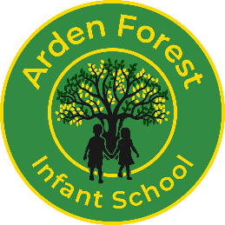
Job Title - Key Stage 1 Class Teacher
School Name – Arden Forest Infant School
Start Date – September 2026
Salary – Teacher Main Scale
Working hours –Full Time Permanent

About Us & The Role
Arden Forest is a two-form entry infant school, located on the outskirts of the large rural village of Bulkington. It is a mixed, lively community with its own shops, library and village centre. The school attracts children from within the local community, but also wider community, including Bedworth, the local army barracks (Bramcote) and traveller communities. We are a well-regarded and happy school where children feel safe and valued.
Key Requirements
We are seeking to appoint a committed and talented class teacher to join our team on a permanent basis from September 2026, or as soon as possible thereafter.
We are looking for a candidate with high expectations who can inspire and motivate pupils to make excellent progress, and who is passionate about delivering engaging and meaningful learning experiences. The successful applicant will be enthusiastic, hardworking and proactive, as well as friendly and approachable, with strong communication skills and a genuine passion for teaching.
Our spacious and well-maintained school site benefits from extensive grounds, offering significant potential for further development, particularly in enhancing curriculum-based outdoor learning opportunities.
We offer:
- Supportive parents and Governors
- Open-minded and enthusiastic staff
- Well-behaved and motivated children
- SLT who are committed to staff well-being, CPD and raising standards.

How to apply/ Additional Information
To apply, please download the attached application pack and return to Sadie Kemp at kemp.s6@welearn365.com Telephone 02476 315913. If you wish to discuss the role or visit our school prior to the closing date please contact us as soon as possible using the details above.

Closing date: 8th May 2026 Interviews: 13th May 2026 – Afternoon

Applications may close early due to the sufficient number of applicants received.
Arden Forest Infant School is committed to safeguarding and promoting the welfare of children, young people and vulnerable adults and expects all staff and volunteers to share this commitment. This post is subject to an enhanced DBS disclosure. Please also be aware that online searches may also be undertaken as part of Safer Recruitment in accordance with KCSIE 2025.

