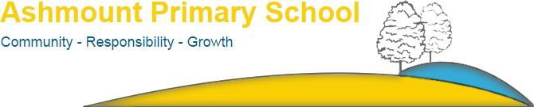
Contents
Class Teacher
Job reference: ASH/
Closing date: noon on Friday 23rd June 2023

Information about the school
Page | 4 | Letter to applicants
Page | 6 | Our school
Page | 8 | Our vision and mission
Page | 10 | Key facts and statistics
Page | 11 | School location
Information about the role

Page | 13 | Advert
Page | 15 | Job Description
Page | 20 | Person Specification
Page | 22 | How to apply

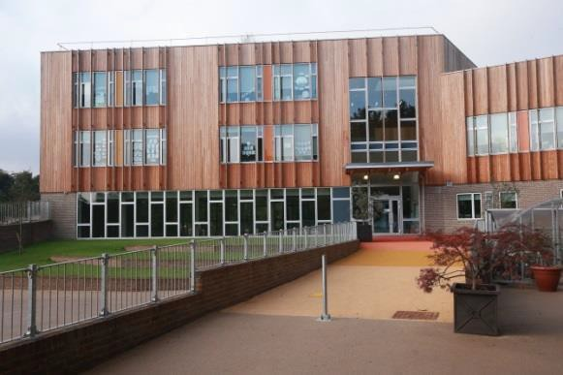

Information about the School

Letter to applicants

Dear Applicant,
Thank you for considering the position of a Class Teacher at Ashmount Primary School. We are looking for a class teacher to join us in September to take over one of our class teacher positions. This is a permanent post in a diverse and exciting school based in a fabulous parkland setting. All candidates will be excellent ECT – MPR 6 class-teachers who are highly skilled and ready to join us on our journey to becoming an outstanding school.
We are proud of the welcoming, inclusive and diverse nature of our school community and we are looking for someone who shares our holistic, caring and creative school ethos and believes that everyone counts at Ashmount! We have worked hard over the last three years on our LBGTQ+ and Black History curriculum and would welcome new colleagues to join us on embedding our learning here.
You will be a key part of our dedicated and enthusiastic team of teachers, teaching assistants and support staff and will work closely with one of our Assistant Headteachers in ensuring the children make great progress in school.
We have recently had our Ofsted inspection and look forward to hearing about the outcome in due course. We are looking teachers who can continue to help us provide exceptional learning for children within our hugely diverse school community. We want to provide an excellent standard of education for all our children, with each child challenged to make exceptional progress across the curriculum and equipped to realise their full potential in life. We value the breadth and creativity of our educational offer at Ashmount. We are proud to offer a range of after-school clubs and activities, recognising that a variety of creative arts and sports extends and diversifies the opportunities for individuals to excel.
Ashmount is housed in a new, carbon-neutral building, which has won national architectural awards. We are in a very special location at the edge of the Parkland Walk nature reserve on the Islington and Crouch End borders, where there are plenty of opportunities for the children to learn outdoors in an environment that changes seasonally. They also encounter the local wildlife, including bats and woodpeckers!
Ashmount is a learning organisation, which is proudly committed to the development of its entire staff. This role is a fantastic opportunity to continue to learn professionally and to contribute to the growth and development of our school. We currently judge all our teaching and learning to be at least good, with much of it outstanding. We are, therefore, looking for someone who has the capacity to support and deliver excellent learning to one of our delightful classes.
Please do come and visit the school to find out more about what makes Ashmount special. We look forward to welcoming you and would welcome both ECT – MPR6 applicants and those from underrepresented groups.
Anthony Carmel (Headteacher)
Jonathan Harwood (Chair of Governors)
Our school
Music
At Ashmount, we are rightly proud of our outstanding music offer. We expect all children to engage in a variety of musical opportunities. All children from Nursery to Year 6 attend a music lesson with one of our trained music teachers. All children in Key Stage 1 and 2 attend weekly singing assemblies and children long to join our 90 strong school choir, who are accompanied by our school orchestra. We regularly have visiting musicians from the Barbican, LSO and other musical organisations who work with the children. Similarly, our own children perform at school recitals. We also take part in choir ensembles at the Union Chapel. We offer after school music tuition and are beginning to send small numbers of children to train with other schools as part of a borough wide primary school orchestra! Our rich music heritage is part and parcel of what we do.

PE
We continue to have a fabulous offer of PE across the school. With specialist support in many year groups and an extensive array of sporting endeavour across the whole school – including Dance, Gymnastics and various ball sports. We are currently, and have been in the past, borough champions in an array of disciplines. Our trophy cabinet is overflowing, but our expectation is that all children will participate – in the right way- with a generosity of spirit and a smile. We are renowned for our sense of fair play. This sporting endeavour continues at lunch and after school with a myriad of after-school clubs offering provision for children from Year 1 to Year 6.

Creative Curriculum
Ashmount is committed to a whole school over-arching creative curriculum where the children learn through topics that link their learning cohesively together. Topics vary throughout the school, which include Year 1 – Poles Apart to Year 6 Protest and Uprising! and their focus on democracy. Our learning is hugely child-centred, rich in outdoor linked experiences and embedded with opportunities for English and Maths where we utilise The Power of Reading and Maths No Problem to further support children’s learning. This is further developed through home learning using our half-termly Power Projects. Learning at Ashmount both at school and at home utilises all of the wider experiences London has to offer. We feel we develop creative, independent learners who will be ready for all the world has to offer them as global citizens. We link this together by supporting our parents with bespoke workshops covering all curriculum areas.

Parental Involvement
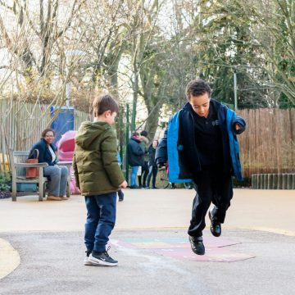
Parents and carers volunteer across the school in different ways, including as part of a highly skilled, effective and committed Governing Body. Our skilful Governing Body is currently full and consists of parents and carers, people from the local community, staff from the school, and representatives from the local authority. We have an incredibly active and strong parent-led PTA group, Ashmount Together, who regularly hold successful and fun social events that bring the school community together and help raise funds for the school. Ashmount Together has, in the past few years, raised money to install a lighting rig in the main hall, a drop-down screen and projector, playground improvements, new school iPads and classroom projectors. At Ashmount, all stakeholders are fully involved in improving the school.

Our Vision and Values
Vision
Our vision is for Ashmount to be a school that:
- Provides an ambitious and rigorous education for all children providing an excellent standard of education, with all children challenged to reach their full potential, so they leave our school well prepared for secondary school.
- Produces happy, well-motivated, well behaved, and healthy children who have a lifelong habit of learning.
- Has a welcoming and inclusive ethos, where everyone feels a sense of belonging.
- Is recognised for our high-quality teaching and a broad and balanced curriculum, including the provision of Arts, Music and PE / Sport.
- Enjoys a successful partnership with parents/carers who are fully engaged in their children’s learning.
- Has excellent links with other schools and other key external stakeholders.

Values
In delivering our vision, we at Ashmount seek to conduct ourselves in line with the following values:
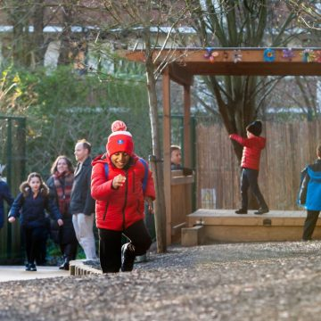
- We believe in a community where all children and all adults feel inspired and supported to provide an outstanding learning environment.
- We believe that everyone succeeds in a warm and welcoming school using a holistic child centred approach.
- We value kindness, co-operation and mutual respect.
- We value diversity in our community as a positive strength and will work actively against discrimination and prejudice and to create an environment where all people are treated fairly and with respect.
- We celebrate that everyone is able to achieve through meaningful opportunities to discover, explore and learn
- As a carbon neutral school we care for the environment and are committed to sustainability and bio-diversity

Achieving our vision
In order to achieve our vision, we seek to ensure that we have the following in place at Ashmount:
- Outstanding teaching and learning.
- High expectations of our staff, children, and parent/carers.
- A well-resourced staff team, which is well- motivated, confident, well trained, supported and empowered.
- High parental involvement and support, with full use of parents’ skills.
- High quality provision for SEN, pupil premium & ethnic minority achievement.
- A culture of self-awareness and improvement among the whole school community (Governors, staff, pupils and parents).
- An award winning, carbon neutral building with excellent facilities throughout and delightful learning spaces.
- Healthy and varied high-quality school meals and a chef who even makes fresh bread each day for the children.
- A growing school population with sound financial management that enables to us maximise our children’s potential.
- A highly committed and skilled governing body which is full, active, informed, and capable.
- Excellent links with the wider community.
- A great out of hours curriculum offer both within and outside of the school day and with external partners on the Crouch Hill campus.

Key facts and statistics

3 – 11 years
Age Range | Location  Crouch Hill Park, Islington, London | Denomination None | www.ashmountprimaryschool.co.uk
 | 408 | 27
 | Number of children | Average class size | Community School & Nursery
60 | 96.7% | 20 | 25
Planned admissions per year | Attendance | Teaching Staff | Support Staff
48% | 16% | 39% | 100%
Children eligible for Pupil Premium | Children with SEN | Children with EAL | ‘Good’ or better quality of teaching and learning

School Location

Ashmount Primary School Crouch Hill Park
83 Crouch Hill, Islington, London N8 9EG
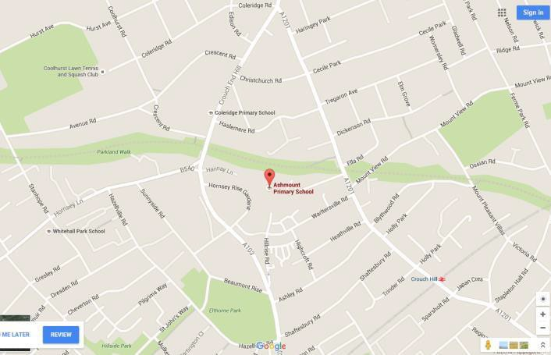

Nearest tube stations
Finsbury Park

Overground Station
Crouch Hill

Islington
Further information about Islington borough is available at www.islington.gov.uk
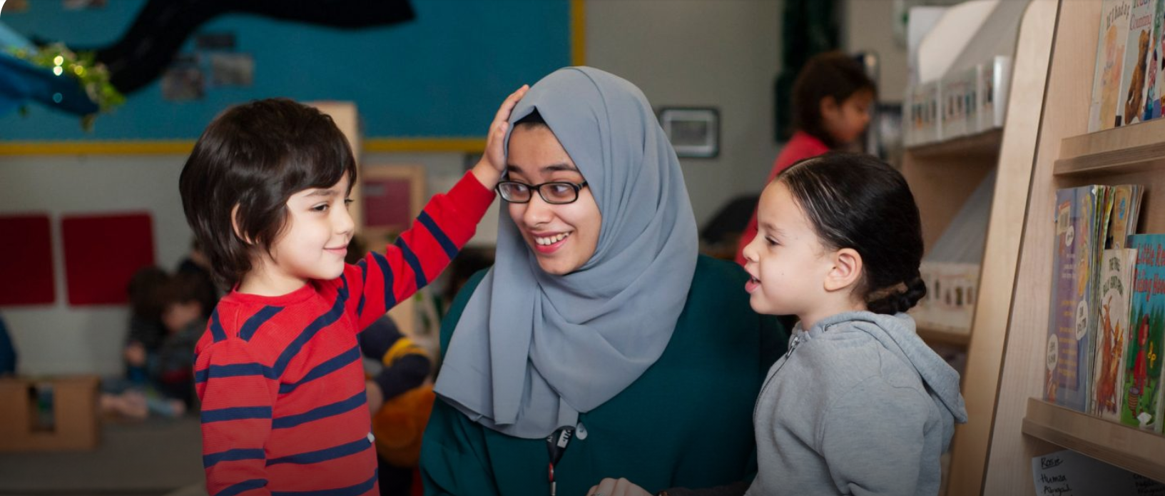

Information about the role

Advert
CLASS TEACHER
- Salary range: MPR1 – MPR6
- Salary: £34,502 - £44,756
- Contract: Permanent, Full time

Required 1st September 2023
This is an exciting opportunity for a dynamic candidate to help support our focus on high achievement and delivering excellence for all. You will be ambitious for the school, be able to build good relationships, and embrace the vibrancy and inclusiveness we value.
We are looking for someone who:
• Is enthusiastic, motivated and ready to make a difference
• Has a commitment to the promotion of high standards in teaching and learning
• Is passionate about enabling every child to fulfil his/her potential
• Has proven excellent classroom practice
• Recognises and values the diverse social and cultural needs of our children and community

Why Ashmount could be the school for you:
• A richly diverse school with a strong community ethos.
• A supportive governing body and a stable, enthusiastic and dedicated staff team.
• A ‘Good School’ that is on the road to Outstanding.
• In a great location - situated in Crouch Hill Park in north Islington with excellent transport links. If you believe you have the vision, drive, determination and enthusiasm to grasp the opportunities this role offers, we would love to hear from you.
Visits to the school are welcomed and encouraged. Please contact our School Business Manager, Mary McGreal, on (0207) 272 7145 to arrange a suitable date.

To apply for this post, please apply online at http://jobs.islington.gov.uk/disciplines. If you require assistance, please email Schools’ HR on schoolsrecruitment@islington.gov.uk quoting reference number ASH/
Closing date for applications: Midday, Friday 23rd June 2023
Shortlisting: Friday 23rd June 2023
Interviews: Monday 26th June 2023

To apply for this post, please apply online at http://jobs.islington.gov.uk/disciplines. If you require assistance, please email Schools HR on schoolsrecruitment@islington.gov.uk quoting reference number ASH/.

Ashmount Primary School is committed to safeguarding and promoting the welfare of children, and expects all staff and volunteers to share this commitment. An enhanced DBS (Disclosure and Barring Service) with barred list check is required for all successful applicants.
Also, if this post is likely to come under the requirements of the Childcare (Disqualification) 2009 Regulations and the successful applicant will be required to declare.

Job Description

JOB DESCRIPTION
POST TITLE: Class Teacher

GRADE: MPR 1 – MPR 6
REPORTS TO: Headteacher

PURPOSE OF THE POST
This job description should be read alongside the range of duties of teachers set out in the annual School Teachers’ Pay and Conditions Document.
Members of staff should at all times work within the framework provided by the school’s policy statements to fulfil the general aims and objectives of the school’s Education Development Plan.

MAIN RESPONSIBILITIES
Relationships with children and young people
- Have high expectations of children and young people including a commitment to ensuring that they can achieve their full educational potential and to establishing fair, respectful, trusting, supportive and constructive relationships with them.
- Hold positive values and attitudes and adopt high standards of behaviour in their professional role.
Frameworks
- Maintain an up-to-date knowledge and understanding of the professional duties of teachers and the statutory framework within which they work, and contribute to the development, implementation and evaluation of the policies and practice of their workplace, including those designed to promote equality of opportunity.
Communicating and working with others
- Communicate effectively with children, young people and colleagues.
- Communicate effectively with parents and carers, conveying timely and relevant information about attainment, objectives, progress and well-being.
- Recognise that communication is a two-way process and encourage parents and carers to participate in discussions about the progress, development and well-being of children and young people.
- Recognise and respect the contributions that colleagues, parents and carers can make to the development and well-being of children and young people, and raising their levels of attainment.
- Have a commitment to collaboration and co-operative working where appropriate.
Personal and professional development
- Evaluate their performance and be committed to improving their practice through appropriate professional development.
- Have a creative and constructively critical approach towards innovation; being prepared to adapt their practice where benefits and improvements are identified.
- Act upon advice and feedback and be open to coaching and mentoring.

PROFESSIONAL KNOWLEDGE AND UNDERSTANDING
Teaching and learning
- Have a good, up-to-date working knowledge and understanding of a range of teaching, learning and behaviour management strategies and know how to use and adapt them, including how to personalise learning to provide opportunities for all learners to achieve their potential.
Assessment and monitoring
- •Know the assessment requirements and arrangements for the subjects/curriculum areas they teach, including those relating to public examinations and qualifications.
- Know a range of approaches to assessment, including the importance of formative assessment.
- Know how to use local and national statistical information to evaluate the effectiveness of their teaching, to monitor the progress of those they teach and to raise levels of attainment.
- Know how to use reports and other sources of external information related to assessment in order to provide learners with accurate and constructive feedback on their strengths, weaknesses, attainment, progress and areas for development, including action plans for improvement.
Subjects and curriculum
- Have a secure knowledge and understanding of their subjects/curriculum areas and related pedagogy including: the contribution that their subjects/curriculum areas can make to cross-curricular learning; and recent relevant developments.
- Know and understand the relevant statutory and non-statutory curricula and frameworks, including those provided through the National Strategies, for their subjects/curriculum areas and other relevant initiatives across the age and ability range they teach.
English, Maths and Computing
- Know how to use skills in English, Maths and Computing to support their teaching and wider professional activities.
Achievement and Diversity
- Understand how children and young people develop and how the progress, rate of development and well-being of learners are affected by a range of developmental, social, religious, ethnic, cultural and linguistic influences.
- Know how to make effective personalised provision for those they teach, including those for whom English is an additional language or who have special educational needs or disabilities, and how to take practical account of diversity and promote equality and inclusion in their teaching.
- Understand the roles of colleagues such as those having specific responsibilities for learners with special educational needs, disabilities and other individual learning needs, and the contributions they can make to the learning, development and well-being of children and young people.
- Know when to draw on the expertise of colleagues, such as those with responsibility for the safeguarding of children and young people and special educational needs and disabilities, and to refer to sources of information, advice and support from external agencies.
Health and well-being
- Know the current legal requirements, national policies and guidance on the safeguarding and promotion of the well-being of children and young people.
- Know the local arrangements concerning the safeguarding of children and young people.
- Know how to identify potential child abuse or neglect and follow safeguarding procedures.
- Know how to identify and support children and young people whose progress, development or well-being is affected by changes or difficulties in their personal circumstances, and when to refer them to colleagues for specialist support.
- To promote the Safeguarding of children

PROFESSIONAL SKILLS
Planning
- Plan for progression across the age and ability range they teach, designing effective learning sequences within lessons and across series of lessons informed by secure subject/curriculum knowledge.
- Design opportunities for learners to develop their literacy, numeracy, ICT and thinking and learning skills appropriate within their phase and context.
- Plan, set and assess homework, other out-of-class assignments and coursework for examinations, where appropriate, to sustain learners' progress and to extend and consolidate their learning.
Teaching
Teach challenging, well-organised lessons and sequences of lessons across the age and ability range they teach in which they:
(a)use an appropriate range of teaching strategies and resources, including e- learning, which meet learners' needs and take practical account of diversity and promote equality and inclusion
(b)build on the prior knowledge and attainment of those they teach in order that learners meet learning objectives and make sustained progress
(c)develop concepts and processes which enable learners to apply new knowledge, understanding and skills
(d)adapt their language to suit the learners they teach, introducing new ideas and concepts clearly, and using explanations, questions, discussions and plenaries effectively
(e)manage the learning of individuals, groups and whole classes effectively, modifying their teaching appropriately to suit the stage of the lesson and the needs of the learners.
- Teach engaging and motivating lessons informed by well-grounded expectations of learners and designed to raise levels of attainment.
Assessing, monitoring and giving feedback
- Make effective use of an appropriate range of observation, assessment, monitoring and recording strategies as a basis for setting challenging learning objectives and monitoring learners' progress and levels of attainment.
- Provide learners, colleagues, parents and carers with timely, accurate and constructive feedback on learners' attainment, progress and areas for development.
- Support and guide learners so that they can reflect on their learning, identify the progress they have made, set positive targets for improvement and become successful independent learners.
- Use assessment as part of their teaching to diagnose learners' needs, set realistic and challenging targets for improvement and plan future teaching.

Person Specification
POSITION: Class Teacher
GRADE: Main Pay Range

CRITERIA

You must demonstrate on your application form that you meet the following essential criteria.

EDUCATION AND EXPERIENCE
Qualified Teacher Status and evidence of appropriate subsequent in-service training.
SKILLS, KNOWLEDGE AND ABILITIES
Proven successful teaching experience preferably across both the Foundation stage and KS1 and in at least one inner city multi-cultural school.
Proven experience of leading and managing change at an appropriate level including the curriculum, classroom organisation and administration in a school.
Proven experience of high standards of classroom practice and of teaching area of responsibility.
PERSONAL QUALITIES
Evidence of the personal and intellectual qualities required to set an example to others and to lead a team.
Respect for the views of parents and a commitment to the importance of the involvement of parents in the learning process.
COMMITMENT TO EXCELLENCE
Evidence of a commitment to excellence and the maximising of academic and personal achievement for all pupils.
INTERPERSONAL SKILLS
Evidence of good interpersonal skills and the ability to work as member of a team and develop and maintain good relations with all members of the school community. To work co-operatively with the staff of the Local Education Authority and relevant agencies as required.
COMMUNICATIONS
Evidence of the ability to communicate clearly both orally and in writing with pupil, parents and colleagues.
EDUCATIONAL AND CURRICULUM MATTERS
An understanding of the different ways in which children learn and the appropriateness of a variety of teaching styles to meet the individual learning needs of each child.
Evidence of good organisational skills to create and maintain a stimulating and attractive learning environment.
Evidence of the ability to organise successfully the curriculum for a class of pupils of mixed abilities, aptitudes and educational needs through planning, preparation, monitoring and assessment.
A thorough knowledge of the area of responsibility including its specific requirements in relation to the National Curriculum and learning strategies for children of all abilities.
Evidence of good general knowledge of the requirements of the National Curriculum.
PERFORMANCE REVIEW
Evidence of the ability to define effective measures for the performance of pupils and classes and to keep these measures under systematic review.
RECORD KEEPING
Evidence of knowledge and understanding of effective record keeping, and its use to promote the educational and personal development of all children within the school.
BEHAVIOUR AND ETHOS
Evidence of the ability to maintain effective classroom discipline in a positive context and to promote well-ordered and self-disciplined behaviour throughout the school.
HEALTH AND SAFETY
An understanding of the responsibility of the class teacher with regard to the health and safety of pupils in their care.
Ability to form and maintain appropriate relationships and personal boundaries with children and young people.
Ability to deliver services to customers meeting the school’s standard for customer care.
A commitment to providing a responsive and supportive service and a willingness to constantly seek ways of improving the service
A commitment to deliver services within the framework of the school’s equal opportunities policy.

How to Apply

Application Deadline
Completed application forms must be received by Midday, Friday, 23rd June 2023
To apply, please do so online via http://jobs.islington.gov.uk/disciplines. If you would like assistance, please contact the Schools’ HR team on schoolsrecruitment@islington.gov.uk quoting reference number ASH/xxx
Please note that application forms should not be returned to the school.

Completing your application
Candidates are asked to complete all the standard information required on the application form, and to submit a supporting statement, addressing all of the criteria identified at application stage.

Visits
Visits to the school are strongly encouraged W/C Monday

5th – 23rd June 2023. Please contact our School Business Manager, Mary McGreal on 0207 272 7145 to arrange a suitable date.

Selection procedure
The shortlisting process and appointment will be made by a panel of Governors, and members of the Senior Leadership Team, assisted by Islington Council staff.
All candidates will be notified of their shortlisting or otherwise Friday 23rd June 2023. Please would all applicants ensure that their preferred means of urgent contact (phone, mobile phone or email) are clearly identifiable from the application form, so that your confidentiality is maintained.
Shortlisted candidates will be given more details that day and the interview process will take place on Monday, 26th June 2023.

References
Candidates are advised that references will be taken up immediately after shortlisting. Candidates are asked to ensure that their referees are warned of the need to respond within the timescale set. In all cases, at least two professional reference is required.
The post will be offered subject to satisfactory completion of pre-employment checks.

Safeguarding children
Prior to appointment, formal checks will be made in accordance with the current statutory requirements relating to child protection.
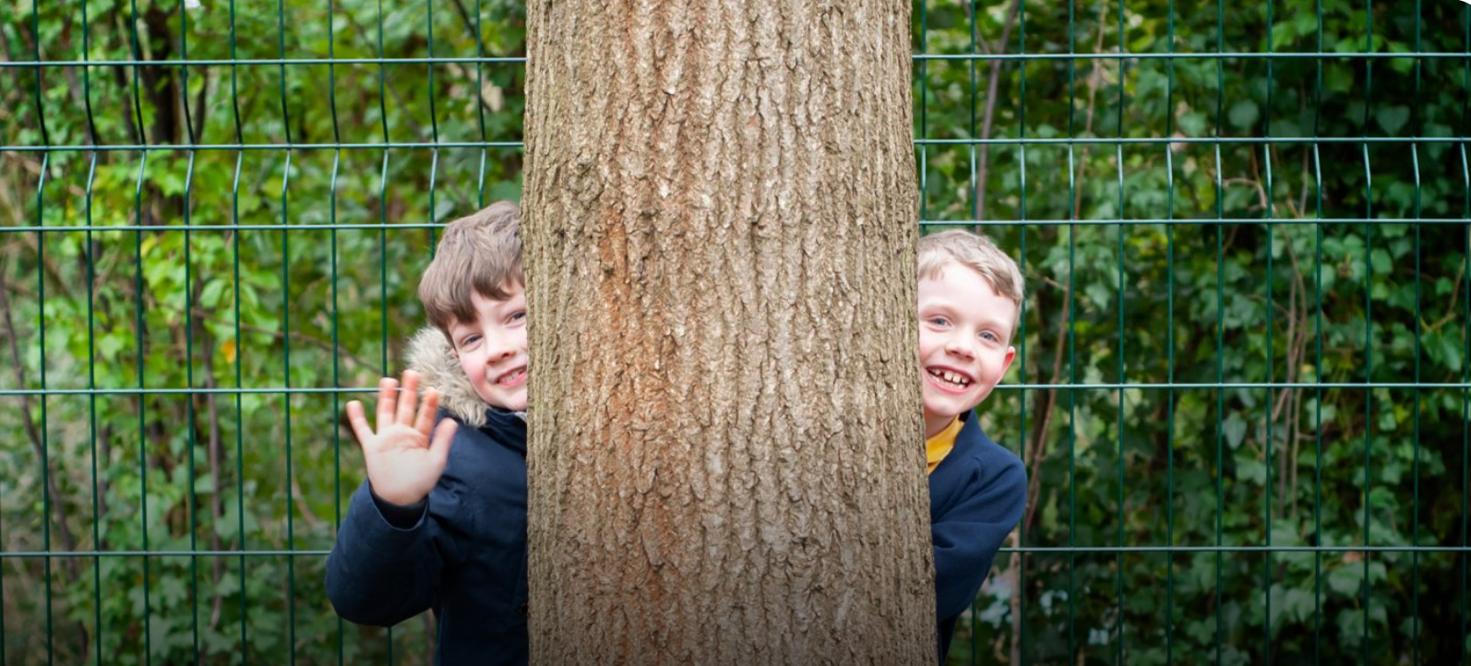

Ashmount Primary School
Crouch Hill Park
83 Crouch Hill, Islington, London N8 9EG

