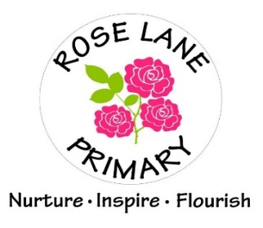

**CLASS TEACHER (Maternity) required from January 2023**

**Salary: MPS/UPS (inner London allowance)**

**Contract Type: Maternity Cover – required for January 2023**

**E-mail:** [office@roselane.bardaglea.org.uk](mailto:office@roselane.bardaglea.org.uk)

**Required: January 2023**

Are you looking for a new challenge? We are seeking to appoint an inspirational and highly motivated class teacher who is willing to work across the Key Stages with energy and enthusiasm to stimulate children to achieve beyond their expectations.

Rose Lane Primary School was established in 2019 from the amalgamation of the Marks Gate Infant and Marks Gate Junior Schools on the border between Barking and Dagenham, Redbridge and Havering. We are currently 3 forms of entry, with a new building recently built we are moving towards a 4FE.

This position is not suitable for Early Careers Teachers.

The successful candidate will:

* be enthusiastic and dynamic with a secure understanding of effective teaching, learning and assessment;
* work with a genuine child-centred approach;
* be committed to ongoing professional development;
* be dedicated to sharing responsibilities for raising standards;
* be excellent communicators, with a strong commitment to working in partnership with parents, governors and the community;
* constantly have high expectations of themselves and all learners; and
* continually promote aspirations and lifelong learning.

We can offer you:

* a positive and stimulating learning environment;
* children who are enthusiastic to learn;
* opportunity for professional development within our school;
* a supportive working culture that values staff at all levels and invests in people.

If you are ready for a new and exciting challenge, we would like to hear from you. You are encouraged to visit us to see if this is the school for you.

Please visit our website [roselaneprimary.org.uk](http://roselaneprimary.org.uk) for application packs or contact the School HR Manager, Karen Cook by emailing [office@roselane.bardaglea.org.uk](mailto:office@roselane.bardaglea.org.uk)

**Closing Date: Friday 7th October 2022 midday**

**Shortlisting: Monday 10th October 2022**

**Observations / Interviews: Thursday 13th October 2022**

Please also note that we will ***only*** communicate further with applicants shortlisted for an interview.

***Rose Lane Primary School is committed to safeguarding and promoting the welfare of children and young people. We expect all staff and volunteers to share this commitment and to undergo appropriate checks including Enhanced DBS checks.***

**Rose Lane Primary School**

Rose Lane

Chadwell Heath

Essex, RM6 5NJ

Tel: 020 8270 4438 office@roselane-bardaglea.org.uk

Headteacher: Jacqui Barnard