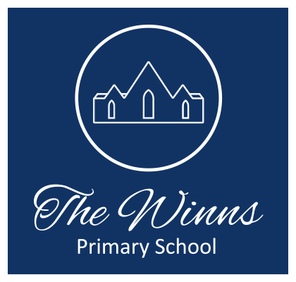

Class Teacher
Job Title: Class teacher – this position is open to teachers who are looking to take on a leadership role, including becoming a subject leader and/or a year group leader.
Pay range: Main Scale or UPS, depending on experience with a TLR 2b
Work Location: The Winns
Reports To: Line Manager & Headteacher
Contract: Permanent
Hours: 32.5 hours
The Winns is a large, three form entry, community primary school located in Waltham Forest. We are a supportive, happy school with a great staff team who care passionately about the children we teach. Our school is next to Lloyd’s Park and the William Morris gallery and benefits from having excellent transport links to central London. We serve a vibrant and diverse community, where excellent relationships promote a warm and secure environment where children feel safe and valued.

We are looking for passionate, enthusiastic teachers who love being in the classroom. If you are committed and driven by a passion to make learning exciting, if you too love learning and want to continue to develop as a teacher and leader and be part of a large, energetic team, we would love to meet you.

Person specification including Key Skills and Competencies:
- Qualified Teacher Status.
- Evidence of a commitment and enthusiasm for collaborative practices and high quality provision in teaching and learning.
- Evidence of an understanding of child development and children's learning within a school context.
- Evidence of an understanding of effective classroom organisation and management.
- Evidence of an ability to form and maintain effective relationships with staff, parents and children.
- Evidence of an understanding of the need for continuity, coherence, and balance in relation to the learning needs of children and appropriate curricular provision.
- Evidence of an understanding of the need for effective planning and assessment in relation to children's learning.

The school is committed to safeguarding and promoting the welfare of children and young people and expects all staff and volunteers to share this commitment and work in accordance with our child protection policies and procedures. Successful candidates will be required to complete an enhanced DBS check. We welcome applications from all sections of the community, regardless of gender, race, religion, disability, sexual orientation or age.

Due to the nature of the post, candidates are not entitled to withhold information regarding convictions by virtue of the Rehabilitation of Offenders Act 1974 (Exemptions) Order 1975 as amended. Candidates who are selected for interview will be required to give details of any criminal convictions on their criminal self-record form and expected to disclose further information when requested. * Because this post involves working in a child centred environment, candidates are required to comply with the school's procedures in relation to Keeping Children Safe in Education (2021).

We warmly welcome visits to our school and would love to meet you. Visits can be arranged during the school day or after school hours. If you are interested in visiting, or would like to find out more about the school, please contact office@winns.waltham.sch.uk to arrange a visit. Please also look at our website for further information about our school.

Closing Date: 24th March 2023

Interviews: Week beginning 27th March 2023

