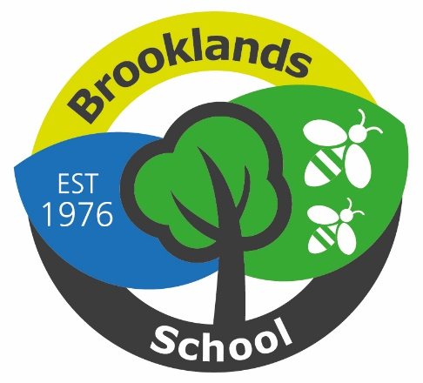

Brooklands School

Class Teacher Person Specification

 | Essential | Desirable
Qualifications and Training | - QTS status | - Qualification in SEND  - Evidence of continuing professional development | - Application form
Experience and Knowledge | - Experience of successfully teaching pupils across a wide range of a wide range of ability, and specifically pupils with a range of complex needs.  - Knowledge and understanding of current key issues within SEND  - Knowledge and understanding of a range of teaching approaches and strategies related to SEND  - Knowledge and understanding of safeguarding legislation and procedures | - Planning and delivering an adapted curriculum | - Application form  - Interview  - References
Personal attributes | - Caring and supportive attitude to pupils, parents and colleagues  - Well motivated and positive outlook  - Innovative and creative approach to teaching and learning  - Ability to demonstrate resilience  - Energy and enthusiasm  - Able to communicate to all audiences effectively and including pupils, parents, colleagues and governors.  - Able to communicate effectively and respectfully to class team and wider school.  - Able to manage own workload to allow an appropriate  work/life balance  - Fully committed to achieving the best outcomes for all our pupils | - Able to communicate though social media and school website | - Application form  - Interview  - References

