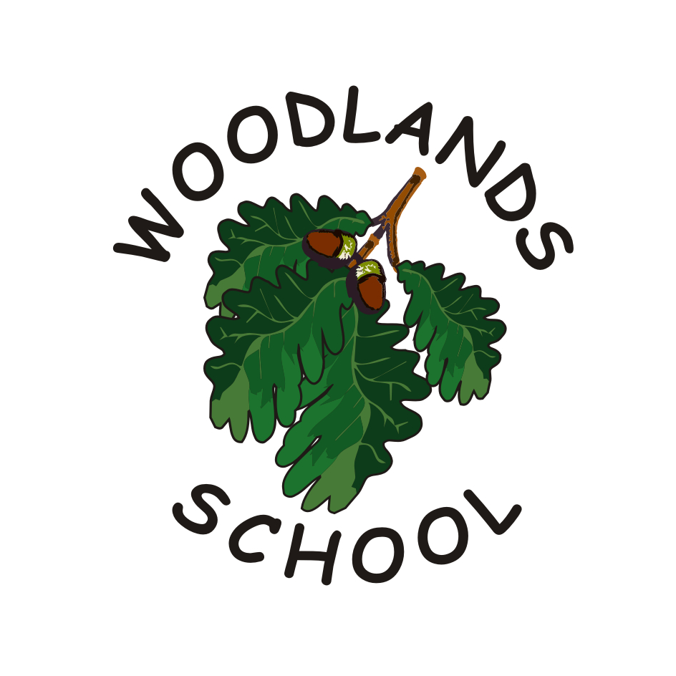
CLASS TEACHER VACANCY
(Lead for Partnership with The Coleshill School)
Required for September 2021

Our Broad Spectrum Special School, which is part of Unity MAT, caters for pupils aged 4-19 years. We have a warm, mutually supportive and caring ethos with enthusiastic and skilled staff who are highly aspirational and committed to pupil welfare, progress and life-chances.

As a community school within the UNITY MAT we aim to share our expertise of high quality education for pupils with special educational needs. Our Partnership with the neighbouring secondary school is an exciting new project.

We are seeking to appoint an enthusiastic, reflective and creative teacher to lead “The Map”: a resourced provision based in a newly designed and built, dedicated environment within the grounds of The Coleshill School (TCS). Experience of working with pupils with a range of complex needs is desirable. A passion for enabling pupils with SEN to achieve their full potential is essential.

Please contact the school office if you would like to arrange a tour. Please refer to the Visitor Protocol document. Please note that, in line with continuing COVID restrictions, tours will be more limited in scope than under normal circumstances.

Closing Date – 12 noon on 21st May 2021
Interviews – week beginning 24th May 2021

Woodlands is committed to safeguarding and promoting the welfare of children and young people and expects all staff and volunteers to share this commitment. This post is subject to an Enhanced DBS Disclosure.

