

Recruitment Pack
Class Teacher

Are you passionate about helping learners to flourish?
Thanks for showing an interest in our school and our Class Teacher roles. We’ve written this pack to help you decide whether it’s right for you and to guide your application.
Whether you’re a teacher or a support team member, working in our outside of the classroom, we’re one school and four campuses.
The ‘golden thread’ that runs between the campuses is that we help learners to build independence and confidence as they journey through school.
We aim to enable learners to participate and develop their abilities with our inclusive and needs based classroom practice with a joined-up approach to relationships, behaviour and teaching and learning.
We are looking for inspiring teachers who will lead and motivate their teams and our learners.
Whether your experience is in Early Years, Primary, Secondary, Mainstream or SEN, we would love to hear from you.
These are full time, permanent positions paying between MPS1-UPS5 (Outer London) dependent on experience plus an SEN Allowance of £2,679.00 per annum.
If you’d like to visit and meet us before you apply, please contact Ellena, our People & Culture Manager, who will gladly help ekelley@westleaschool.co.uk




About the school
Based in the borough of Enfield, we provide education to children and young adults with special educational needs and disabilities, from the ages of 4 to 25. We pride ourselves on creating an inclusive environment where everyone feels welcome.
Our four campuses – Meridian, Haselbury, Learning for Life and Horizon – serve more than 500 learners and are home to 230 employees.
We’re a strong community that works together with the common goal of helping each other to flourish. Our learners leave confident and able to progress onto further education and work.
We’re a disability confident employer that’s Investors in People accredited, with firmly held values placed at our core.
THE SCHOOL AT A GLANCE
- There has been a school at Haselbury Road since 1938, which turned into a special school in 1970.
- In 2014, there were 80 learners on a single site. We’ve grown a lot since then.
- We cater for students with a range of complex special educational needs and disabilities.
- We’ve expanded rapidly in response to increased demand across the borough of Enfield.
- Throughout their journey, learners develop vital life and work skills, as well as achieve academically.
- Our provision includes the Attendance Support Service (ASU), Home Tuition Service and a post 16 programme that enables learners to go to a local college.
- Our Travel Training Programme enables learners to travel confidently and independently.
- We actively prepare learners for adulthood and the workplace. This is key to what makes us special.
- Learners gain work experience with local employers and through our partnerships with the Enterprise Cooperative Trust (ECT) and Learning for Life Charity (LFLC).
- Our Supported Internship Programme gives young people aged 16 to 25 an opportunity to work. 80% of our interns get jobs and 90% retain them.
- We’re a founder member of the Enterprise Cooperative Trust.

Our why, what and how
In September 2021, we developed our strategic framework. It’s a simple image of a school with a roof, four pillars and foundations.
It helps us describe why we exist, what we’re here to do and how we’re going to do it. Think of it as a roadmap that guides our decisions and keeps us on the right path.
It’s a useful model that frames our long-term, high-level school development plan, which we’ll be working on for many years to come.
Our vision, mission and values inspire and unite us. Our vision statement explains why we exist; it’s our guiding star and something we aspire to. It unites the school with the organisations in our wider family: the Enterprise Cooperative Trust (ECT) and Learning for Life Charity (LFLC).
Our mission statement describes the ‘business’ we’re in and what we’re focused on doing today and every day. It reminds us of who we serve and what we do in pursuit of our vision.
The average person spends more than 99,000 hours of their life at work. We believe that a good life is one where you spend this time doing something fulfilling and making a real difference to people’s lives. That’s what we’re all about.
It feels great knowing that what we do each day is helping our people, learners and families to flourish.
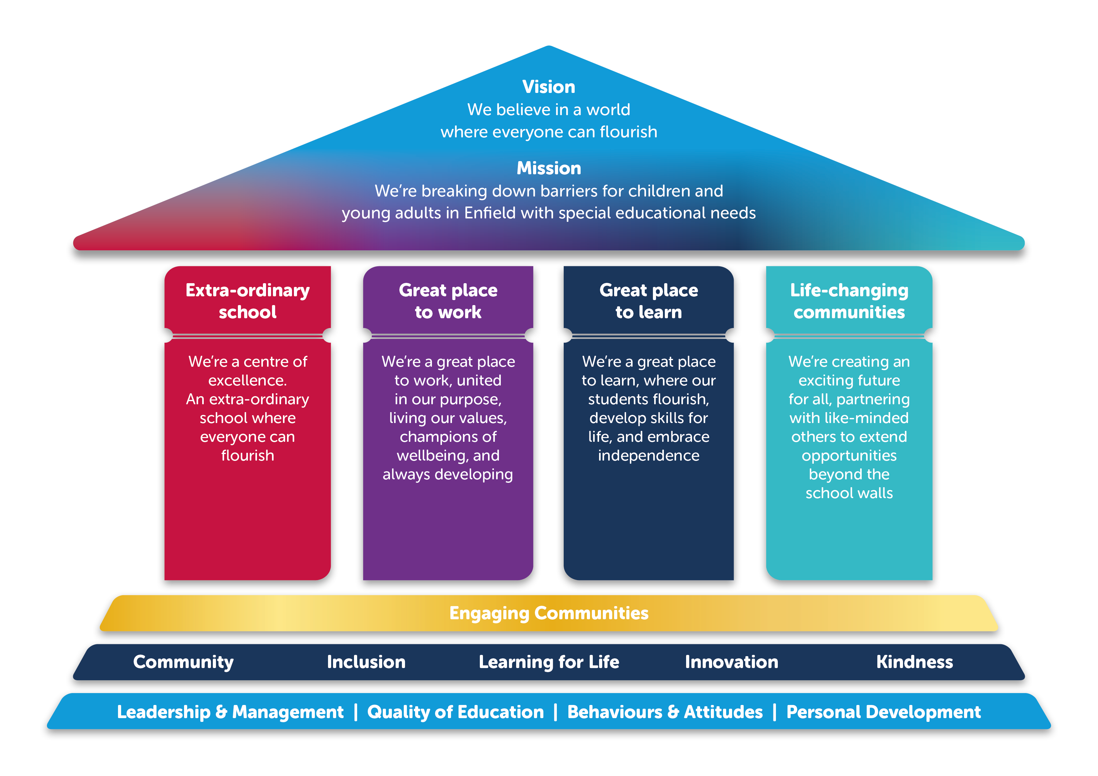

Vision, mission and values
Our vision, mission and values guide, inspire and unite us.
  - our VISION
We believe in a world where everyone can flourish.

  - our MISSION
We’re breaking down barriers for children and young adults in Enfield with special educational needs.

  - our values
Learning for Life
We help learners succeed beyond the classroom. They develop skills, confidence and independence ready for adulthood, further education and work.

Community
We’re one big family uniting together so everyone can flourish. We enable learners to make a difference in the local community.

Inclusion
We ensure everyone is welcome, feels they belong, and opportunities are open to all. We teach, inspire and support learners to be inclusive and value differences.

Innovation
We help learners to reach for the stars and overcome obstacles. We challenge everyone to be creative and break down barriers.

Kindness
We make kindness our default setting. We teach learners to be kind and compassionate to themselves and others. We role model this behaviour every day.

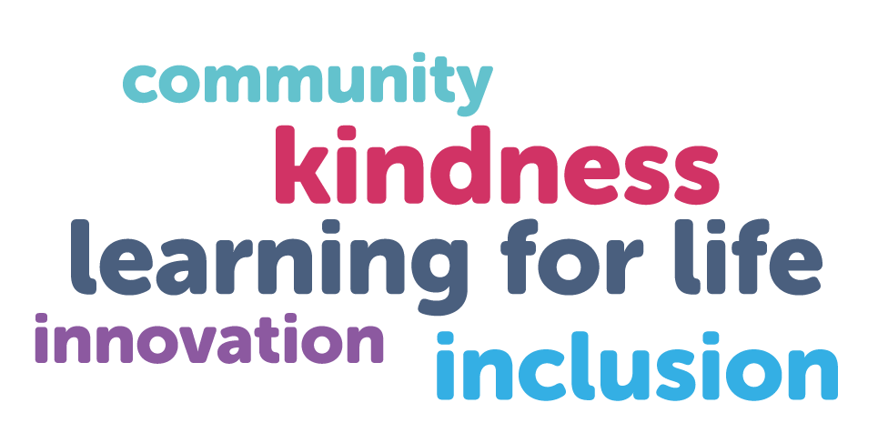
One school, four campuses
Our campuses have a shared purpose, and we work together towards common goals.
Regardless of job title, location, or team, everyone has an important role to play in helping each other and our learners to flourish.
The ‘golden thread’ that runs between the campuses is that we help learners to build independence and confidence as they journey through the school.

  - MERIDIAN CAMPUS
Catering for primary aged children, Meridian is based at two architecturally different sites: one a church, and the other a modern, purpose-built school. Learners start their journey by ‘Taking Off!’


  - HASELBURY CAMPUS
Haselbury is home to Key Stage 3 learners aged from 11 to 14, who are based on one site. We welcome students from Meridian and other local schools. Haselbury learners are ‘Flying High!’


  - LEARNING FOR LIFE CAMPUS
Spread across two sites, Learning for Life caters for Key Stage 4 students aged 14 to 16. Here, learners are ‘Soaring!’ and gain independence, attending college and work experience.


  - HORIZON CAMPUS
Horizon Sixth is home to our post 16 learners (Key Stage 5) and our Supported Internship Programme. Spread across three sites, there really is ‘No Limits!’ to what our young people achieve, with many going on to further education or employment.



  - AN OUTSTANDING SCHOOL
Ofsted inspected in May 2023 and said we continue to be an outstanding school.

Our extended family

An outward looking and ‘extra’ ordinary school, we partner with likeminded people and organisations across and beyond the borough.
Our partners include the Enterprise Cooperative Trust and Learning for Life Charity. These organisations are part of the West Lea family.
We created the trust and charity to extend our reach beyond the traditional classroom. Whilst our curriculum includes life, social and work skills, through ECT and LFLC we provide more opportunity for our learners and others across Enfield.

  - ENTERPRISE COOPERATIVE TRUST (ECT)
A not-for-profit foundation cooperative, the ECT launched in June 2022.
The trust includes organisations from education, the charity sector, community interest groups, business and local government. We’ve come together to address key problems in the Enfield borough.
We aim to raise standards in local schools and create life-changing opportunities for young people. Being a member of the trust enables us to look at education in a different and collaborative way.
We’re looking to make an impact in four key areas:
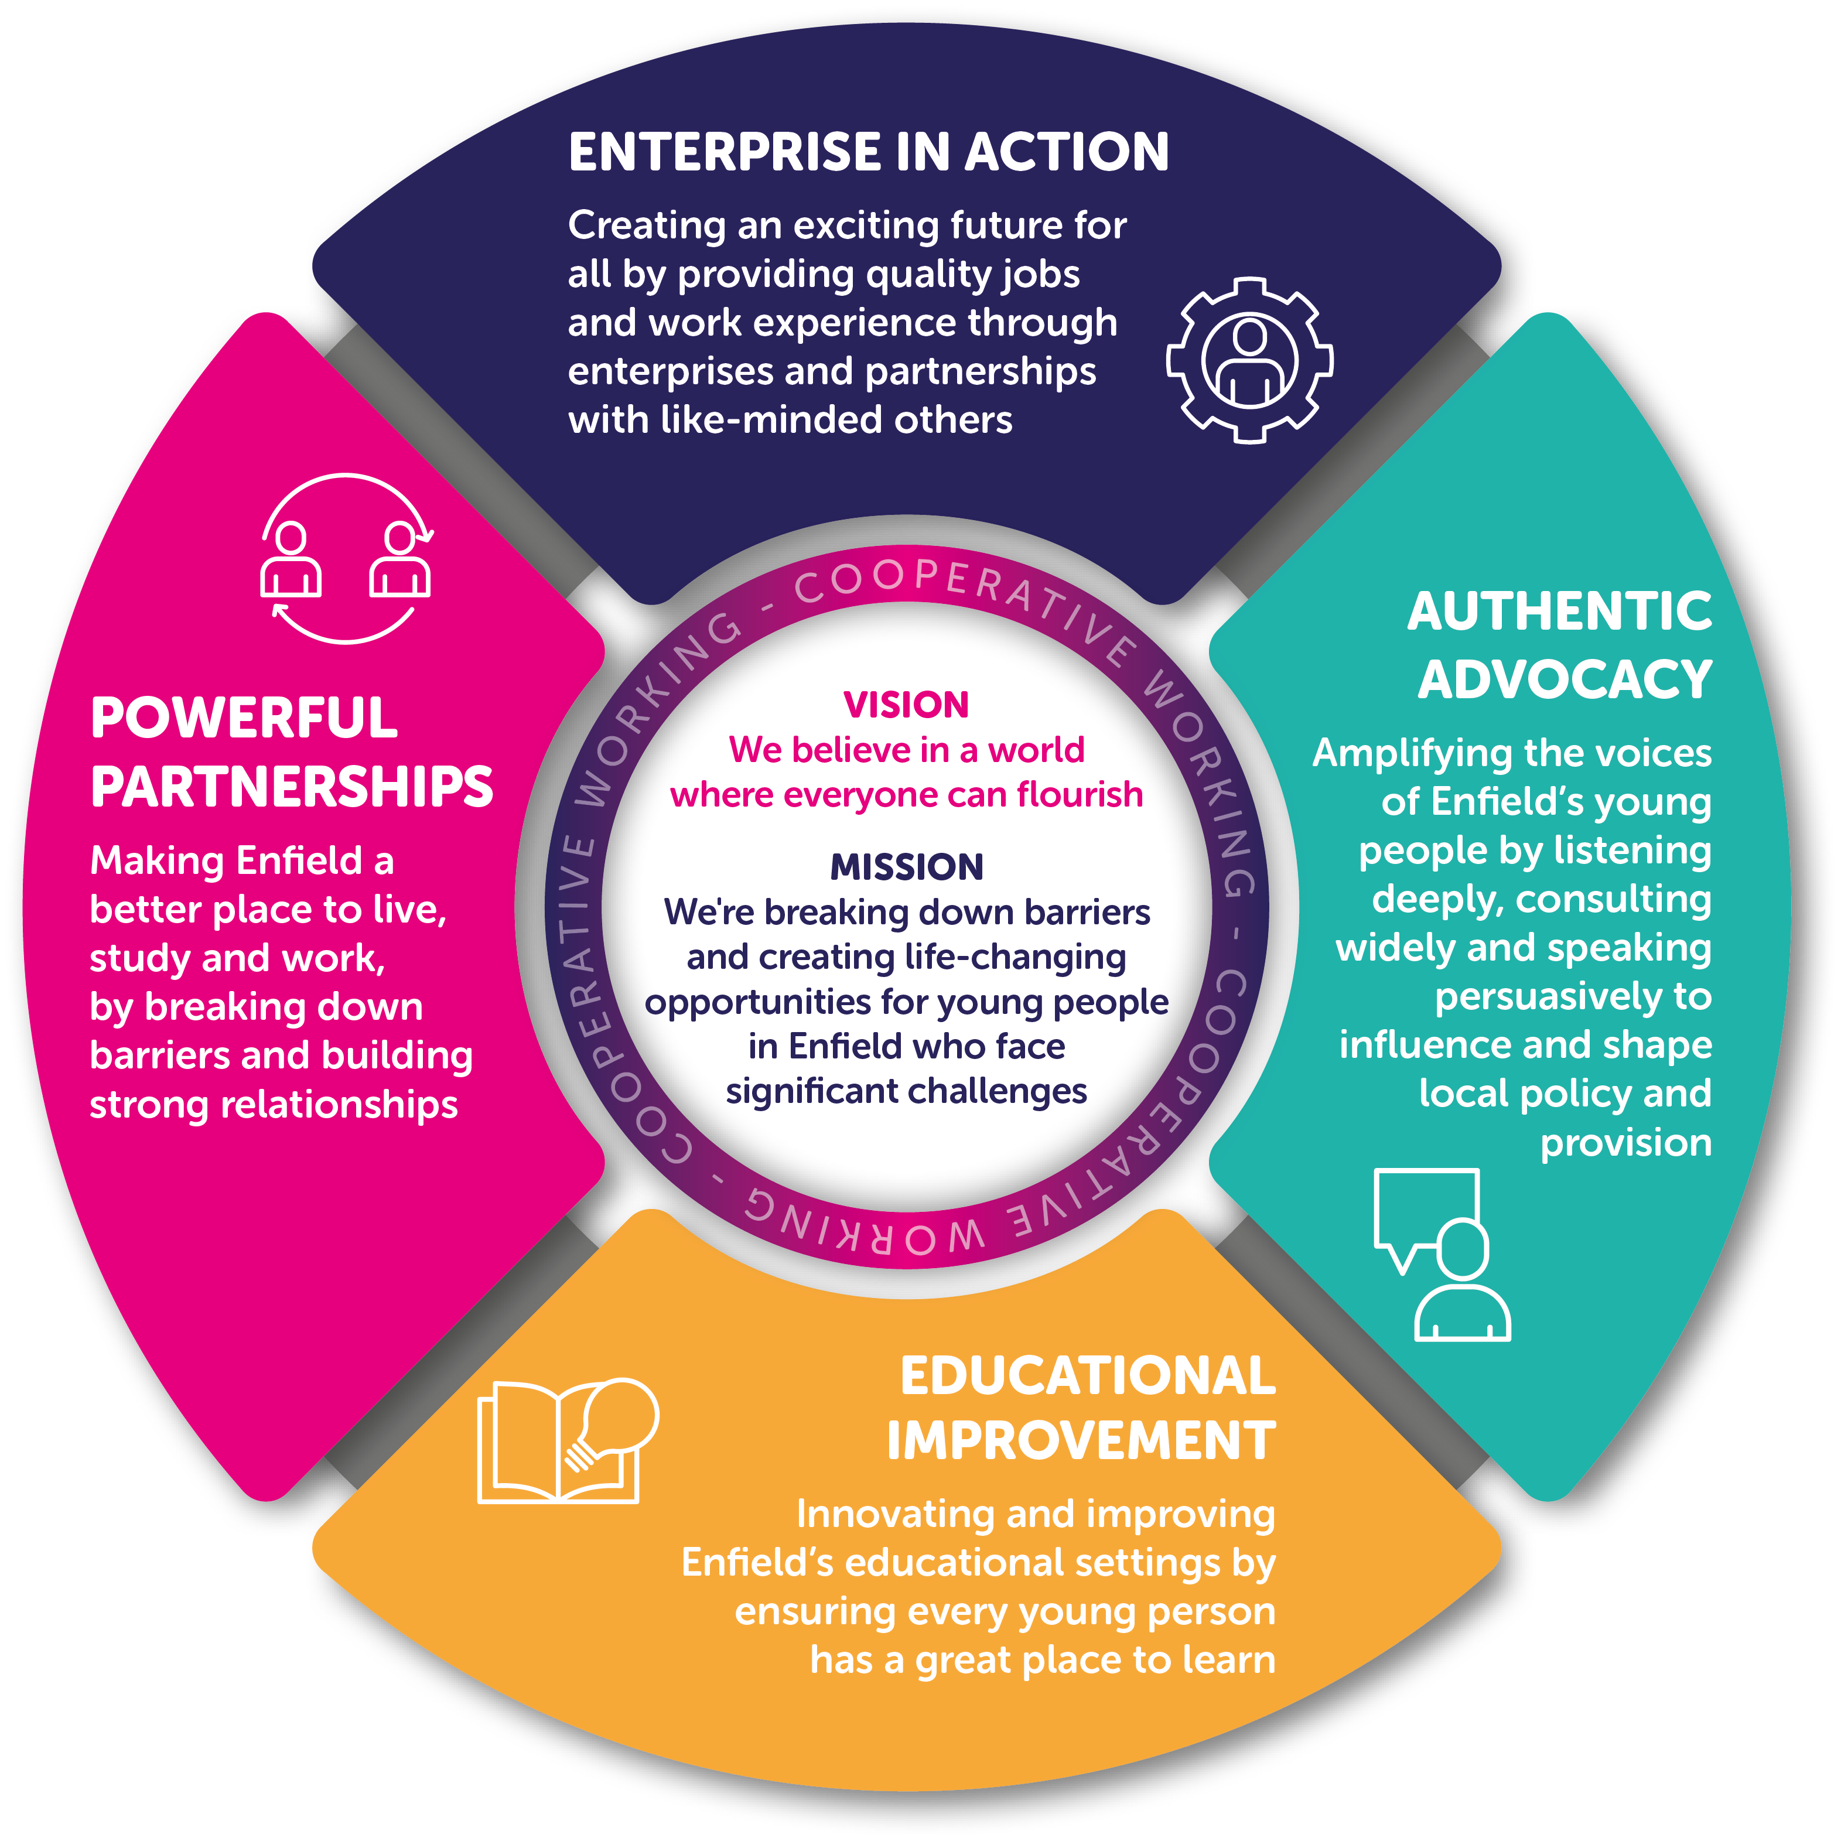


  - THE LEARNING FOR LIFE CHARITY (LFLC)
LFLC is a registered charity and ECT partner. Founded in 2014, it aims to build upon the school’s life and work curriculum.
To mark its tenth birthday in December 2024, the charity’s trustees refocused its vision, mission and values.
LFLC provides disabled and disadvantaged young people in Enfield with life-changing chances to work. This includes borough-wide work experience and workplace support.
LFLC brings its values of inclusion, inspiration and innovation to life through its two charity shops, numerous social enterprise projects, and Access to Work funded job coaches for early careers employees.
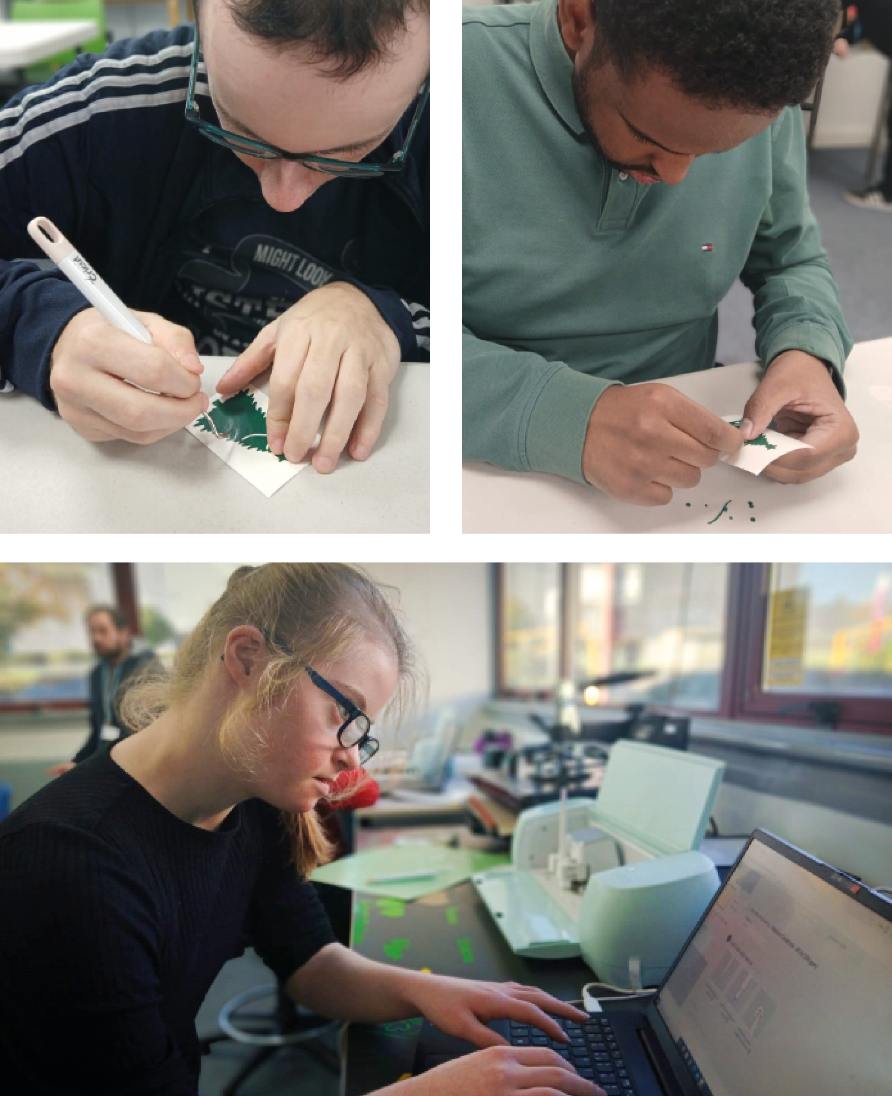






Class Teacher Job Description
A teacher at West Lea School is someone who knows what is important to them and who uses their values, and those of the school, as a guide and a motivator.
We aim to enable learners to participate and develop their abilities with our inclusive and needs based classroom practice with a joined-up approach to relationships, behaviour and teaching and learning.
Class Teams, (Teachers, HLTA and TAs), work together to break down barriers through their use of our personalised, adaptive and inclusive curriculum. Class Teams enable learners to enjoy a range of activities that broaden their horizons as well as developing future proofed skills.

Who we are looking for
We’re looking for exceptional candidates with the following attributes:
- Committed and passionate about working with learners with a wide and diverse range of SEN and can embrace the school’s vision, aims and core value of ‘Learning for life’
- An exceptionally enthusiastic and committed teacher who can motivate our learners and lead and inspire their class team to raise standards in learner outcomes
- An advocate for our learning for life approach, which puts developing independence and life skills at the heart of our curriculum alongside ambitious academic expectations
- A role model who is aligned with our values
- A lifelong learner who continues to develop and grow, personally and professionally
- Works well with others: we’re one school and one team

Who it would suit?
We are seeking innovative and dynamic individuals, who will continue to inspire and motivate our staff and support and encourage our learners to make excellent progress, whatever their starting point or situation. We are looking for a person who can demonstrate vision, resilience and empathy, who embodies our core value that we are all ‘learning for life’. We are a ‘values based’ organisation and, as such, we expect our staff to embody our values. You share in the belief that all our learners can achieve and through working as a community with kindness, you are committed to ensuring all have positive futures.

Key relationships
An Assistant Headteacher at your campus will be your line manager. You will also lead your class team and will be pivotal in their development.

Principle responsibilities
Teachers across the whole school work to allow all our learners to flourish at West Lea whilst also promoting their independence through:
- Leading, supporting and developing their class team
- Providing pastoral care and support to learners within a secure learning environment
- Taking responsibility for planning, implementing and reviewing appropriate work programmes for identified learners in line with the national curriculum and school policies
- Maintaining assessment records and report on learners’ progress to key stakeholders in accordance with school policy

LEARNING FOR LIFE:
- Lead your own development through your own personalised learning plan
- Lead and develop all support staff through the Partnering for Performance process
- Be committed to seeing the potential in every learner, and supporting them in finding their pathway to adulthood so that they can flourish
- Keep up to date with changes in the curriculum and other key educational policy and practice developments to identify best practice

COMMUNITY:
- Be proactive in knowing all learners’ interests, needs, context and circumstances
- Develop supportive relationships with the families of learners in the class and communicate and consult with parents and carers regularly
- Ensure well sequenced planning in accordance with National and School Curriculum Policies, in co-operation with colleagues and the wider senior team, to ensure that learners experience a broad and balanced curriculum that prepares them for adulthood
- Organise and safely manage the learning activities for which responsibility has been given
- Ensure the implementation of effective assessment processes by providing verbal and written feedback to support the evaluation of learners’ progress and report to all key stakeholders, most notably the students and their parents/carers
- Work closely with colleagues to support curriculum development including contributing to the writing of medium- and short-term planning
- Support (and lead where appropriate) the wider curriculum for our learners including residentials
- Liaise with both in-house pastoral leads as well as external therapists, and other external agencies as required
- Carry out other duties of a similar nature from time to time as may be required by the senior leadership team

INCLUSION:
- Build positive relationships with all learners to support and promote their learning and wellbeing throughout the day
- Provide clear, structured lessons, maintaining appropriate pace and challenge
- Ensure a close match between the learning experiences offered and the individual needs of the learners in the class, so as to give each one of them an opportunity to achieve to the maximum of their potential
- Assess learners’ responses to learning tasks and where necessary modify methods to meet needs
- Plan, coproduce and monitor each individual learners personalised learning plan (PLP) with all key stakeholders
- Plan weekly in accordance with national and school curriculum policies and in co-operation with the multidisciplinary team, to ensure that students experience a relevant and stimulating curriculum
- Promote and support the inclusion of all learners and develop their independence and self-esteem through both the in-house delivered curriculum and enrichment opportunities including trips that are accessible and meaningful for all
- Lead and support the class team in developing their understanding of the needs of our learners

INNOVATION:
- Be open to new ideas and seek solutions to support all learners especially those who are vulnerable and hard to reach
- Be proactive in the use of teaching strategies to adapt to the needs of each individual learner, ensuring high levels of student interest and promoting communication and independence
- Ensure that learners’ work is closely linked to first-hand practical experience and provide opportunities to practice these skills in real- life contexts (including at work)
- Provide learners with opportunities to lead their own learning and become independent thinkers and learners

KINDNESS:
- Ensure positive regard for all learners (and our people) and develop excellent relationships
- Create calm but stimulating learning environment that maintains the highest standards of organisation and ensuring displays effectively support learners
- Foster each learners’ self-image and esteem and establish relationships which are based on mutual respect, ensuring every student has a voice
- Be proactive in prevention and de-escalation of learner dysregulation and incidents and apply policies where relevant
- Understand that behaviour is a form of communication and work tirelessly to break down barriers for our learners
- Use behaviour management strategies, in line with school policy and procedures
- Be an exemplary model of both the values and what we expect of all adults working at this school - Be ready, Be Safe, Be Kind
- Recognise and praise positive behaviours

HEALTH & SAFETY:
- Ensure the health and safety of learners and staff is maintained during all activities, both inside and outside the setting
- Be responsible for trips and events following school procedures to ensure that they are robustly risk assessed in consultation with leaders
- Ensure that the medical needs for all learners is known by all the class team and is effectively managed as per their care plans
- Have due regard for safeguarding and promoting the welfare of children and young people and to follow the child protection procedures adopted by the London Child Protection Procedures and the school’s safeguarding policy
- Support and implement the school and Local Authority’s Equal Opportunities, Whistleblowing and Data Protection policies

  - GENERAL REQUIREMENTS
- Be an exemplar of the Teacher Standards
- Contribute to the wider life of the school and Enterprise Cooperative Trust
- Carries out any other reasonable duties and responsibilities requested by the line manager
- The post holder will be expected to comply with West Lea’s Schools policies and procedures at all times. These include, but are not limited to child protection, equal opportunities, data protection and health and safety
- The school has a clear policy for reporting suspected/actual child abuse and this procedure must be followed and reported (in writing) to a designated teacher for further action
- In order to do their job, the post holder will be trained and coached in the relevant procedures and policies of West Lea School. They will be expected to familiarise themselves with the school and policies and to seek advice and guidance from the line manager if required
- Undertake Staff Development/CPD Training as required by the nature of this post and the range of duties described within this job description

The key tasks listed above are only an indication of the main tasks required to be performed. It is not an exhaustive list of duties and responsibilities and may be subject to amendment to take account of changing circumstances. Any changes will be made following discussion with the post holder.

Class Teacher Person Specification
Experience of successful teaching and school management | Essential | Desirable
A teacher with high expectations and proven excellent classroom practice, in either a mainstream of specialist setting | P
Knowledge and good understanding of safeguarding procedures | P
Teaching experience in more than one key stage |  | P
Experience of different communication approaches to support learners with a range of complex special needs |  | P
Knowledge and good understanding of positive behaviour management strategies | P
Training and qualifications | Essential | Desirable
Qualified Teacher Status (QTS) | P
Post qualification experience |  | P
Experience of involvement in recent professional development activities | P
Specific SEN knowledge or qualification |  | P
Recent participation in a range of CPD | P
Knows and can do | Essential | Desirable
Proven ability in adapt and differentiate the curriculum | P
A willingness to lead and be involved in extracurricular activities including residentials | P
Proven record of using assessment procedures effectively | P
Demonstrate personal enthusiasm for and commitment to the learning process | P
Access, analyse and interpret information in order to raise standards | P
Full working knowledge of relevant policies, codes of practice and legislation including safeguarding | P
Commitment to the protection and safeguarding of children and young people. | P
Full working knowledge and experience of implementing national curriculum and other relevant learning programs | P
Good ICT skills and can use IT effectively to support learning | P
Expertise in the use of assessment for learning | P
Knowledge of inclusion | P
Good verbal and written communication skills | P
Good understanding of child development and learning processes | P
Organise, lead and motivate a team, and work well as part of it | P
Plan effective activities for students to support their learning in achieving EHCP outcomes | P
Ability to use coaching and mentoring skills with colleagues and students |  | P
Respect and value the different experiences, ideas and backgrounds others can bring to work and to teams | P
To be able to work closely with other professionals for example SALT/physio | P
Calm under pressure and able to adapt to change quickly | P
Motivate, inspire and have high expectations of pupils | P
Ability to work as part of the whole school team, contributing to group thinking and planning etc. | P
Desire to constantly improving own practice/knowledge through self-evaluation and learning from others | P
Committed to personal and professional development | P
Prioritise, plan and organize themselves and others for example TAs within a class | P
Think creatively to anticipate and solve problems |  | P
Ability to work on own initiative and make decisions | P
Ability to develop good working relationships with staff, pupils, visitors and all users of the school site | P
Ability to work without supervision |  | P
Ability to act as a role model for staff | P
Ability to manage own work load and meet deadlines |  | P

Application process
To apply for the role, please review our application pack and complete the form at the following link https://www.eteach.com/careers/westleaschool-co/

For more information, or to arrange a visit to the school, please contact Ellena Kelley at ekelley@westleaschool.co.uk
Application deadline Open
Interviews to be held Open
Start date November 2025 or January 2026
Salary MPS/UPS (Outer London) Dependent on experience + SEN Allowance £2,679.00
Contract type Full time, permanent
We’re committed to safeguarding and promoting the welfare of children and young people. If you’re successful, we will complete a full Disclosure and Barring Service (DBS) check and will require proof of ID, medical clearance and the right to work in the UK.



Add in blue black cover

