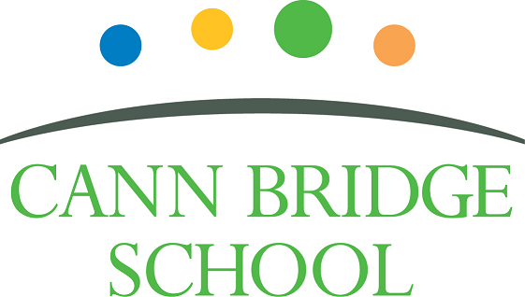

**Class Teacher**

**Candidate Information Pack**

**November 2024**

**Welcome from the Headteacher**

Dear Prospective Candidate,

Thank you for your interest in joining our dedicated and compassionate team at Cann Bridge School. As the Headteacher, I am delighted to introduce you to our school and the opportunities that await you here.

Cann Bridge School, located in Estover, Plymouth, is a local authority maintained special school serving children and young people aged 3 to 19 years from Plymouth, Devon, and Cornwall. With a capacity for 108 pupils, we are an oversubscribed school, currently educating 118 learners.

Our school is uniquely designed for children and young people with complex cognition and learning needs, all of whom have an Education, Health, and Care Plan indicating either Severe Learning Difficulty or Profound and Multiple Learning Difficulty. Many of our learners also have additional specific learning difficulties, such as Down's Syndrome, Autistic Spectrum Condition, speech and language difficulties, physical disabilities, or complex medical conditions. To learn more about Cann Bridge School and the wonderful things happening, please visit our:

* Website: [www.cannbridgeschool.co.uk](https://cannbridgeschool.co.uk/)
* Facebook: [www.facebook.com/cannbridgeschool](https://www.facebook.com/cannbridgeschool)
* School Newsletters [www.cannbridgeschool.co.uk/newsletters-forms](https://cannbridgeschool.co.uk/newsletters-forms/)

At Cann Bridge School, we are committed to creating a nurturing and inclusive environment where every learner is given the support and encouragement they need to thrive. We are learner-focused, and it is our mission to provide the highest quality of education tailored to the unique needs of each child and young person. Our dedicated and hardworking staff create a calm and purposeful environment, delivering personalised learning opportunities through our Pathways to Independence Curriculum. Detailed outlines of our EYFS and 14 to 19 Curriculum are also available on our website.

With a history spanning over 60 years, previously known as Downham School, Cann Bridge School moved to its current purpose-built facilities on the Tor Bridge Partnership site in 2012. We are co-located with Torbridge High, Torbridge Primary, and Plym Bridge Nursery. Recent expansions include a Post-16 unit (Post Bridge College) in 2016, remodelling in 2022, and the addition of two modular classrooms in 2024. We are fortunate to have excellent facilities and resources including sensory rooms, immersive room, warm water pool, science garden, soft play and Forest Schools area to name a few. We continuously striving to enhance and develop these further and our active Friends of Cann Bridge (PTFA) plays a crucial role in supporting these endeavours.

Our school is undergoing significant and exciting changes, as outlined in our School Development Plan (SDP), which identifies key areas for improvement to ensure we remain progressive and provide the highest quality education for our learners. The SDP is available on our website. We are dedicated to ongoing training and development for our staff, ensuring they are equipped with the latest knowledge and techniques in special education.

The role of a Class Teacher at Cann Bridge School is both challenging and immensely rewarding. You will have the opportunity to make a profound difference in the lives of our learners, helping them achieve their full potential and develop essential life skills. Our curriculum is designed to be flexible and responsive, addressing each learner’s individual strengths and needs. We are seeking dynamic, aspirational Class Teachers who share our commitment, vision, and values to the education of children and young people with SEND. Together, we prioritise meeting the unique needs of our learners, ensuring they are well-prepared for their futures.

We look forward to welcoming passionate, innovative, and caring individuals to our school. If you are ready to take on this rewarding challenge and make a positive impact, we would be thrilled to receive your application. We encourage all applicants to visit the school prior to applying.

Once more, thank you for your interest in the role of Class Teacher at Cann Bridge School. We look forward to receiving your application.

Warm regards,



Shane Baker

Headteacher

**Our Vision & Values**

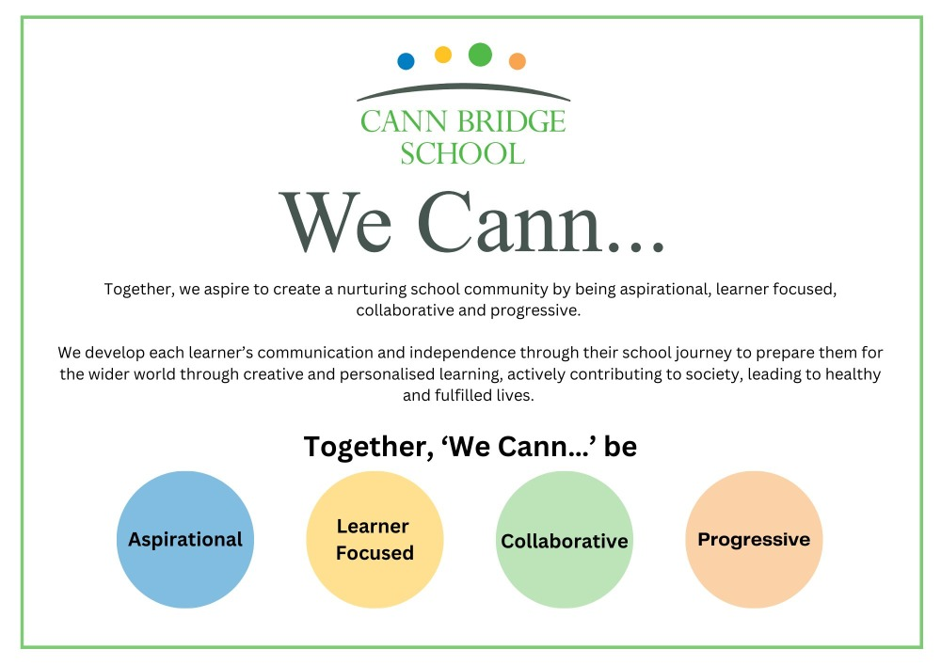

**The Role**

The role of a Class Teacher at Cann Bridge School is to deliver high-quality teaching and learning to learners with severe learning difficulties. This involves creating and implementing personalised lesson plans that address the unique needs of each learner, ensuring their educational, social, and emotional development. Teachers will work closely with a multidisciplinary team, including therapists and support staff, to provide a comprehensive learning experience that integrates Personalised Learning Goals with necessary therapeutic interventions. The aim is to help learners achieve their full potential and develop essential life skills in a supportive and nurturing environment.

In addition to classroom responsibilities, a Class Teacher at Cann Bridge School is expected to engage in ongoing professional development to stay current with best practices in special education. They will contribute to the continuous improvement of the school’s curriculum and participate in school-wide initiatives as outlined in the School Development Plan. The role requires a commitment to fostering a positive and inclusive school culture, collaborating with colleagues, and maintaining open communication with parents and carers to support each learner's progress and well-being.

**Recruitment Timeline**

* Opportunities to visit Cann Bridge School: 19th Nov @ 10am or 26th Nov @2pm. Please contact the school to arrange your visit or to request an alternative time – 01752 207909 or [HR@cannbridge.co.uk](mailto:HR@cannbridge.co.uk)
* Application closing date: Midday 29th November
* Candidate shortlisting: Afternoon 29th November
* Interviews: Wednesday 4th or 5th December 2024

Complete applications should be sent to: HR@cannbridge.co.uk

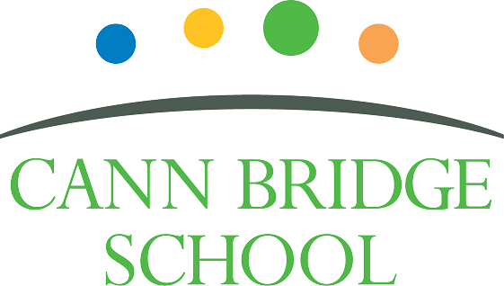

**Job Description: Class Teacher**

Cann Bridge School is committed to creating a diverse workforce. We’ll consider all qualified applicants for employment without regard to sex, race, religion, belief, sexual orientation, gender reassignment, pregnancy, maternity, age, disability, marriage, or civil partnership.

**Job details**

**Position:** Class Teacher

**Location:** Cann Bridge School, Estover, Plymouth

**Salary:** Main Pay Range 1 to 6 or Upper Pay Range 1 to 3, plus Special Educational Needs Allowance 1.

**Contract type:** Full-time permanent

**Reporting to:** Key Stage Lead and Senior Leadership Team

**Responsible for:** Class based support staff

**Start Date:** January 2025 or April 2025

**Main purpose**

The class teacher will:

* Deliver high-quality education to learners with severe learning difficulties (SLD).
* Create and implement personalised lesson plans addressing each learner's unique needs.
* Ensure the educational, social, and emotional development of learners.
* Collaborate with a multidisciplinary team, including therapists and support staff.
* Develop and manage a team of support staff to enhance teaching, learning, assessment and well-being.
* Integrate educational goals with necessary therapeutic interventions.
* Help learners achieve their full potential and develop essential life skills.
* Monitor and evaluate pupil progress through ongoing formative and summative assessments.
* Report to families and school leaders on learner progress and outcomes.
* Engage in ongoing professional development to stay current with best practices in special education.
* Contribute to the continuous improvement of the school’s curriculum by being an active member of a curriculum team.
* Participate in school-wide initiatives as outlined in the School Development Plan.
* Foster a positive and inclusive school culture, adopting and adhere to the school policies and procedures.
* Develop a high-quality total communication learning environment.
* Maintain open communication with parents and carers to support learner progress and well-being.
* Fulfil the professional responsibilities of a teacher, as set out in the School Teachers’ Pay and Conditions Document
* Meet the expectations set out in the Teachers’ Standards.

**Duties and responsibilities**

**Teaching**

* Plan and teach well-structured lessons to assigned class/es, following the school’s plans, curriculum and schemes of work
* Assess, monitor, record and report on the learning needs, progress and achievements of assigned learners, making accurate and productive use of assessment
* Adapt teaching to respond to the strengths and needs of learners
* Set high expectations which inspire, motivate and challenge learners
* Promote good progress and outcomes by learners
* Demonstrate good subject and curriculum knowledge

**Whole-school organisation, strategy and development**

* Contribute to the development, implementation and evaluation of the school’s policies, practices and procedures, so as to support the school’s vision and values
* Make a positive contribution to the wider life and ethos of the school
* Work with others on curriculum and learner development to secure co-ordinated outcomes

**Health, safety and discipline**

* Promote the safety and wellbeing of learners and staff
* Maintain good order and discipline among learners, managing behaviour effectively to ensure a good and safe learning environment
* Maintain and develop a learning environment in line with the school’s policies maintaining good housekeeping and health and safety expectations

**Professional development**

* Take part in the school’s appraisal procedures
* Take part in further training and development in order to improve own teaching
* Take part in the appraisal and professional development of others, where appropriate

**Communication**

* Communicate effectively with learners, parents and carers and staff
* Lead a weekly class meeting with own class team

**Working with colleagues and other relevant professionals**

* Collaborate and work with colleagues and other relevant professionals within and beyond the school
* Develop effective professional relationships with colleagues

**Personal and professional conduct**

* Uphold public trust in the profession and maintain high standards of ethics and behaviour, within and outside school
* Have proper and professional regard for the ethos, policies and practices of the school, and maintain high standards of attendance and punctuality
* Understand and act within the statutory frameworks setting out their professional duties and responsibilities

**Management of staff and resources**

* Direct and supervise support staff assigned to them, and where appropriate, other teachers
* Contribute to the recruitment and professional development of other teachers and support staff
* Deploy resources delegated to them

**Safeguarding**

* Work in line with statutory safeguarding guidance (e.g. Keeping Children Safe in Education, Prevent) and our safeguarding and child protection policies
* Work with the designated safeguarding lead (DSL) to promote the best interests of learners, including sharing concerns where necessary
* Promote the safeguarding of all learners in the school

Please note that this is illustrative of the general nature and level of responsibility of the role. It is not a comprehensive list of all tasks that the teacher will carry out. The postholder may be required to do other duties appropriate to the level of the role, as directed by the headteacher or line manager.



**Person Specification: Class Teacher**

|  |  |  |  |
| --- | --- | --- | --- |
| **Criteria** | **Qualities**  **Essential** | **Qualities**  **Desirable** | **Method of Assessment** |
| **Qualifications and training** | * Qualified Teacher Status (QTS), Qualified Teacher Learning and Skills status (QTLS) or equivalent * Degree | * Qualification in Special Educational Needs | Application form |
| **Experience** | * Successful teaching experience in a primary/secondary/special education setting. * Proven experience working with learners with SEND * Teaching, learning and assessment practices which demonstrate improved learner outcomes over time. * Creating Individualised Education Plans (IEPs) (known as Personalised Learning Goals at Cann Bridge School). * Adapting teaching methods and resources to meet the needs of diverse learners. * Implementing positive behaviour management strategies consistently in line with schools’ policies and procedures. | * Demonstrable evidence of raising the standards of teaching, learning and assessment * Experience of leading subject/curriculum development across a whole school * Experience of teaching children and young people with severe learning difficulties * Effective collaboration with external agencies * Experience of using systems such as SIMS, CPOMS, Evisense, Connecting Steps/B Squared, Immersive Studio, National College, Evolve and Microsoft applications. | Application form  Interview process |
| **Skills & Knowledge** | * Knowledge of effective teaching and learning strategies * A good understanding of how children learn * Excellent communication skills, both verbal and written, with the ability to engage effectively with learners, families, and colleagues. * Ability to build effective professional working relationships * Able to use technology systems integrally to monitor and support the raising of learner achievement * Good understanding of safeguarding and child protection * Knowledge of effective positive behaviour support strategies * Good ICT skills, particularly using ICT to support learning * Knowledge of Keeping Children Safe in Education (KSCiE) and Prevent * Knowledge of the National Curriculum | * Leading support staff appraisal processes * Good understanding of the Education, Health, and Care Plan (EHCP) and how these can be used to personalise learning. * Experience and/or knowledge of CPI Safety Intervention or similar i.e. Team Teach. * Experience and/or knowledge trauma informed practice/schools. * Experience and/or knowledge SoSAFE! * Demonstratable knowledge of current research-based teaching principles and strategies i.e EEF and Rosenshine Principles * Knowledge and understanding of the Preparation for adulthood agenda * Experience of assessing learners using the Engagement Model | Application form  Interview process |
| **Personal qualities** | * A commitment to getting the best outcomes for all learners and promoting the ethos and values of the school * High expectations for children’s attainment and progress, improving outcomes for children with SEND. * Ability to work under pressure and prioritise effectively, ensuring a work-life balance * Commitment to maintaining confidentiality at all times * Commitment to safeguarding and equality and diversity, ensuring that personal beliefs are not expressed in ways that exploit the position * Empathetic and patient, with a strong understanding of the challenges faced by learners with special needs. * Motivated, with a positive attitude and the ability to inspire and engage learners. * Able to work collaboratively and build effective teams with good presence * Strong personal integrity, honesty, dedication, reliability, and resilience * Demonstrate initiative in solving problems * Good organisational skills * Maintain and promote the expected professional standards of self and others (Teachers’ Standards) * Aware of own strengths and areas for development with a commitment to own professional development. | * Able to manage and resolve conflict | Application form  Interview process |

This job description may be amended at any time in consultation with the postholder.

**Last review date:** November 2024

**Line manager’s signature:** _______________________________________

**Date:** _______________________________________

**Postholder’s signature:** _______________________________________

**Date:**  _______________________________________