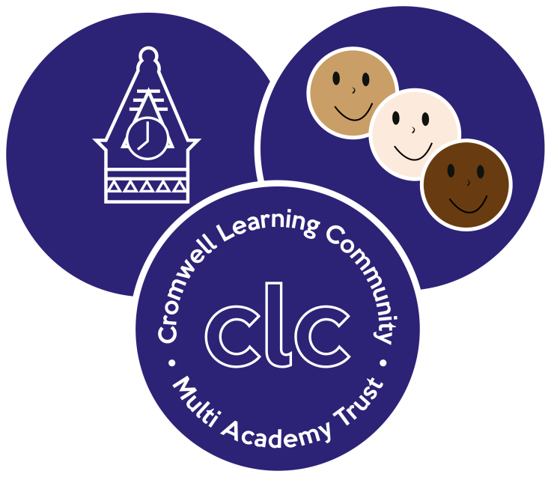 | Cromwell Learning Community Academy Trust  Class Teacher  Job Description

PROFESSIONAL ATTRIBUTES

Relationships with Children and Young People
Have high expectations of children and young people including a commitment to ensuring that they can achieve their full educational potential and to establishing fair, respectful, trusting, supportive and constructive relationships with them.

Demonstrate the positive values, attitudes and behaviour they expect from children and young people.

Framework
Maintain an up-to-date knowledge and understanding of the professional duties of teachers and the statutory framework within which they work, and contribute to the development, implementation and evaluation of the policies and practice of their workplace, including those designed to promote quality of opportunity.

Communicating and working with others
Communicate effectively with children, young people, colleagues, parents and carers.

Recognise and respect the contributions that colleagues, parents and carers can make to the development and well-being of children and young people, and to raising their levels of attainment.

Recognise that communication is a two-way process and encourage parents and carers to participate in discussions about the progress, development and well-being of children and young people.

Have a commitment to collaboration and co-operative working.

Personal Professional Development
Evaluate their performance and be committed to improving their practice through appropriate professional development.

Have a creative and constructively critical approach towards innovation, being prepared to adopt their practice where benefits and improvements are identified.

Act upon advice and feedback and be open to coaching and mentoring.

PROFESSIONAL KNOWELEDGE AND UNDERSTANDING

Teaching and learning
Have a good, up-to-date knowledge and understanding of a range of teaching, learning and behaviour management strategies and know how to use and adapt them, including how to personalise learning and provide opportunities for all learners to achieve their potential.

Assessment and monitoring
Know the assessment requirements and arrangements for the subjects/curriculum areas they are trained to teach, including those relating to public examinations and qualifications.

Know a range of approaches to assessment, including the importance of formative assessments.

Know how to use local and national statistical information to evaluate the effectiveness of their teaching, to monitor the progress of those they teach and to raise levels of attainment.

Know how to use reports and other sources of external information related to assessment in order to provide learners with accurate and constructive feedback on their strengths, weaknesses, attainment, progress and areas for development, including action plans for improvement.

Subjects and curriculum
Have a secure knowledge and understanding of their subjects/curriculum areas and related pedagogy including: the contribution that their subjects/curriculum areas can make to cross-curricular learning; and recent relevant developments.

Know and understand the relevant statutory and non-statutory curricula and frameworks, including those provided through the National Strategies, for their subjects/curriculum areas, and other relevant initiatives applicable to the age and ability range for which they are trained.

Literacy, numeracy and ICT
Have passed the professional skills tests in numeracy, literacy and Information and Communications Technology (ICT).

Know how to use skills in literacy, numeracy and ICT to support their teaching and wider professional activities.

Achievement and diversity
Understand how children and young people develop and that the progress and well-being of learners are affected by a range of developmental, social, religious, ethnic, cultural and linguistic influences.

Know how to make effective personalised provision for those they teach, including those for whom English is an additional language of who have special educational needs or disabilities, and how to take practical account of diversity and promote equality and inclusion in their teaching.

Understand the roles of colleagues such as those having specific responsibilities for learners with special educational needs, disabilities and other individual learning needs or disabilities, and how to take practical account of diversity and promote equality and inclusion in their teaching.

Know when to draw on the expertise of colleagues, such as those with responsibility for the safeguarding of children and young people and special educational needs and disabilities, and to refer to sources of information, advice and support from external agencies.

Health and Well-being
Know how to identify potential child abuse or neglect and follow safeguarding procedures.

Know how to identify and support children and young people whose progress, development or well-being is affected by changes or difficulties in their personal circumstances, and when to refer them to colleagues for specialist support.

Know the current legal requirements, national policies and guidance on their safeguarding and promotion of the well-being of children and young people.

Know the local arrangements concerning the safeguarding of children and young people.

PROFESSIONAL SKILLS

Planning
Plan for progression across the age and ability range for which they are trained, designing effective learning sequences within lessons and across series of lessons demonstrating secure subject/curriculum knowledge.

Design opportunities for learners to develop their literacy, numeracy, ICT and thinking and learning skills appropriate within their phase and context.

Plan, set and assess homework, other out-of-class assignments and coursework for examinations, where appropriate to sustain learners’ progress and to extend and consolidate their learning.

Teaching
Teach lessons and sequences of lessons across the age and ability range for which they are trained and in which they:

- Use a range of teaching strategies and resources, including e-learning, taking practical account of diversity and promoting equality and inclusion.

- Build on prior knowledge, develop concepts and processes, enable learners to apply new knowledge, understanding and skills and meet learning objectives.

- Adapt their language to suit the learners they teach, introducing new ideas and concepts clearly, using explanations, questions, discussions and plenaries effectively.

- Demonstrate the ability to manage the learning of individuals, groups and whole classes, modifying their teaching to suit the stage of the lesson.

Teach engaging and motivating lessons informed by well-grounded expectations of learners and designed to raise levels of attainment.

Assessing, monitoring and giving feedback
Make effective use of a range of assessment, monitoring and recording strategies.

Asses the learning needs of those they teach in order to set challenging learning objectives. Provide timely, accurate and constructive feedback on learner’s attainment, progress and areas for development.

Support and guide learners to reflect on their learning, identify the progress they have made and identify their emerging needs.

Reviewing teaching and leaning
Evaluate the impact of their teaching on the progress of all learners, and modify their planning and classroom practice where necessary.

Learning environment
Establish a purposeful and safe learning environment conducive to learning and identify opportunities for learners to learn in out-of-school contexts.

Establish a clear framework for classroom discipline to manage learner’s behaviour constructively and promote their self control and independence.

- Establish a purposeful and safe learning environment which complies with current legal requirements, national policies and guidance on the safeguarding and well-being of children and young people so that learners feel secure and sufficiently confident to make an active contribution to learning and to the school.

- Make use of the local arrangements concerning the safeguarding of children and young people.

- Identify and use opportunities to personalise and extend learning through out-of-school contexts where possible making links between in-school learning and learning in out-of-school contexts.

- Manage learner’s behaviour constructively by establishing and maintaining a clear and positive framework for discipline, in line with the school’s behaviour policy.

- Use a range of behaviour management techniques and strategies, adapting them as necessary to promote the self-control and independence of learners.

Promote learners’ self-control, independence and cooperation through developing their social, emotional and behavioural skills.

Team working and collaboration
Work as a team member and identify opportunities for working with colleagues, managing their work where appropriate and sharing the development of effective practice with them.

Ensure that colleagues working with them are appropriately involved in supporting learning and understand the roles they are expected to fulfil.

Line management – responsibility to and for
Responsible to the Leadership team.

Conditions of employment
This appointment is subject to the current conditions of employment of teachers contained in the School Teacher’s Pay and Conditions Document, the Education Act 1997, the required standards for Qualified Teacher Status, subsequent Orders in terms of duties and working time, also any local agreements, Local Authority circulars and guidelines giving interpretations of teacher’s conditions of service.

Review and amendments
This job description subject to an annual review. It may be amended at the request of the Head teacher or the post holder but only after full consultation with the post holder.

Complaints
If following review and amendments, agreement is not reached, the appropriate procedures should be used for the settling of any disputes.

