To arrange a visit to the school, please contact Helen Millward (HR Manager & Office Manager) on **0207 987 3737**.

An application form can be found on the vacancies page of the school’s website.

Please email your completed application to: [**h.millward@cyriljackson.towerhamlets.sch.uk**](mailto:h.millward@cyriljackson.towerhamlets.sch.uk)

**Application closing date:**

**(9am) Monday 1 March 2021**

**Shortlisting and communication:**

**Thursday 4 March 2021**

**Interview date:**

**Friday 12 March 2021**

Cyril Jackson Primary school is committed to safeguarding and promoting the welfare of children and expects all staff and volunteers to share this commitment.

Vigorous checks will be completed prior to interview and references from applicants current/most recent employer will be requested.

The successful candidate will require an enhanced DBS clearance.

**cLASS TEACHER**

**Start date: September 2021**

**NQTs or experienced staff may apply**

Cyril Jackson is an outstanding, ambitious and inclusive community school with a national and international reputation for providing a high standard of education.

Our staff are highly committed, hardworking and motivated. We are seeking to appoint a Class Teacher to help us provide a supportive, stimulating environment and to share our high expectations of achievement for all our children.

We are looking for someone who:

* demonstrates a clear understanding of what constitutes outstanding teaching and learning, and has the ability to lead by example
* inspires and motivates staff, parents, carers and children
* demonstrates exceptional knowledge of the curriculum
* demonstrates excellent management, interpersonal and organisational skills
* supports teams in working together to raise levels of achievement and attainment for all
* shows commitment to ensuring equality of opportunity for all learners
* is a dynamic and creative practitioner

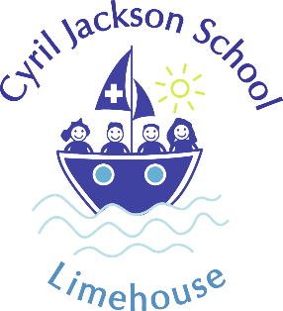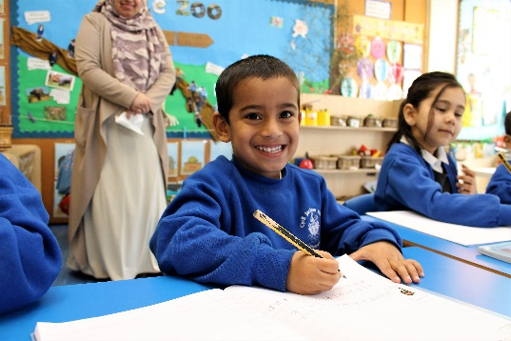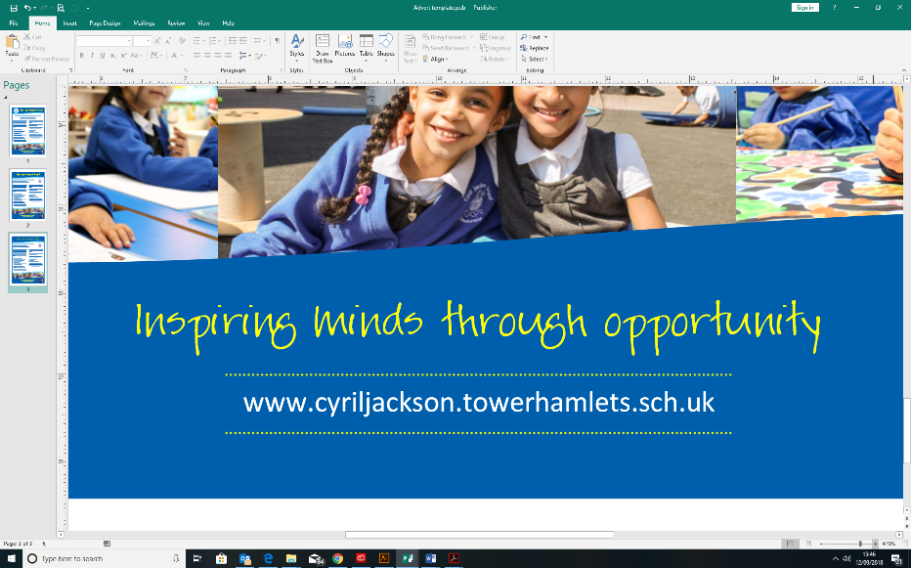

www.cyriljackson.towerhamlets.sch.uk

