January 2023

Dear Colleague

Thank you for your interest in the post of Class Teacher at Castle Hill School. In addition to your application I would like you to write a brief outline (no more than 500 words) on the following statement:

‘What are the skills and attributes needed to become a teacher in a school like Castle Hill?’

Visit to the school are encouraged on the following dates:

All application forms should be returned directly to the school FAO: Recruitment or emailed to recruitment@castlehillschool.org.uk.

Good luck

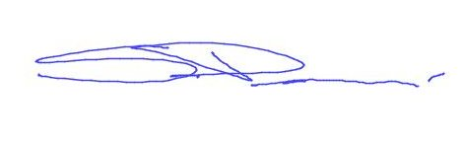

Steve Perren

Principal

