
Class Teacher Job Pack

Together we will; respect, achieve and make good choices.

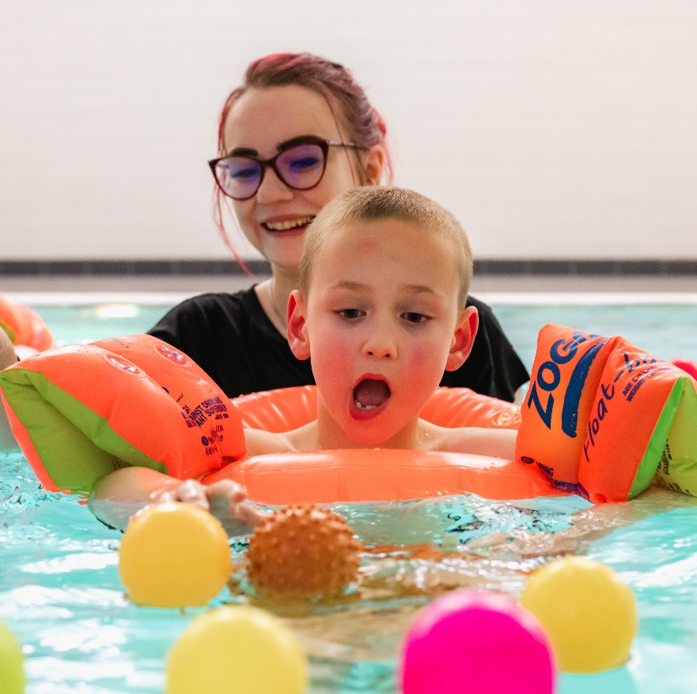

Class Teacher

“Igniting the flicker into a flame.”

Glenwood teachers take a lead role in supporting us to discover the unique value of each young person. Working together we support young people to develop the best ways each individual can share their “fabulousness”; Teachers have the privileged opportunity to guide a step and shape the path in the young person’s transformational journey.

Message from the Headteacher

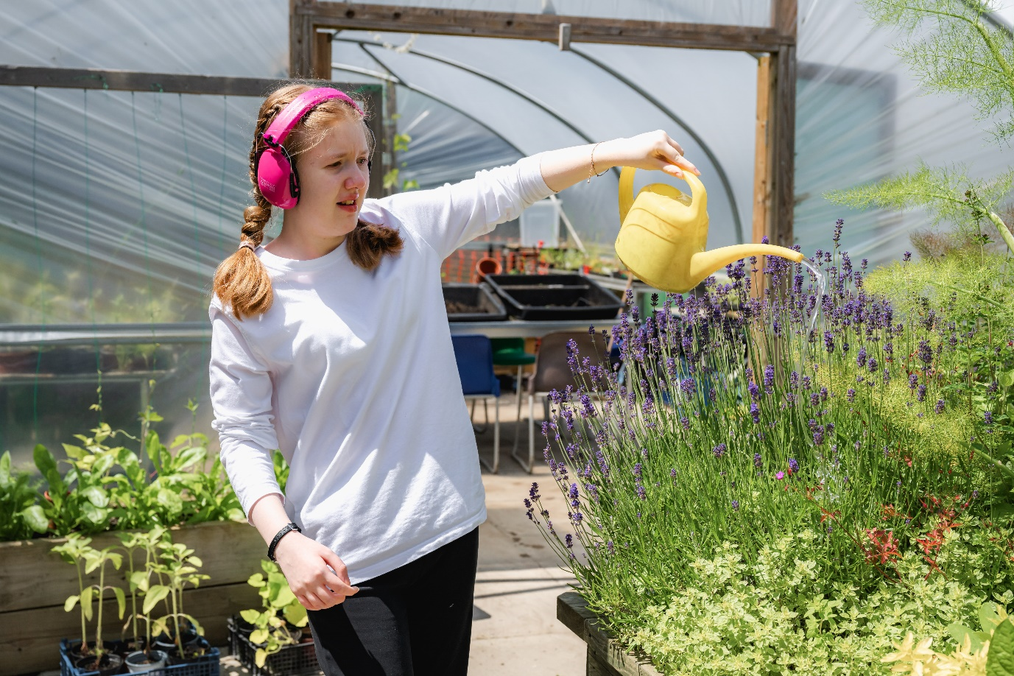

Thank you for being intrigued in the role of class teacher at Glenwood School. Glenwood is an amazing place to be, for both learners and staff.
Glenwood School will aim for nothing but the best in support of its learners. Its mission is to be transformational.
Our model is deeply rooted in making progress that is meaningful for learners and their families.
The successful candidates will be professionals who recognise the importance of doing things differently to ensure learners achieve and enjoy life.
We are looking for a class teacher who can recognising the unique “fabulousness” and unique contributions of our learners, demonstrate initiative and contribute great ideas towards their lives.
As a class teacher at Glenwood School, you will be a member of a daring and dynamic team and work closely with a diverse team of education and health professionals.
This is a challenging role which will be demanding in terms of thinking outside the box and coming up with brave and creative solutions. However, support will be there when you need it. We offer the chance to shape a role and to be involved with something very special.
We are looking forward to welcoming new professionals to a team. Tours and conversations with the Headteacher are expected. We look forward to meeting you and we are curious to know what your first question will be. It will tell us so much about you!

Our Advertisement for Class Teacher



A very exciting chance to influence the next stage of the development of our highly respected local special school and to deliver transformational outcomes for our young people who already shine bright.

Our School: Glenwood is a brave special school for pupils aged 3-19 years. We provide for 228 young people. We moved into a superb building in September 2017 and we also benefit from a separate residential provision, which is used as an educational intervention as part of the school’s holistic approach.

Closing Date:
TBC

Shortlisting:
TBC

Interviews:
TBC

Pay Scale:
Standard national scale in line with the current School Teachers’ Pay and Conditions document plus SEN1

Please contact the school to arrange a preliminary discussion and or a visit, on 01268 792575 or email: admin@glenwood.essex.sch.uk.

Why Work at Glenwood?
Staff Testimonial – Class Teacher:
I started working at Glenwood School in September 2022 as a Class Teacher. At first, I was nervous and apprehensive about moving from a mainstream setting, however, the nerves soon disappeared once I met the learners and staff. The staff are so supportive and are eager to help you in all aspects of school life. At Glenwood School, it’s not just the learners that learn - the teachers are constantly picking up new skills too. The learners benefit from a highly structured environment, which means there’s no better way to hone your classroom management and organisational skills! Not only that, but you’ll also improve your interpersonal skills and communication skills, and you’ll learn how to interact with and be part of a wider team, including parents, other teachers, specialists and even psychologists. Working at Glenwood School has given me the freedom to be creative with what I teach and how I teach it. It’s all about the individual learner and finding ways to inspire them. At Glenwood School the curriculum is not a one size fits all strategy - it’s about trying new things and adapting your teaching style to meet individual needs. Without a doubt, one of the most rewarding parts of working at Glenwood is that you get to learn from the young people in your class every day. Watching them overcome obstacles and work so hard to make progress is one of the most inspiring things in the world - and despite the challenges involved with SEN teaching, there’s nothing more rewarding than seeing a learner succeed.

Staff Testimonial - HLTA:
I started at Glenwood just over 5 years ago, the school has helped me to develop into my current role as a HLTA and also supported me to undertake the Level 3 teaching assistant qualification. I really enjoy working here, it is an amazing school with some amazing colleagues and learners. Over the years here I have worked across the school, every day is full of different challenges but what we get in return from our learners is priceless.
Staff Testimonial - LSA:
I have worked at Glenwood School for over 6 years now. I have worked with different learners of various ages and abilities, and each day I am still learning from them all. When I am working with our young people, I love to see the progress they make over time and making a difference to their life. I feel very lucky to be part of the Glenwood team and have support from others.

Our Curriculum Worlds
Every one of our young people is inspirational and can lead the way.
It is our role to support each learner, to recognise their own value and find ways of sharing this with the World Beyond Glenwood.
We create a personalised curriculum, with communication at the core. In planning for each learner, we start from where the learner is. Each individual’s curriculum must come out of what we know about them and what they want and need and the knowledge, visions and priorities of parents, carers and other professionals. We think about future outcomes and put targets and strategies in place to begin the journey of equipping them with skills that will lead to a future where they can be happy, communicate as well as they can and be as independent as possible.

SAS Staff Benefit Scheme at Glenwood

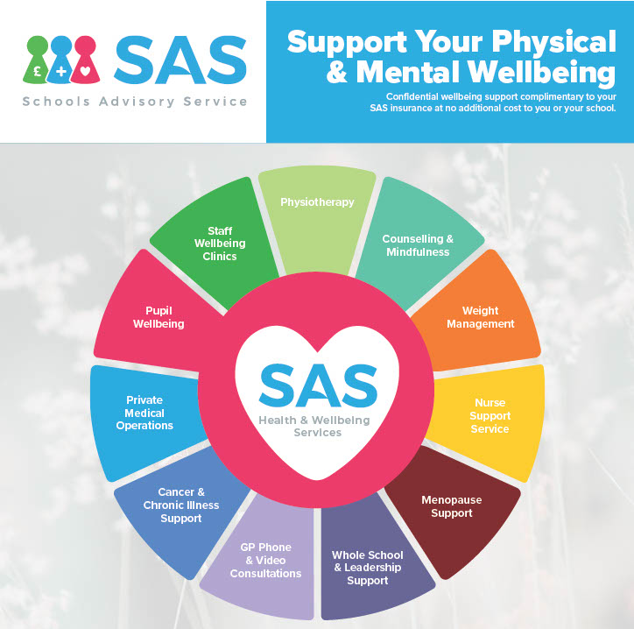

This scheme includes the following benefits which are available to all staff working for Glenwood School:
- Integrated GP Service with unlimited consultations
- Private Physiotherapy Service
- Private Counselling
- Nurse Support
- Access to online workouts, weight loss programmes, meditations, nutritional support and personal trainer programmes
- Discounted Food Sensitivity testing
- Mastering mindfulness programmes

Class Teacher – Job Description

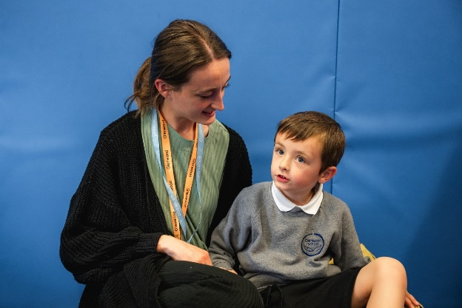

Glenwood Class Teacher

“Igniting the flicker into a flame”

Main purpose of the job:
Glenwood teachers take a lead role in supporting us to discover the unique value of each young person. Working together we support young people to develop the best ways each individual can share their “fabulous-ness”; Teachers have the privileged opportunity to guide a step and shape the path in the young person’s transformational journey.

Post title: | Class Teacher
School: | Glenwood School
Pay range: | Standard national scale in line with the current School Teachers’ Pay and Conditions document plus SEN1 allowance
Line manager: | Senior Leader
Supervisory responsibility: | HLTAs, LSAs & MDAs

Leading teaching and learning:
- Be confident leaders of curious and effective class-teams.
- Support your class team to work together in a creative and solution focussed way
- Be an excellent role model, exemplifying a high standard of teaching and promoting high expectations for all members of the team.
- Be responsive to the priorities raised for learners ensuring there is highly individualised planning; with a full understanding that something new and unique may need to be created rather than relying on pre-existing strategies and resources. Thinking afresh every time we learn something new about them.
- Ensure that Annual Review documentation and your contributions to meetings have a significant impact on the quality of the young person’s experience and achievements; and that these meetings play an important part in developing shared priorities with the family.
- Be a role model in listening to the many ‘voices around the learner’, incorporating all we learn into their curriculum and support strategies; only by listening and looking do we learn where to go next.
- Work with your class team to raise standards through staff performance management
- Assist with the development and delivery of training, and support your class team in the areas of teaching and learning
- Work in collaboration with Curriculum Leaders on the development and review of the curriculum including planning, recording, reporting, and assessment for each learner in your class
- Support the Senior Leadership Team with all processes including monitoring and evaluating the quality of education taking place to ensure a consistently high quality
- Ensure communication and safeguarding across school staff and families is highly effective
- Effectively narrate the progress journey and identify where further development should be achieved
- Contribute to the day-to-day effective organisation and running of the school
- Undertake any professional duties, reasonably delegated by the headteacher

Developing self and others:
- Adapt approaches according to the needs of the situation or the colleague
- Support the development of collaborative approaches to curriculum development and learning within the school and beyond
- Support the induction of staff new to the school and those being trained within the school as appropriate
- Take responsibility and accountability for the professional development of the class team
- Lead by example to motivate and work with others; recognising and developing the strengths of others to have the optimum impact on the young people and the school
- Fully engage in the annual appraisal process for class team
- Know many minds support the best way forward

Under the overall direction of the Headteacher and Deputy Headteacher:
- Reflect our Glenwood values by being kind and understanding to learners and staff through all our interactions and professional decisions
- Carry out the professional duties of a teacher; being a role model for inspirational practice and being responsive to the ever-changing needs of the learner
- Be responsible for promoting excellent progress across your class
- Monitor progress towards achievement in your class
- Be responsible for the standards and performance in your class; supporting others to use all the expertise within Glenwood to achieve amazing outcomes
- Take responsibility for promoting and safeguarding the welfare and wellbeing of children and young people within the school; ensuring our learners are the most confident and happy young people.
- Ensure we are truly working in partnership with families, sharing the journey of their young person through Glenwood.

Shaping the future:
- Demonstrating initiative and contributing great ideas towards the lives of learners
- Lead by example when implementing and managing strategies for change
- Lead by example to embed finding answers and solutions as a strong part of the school culture

Securing accountability:
- Contribute to the reporting of the school’s performance to the school’s community
- Promote and protect the health and safety welfare of learners and staff
- Take responsibility for promoting and safeguarding the welfare of children and young people within the school

Strengthening community:
- Ensuring our respectful and compassionate relationship with families means we are discussing the same young person throughout the Glenwood Journey
- Develop and maintain contact with all specialist support partners as appropriate
- Organise and conduct meetings where appropriate with parents and carers to ensure positive outcomes for learners and their families
- Attend meetings with parents and carers as appropriate to ensure positive outcomes for all parties
- Promote positive relationships and work with colleagues in other schools and external agencies

Class Teacher – Person Specification
Knowledge and Qualifications
Essential:
- Qualified Teacher Status
- Degree or equivalent
- An extensive knowledge of differentiation for learners with special educational needs
- A good understanding of assessment and the use of assessment information
- Knowledge and experience of safeguarding processes and approaches in relation to the learner profile at Glenwood
- Knowledge of how to support learners who may find school and social settings difficult
- Commitment to Professional development
Desirable:
- Evidence of further study and research
- Master’s Degree or equivalent
- Knowledge and experience of specialist programmes and approaches for children/young people with Special Educational Needs, e.g. TEACCH, PECS
Professional Skills and Experience
Essential:
- Experience of teaching across a variety of learner needs
- Demonstrate consistently high-quality teaching strategies
- Support and motivate both colleagues and learner by leading through example
- Knowledge of how effective curricular thinking and planning can impact on progress
- Ability to manage a team to successfully achieve agreed goals
- Experience of working positively and productively with parents/carers
- An understanding of the essential qualities necessary for improving the quality of learning and teaching
- The ability to work with a wide range of professionals and multi-agency approaches
- Communicate effectively to a wide range of audiences (verbal, written, using ICT as appropriate).
- Ability to deliver effective professional development for staff
- Deal successfully with situations that may include difficult situations and conflict resolution.
- The ability to maintain a work/life balance and awareness of own wellbeing
Desirable:
- Successful experience of teaching in a special school
- Experience of working in different key stages and phases of education
Personal Skills, Qualities and Attributes
Essential:
- Ability to relate positively to and show respect and kindness to all members of the school and wider community
- Strong interpersonal, written and oral communication skills
- Self-motivated with high levels of personal drive, able to work with minimal supervision
- Be an effective team player who works collaboratively and effectively with others.
- The ability to enthuse and inspire others
- Strong organisational and time management skills
- Ability to work under pressure and meet deadlines
- Approachable, able to develop and maintain positive professional relationships with others
- High expectations of self, other staff and learners
- Commitment to the broader life of the school
- The ability to make decisions based on the available information with confidence, clarity and decisiveness
- A sense of humour and fun!



