6th April 2021
Dear Colleague,

Thank you for your interest in the post of Class Teacher at Thomas Buxton Primary School. These are extraordinary times and looking for your first or next teaching post is an important step in your career. It is helpful to find out as much about a school as you can before making an application and I would encourage you to make the most of our school website. It really does reflect the ethos and spirit of our wonderful school community. You are also welcome to visit our school in person and I ask that you contact the school via shifab@thomasbuxton.towerhamlets.sch.uk to arrange a suitable time

Firstly, we have the best children in all of London! They are keen to learn, well behaved and they really enjoy coming to school. Our parents and carers value education and support the school brilliantly. We are a happy, successful and forward-thinking school community set in the heart of Whitechapel. Using the local area and amazing locations in Central London is important to us in bringing the curriculum to life and making learning meaningful to children.

If you are successfully appointed, we offer you a commitment to your professional development as part of a dynamic team. Clear systems and structures ensure that there is transparency and good communication throughout the school. Our school motto is “Learning Together” and it is expected that all of us demonstrate this, whatever our role in school. Tower Hamlets is a supportive and inclusive Local Authority; it is a great place in which to be a teacher. Strong networks between schools (informally and formally through the E1 Schools Partnership) mean that there is a strong sense of identity and loyalty to the children and community we serve.

On our school website, you will find other key information about the school; the prospectus, school improvement plan and teaching and learning policy will give a broader picture of who we are and if we are the right place for you to grow as a teacher.

We look forward to receiving your application.

Yours sincerely
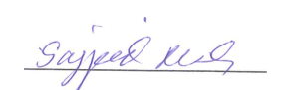
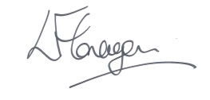
Lorraine Flanagan Sajjad Miah
Headteacher Chair of Governors

