

Empingham CE Primary School

Teacher Vacancy

Commencing September 2021

# Closing date for applications Friday 27th March 12.00pm

# Interviews to be held Week Commencing 30th March.

# For a job description and application form, please contact the school office.

# Visits to the school would be warmly welcomed.

# Empingham CE Primary School

# **01780 460246**

# **empinghamoffice@rltschools.com**

# 

# We are committed to the safety and welfare of our children and therefore the appointed person will be subject to an enhanced DBS Disclosure Check.

# Job application packs are also available at: [www.empinghamprimaryschool.co.uk](http://www.empinghamprimaryschool.co.uk)

www.example.com

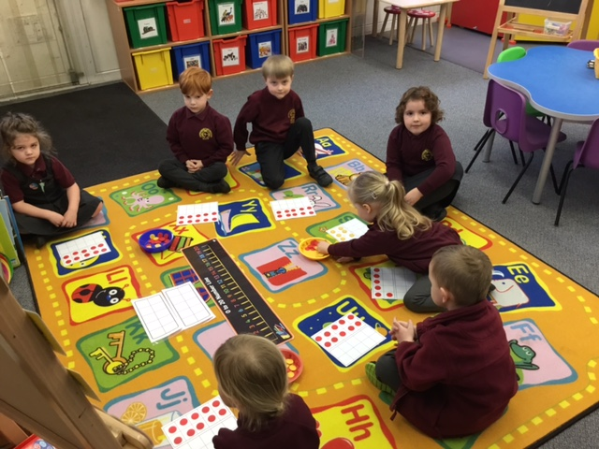

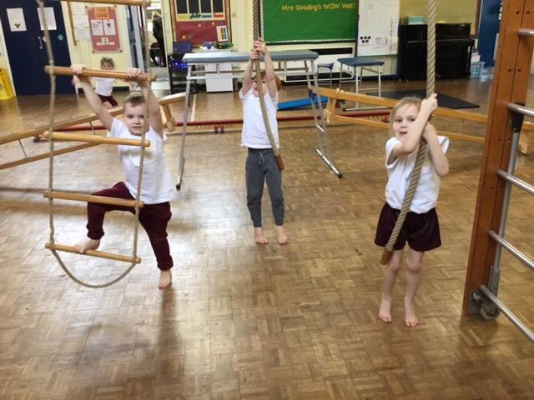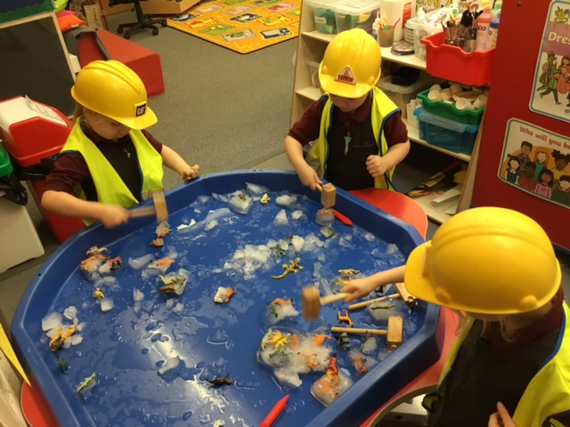

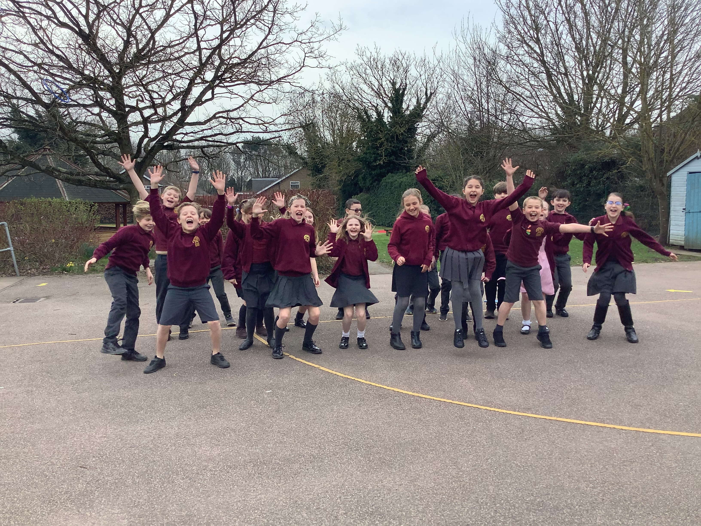

We are seeking to appoint an exciting, inspiring and enthusiastic teacher to join us and be part of our happy, caring school.

**Class Teacher – Full Time - Permanent**

This is an exciting opportunity to work within our growing school.

**"We are a family school and everyone cares for each other"**

Pupil Survey 2019

**‘Pupils make good progress in their learning and achieve well.**

**Pupils’ outcomes at the end of Year 6 have been significantly above the national averages for all subjects for the past three years.’ – OFSTED**

# Closing date for applications Friday 23rd April 2021 12.00pm

# Interviews to be held Week Commencing 26th April 2021.

# For a job description and application form, please contact the school office.

# Empingham CE Primary School

# **01780 460246**

# **Empinghamoffice@rltschools.com**

# 

# We are committed to the safety and welfare of our children and therefore the appointed person will be subject to an enhanced DBS Disclosure Check.

# Job application packs are also available at: [www.empinghamprimaryschool.co.uk](http://www.empinghamprimaryschool.co.uk)