 

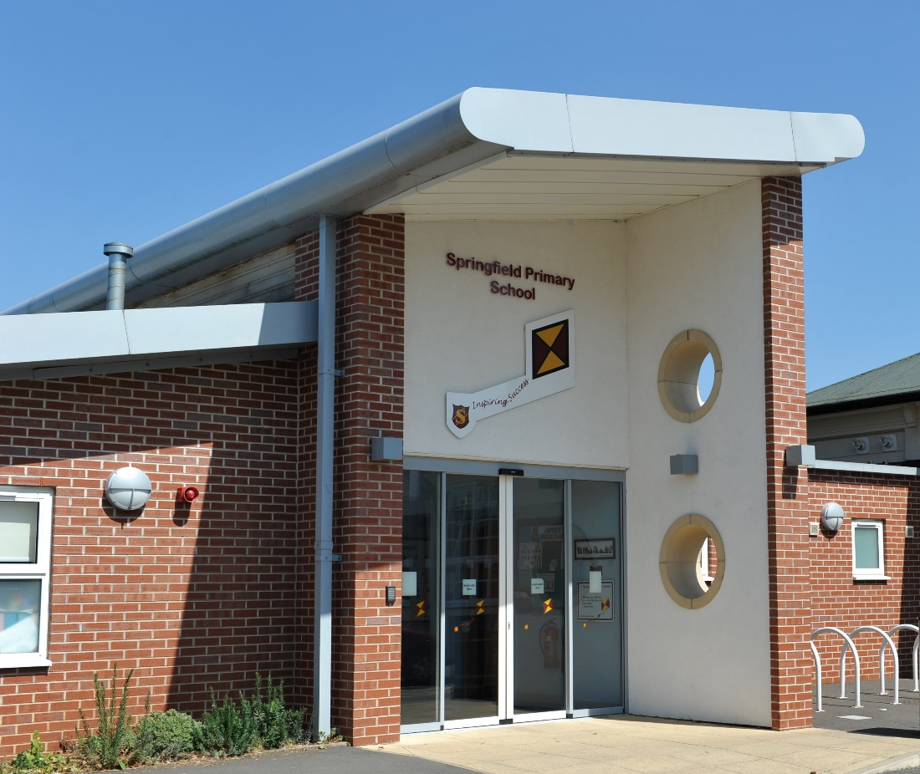

**Job Application Pack**

**Springfield Primary School**

**Full-time class teacher in Enhanced Resource Facility, permanent.**

**Salary: Main Pay Scale / UPS plus SEN allowance**

**Closing Date: Friday 16th May 2025 at 12 noon**

**Proposed Interview Date: Wednesday 21st May 2025**



**Welcome letter from David Blackwell, Headteacher of Springfield Primary School**

Dear Candidate

Thank you for showing an interest in the role of class teacher at our school. We are pleased to be able to offer two positions to add to our existing staff, both in the Enhanced Resource Facility. This is an extremely exciting time to join our ERF team at Springfield; we are currently in the final stages of planning a significant expansion, which will include a brand new custom designed building, including a bespoke sensory room, three new classrooms and new outdoor play area.

We are looking for somebody who is inspirational, hard-working and proactive; driven by the desire to inspire and achieve the best possible outcomes for all pupils.

We are seeking a candidate who will strengthen the staff team, building on the successes of the school, so that it continues to thrive and flourish and provide an excellent primary education experience to its pupils. The successful candidate will possess highly effective communication skills and be able to work with a range of different stakeholders in ensuring that all pupils at Springfield achieve success.

Alongside our inclusive mainstream provision, Springfield has an Enhanced Resource Facility, which provides specialised provision for children with communication and interaction difficulties, such as Autism Spectrum Disorder.

We aim to promote a love of learning and use our extensive school grounds to facilitate this, whilst also incorporating the use of our Forest School area to support mental health and wellbeing.

Our schools are part of the Odyssey Collaborative Trust. Our Trust is committed to supporting and delivering education of the highest quality across the trust. Each of our schools is unique, and has their own vision and values in order to provide our children with the opportunities they deserve.

This is a tremendous opportunity to make a difference and to be part of a dynamic and innovative staff team.

We look forward to receiving your application and working with you on your own professional journey to excellence.

Best regards

David Blackwell

Headteacher

Springfield Primary School



**About the school**

Everyone involved at Springfield works very hard to make the school a happy and safe place for the children to flourish and grow. We aim to provide our children with the skills that they will need to reach their full potential. We believe in traditional values but we are always aware that we are preparing the children for today and tomorrow. Our emphasis is on teaching children how to improve their own learning and developing skills to live harmoniously with others.

The primary phase of education is one of the most important in a child's learning journey and at the centre of their future development. It is a time when we aim to nurture in children, a lifelong love of learning. In leading children on this journey, we pride ourselves on making the route fun and, exciting. We are very proud of all our children and staff.

Our School Vision and Aims are based on the outcomes of the Every Child Matters agenda and promote the developing of skills and attitudes needed to become successful adults in the 21st century.

We also recognize the need to prepare our children for life in a rapidly changing world, where an understanding and tolerance of other people is so necessary.

* Develop an outstanding school of choice that will be a recognised example of success for others in the City of Derby, with strong partnerships within education and across the wider community

* Educate children to become health-conscious adults who make reasoned, informed choices, enjoying good physical and mental health.

* Ensure the safety and well being of all members of the school community and develop an ethos of caring and collective responsibility for every individual.

* Achieve very high standards across the curriculum, through learning that is enjoyable and relevant, helping every child realise their full potential.

* Encourage children to take advantage of opportunities and be active participants in their education and the local community, developing self-confidence and promoting positive behavior.

* Develop a love of learning, equipping the children with the skills needed for life and raising the aspirations of the pupils in the school.

* Enrich the experiences of our pupils, to enable them to live their lives harmoniously in a multi-cultural and inclusive environment, with a respect for diversity.

Children in the ERF have access to an adapted version of the mainstream curriculum and, in addition to this, there are sessions that focus on communication and language; social activities and life skills. The children are in small groups for English and Maths, with learning carefully targeted to meet the needs of each child, in order to help them succeed.

Our Secure building and outdoor area provide safe and nurturing environment; in addition to this, our children also benefit from the fantastic outdoor facilities of the main school and develop their independence and life skills through visits to the local community.

Our skilled team of teachers and support staff ensure that each child’s timetable is carefully designed to meet individual needs, providing rich opportunities for children to achieve. Children with an Enhanced Resource place belong to one of the ERF’s four classes, as well as being a member of one of the schools mainstream classes, meaning that they have opportunity to access all the facilities and provision available within the mainstream school and the Enhanced Resource Facility.

**Employee Benefits**

Springfield Primary School has a supportive working culture which is designed to support our employees. Together, we share a mission to improve educational standards, and work in collaboration to deliver on our goals. Above all, we understand that we all benefit from creating a working environment in which teachers and education support professionals feel valued and able to derive satisfaction from their work.

As part of this we:

• Recognise the importance of employee wellbeing, mental health and a managed workload, and the place that wellbeing plays in the recruitment and retention of employees.

• Encourage employees to undertake training and development including apprenticeship opportunities, and where appropriate, to explore new challenges within the Trust. Professional development is central to the annual professional performance review framework.

• Are open to ideas which help to improve the employee experience and encourage the sharing of good practice between schools.

• Are clear about our expectations of employees and offer a transparent and supportive working culture in return.

• Conduct regular employee wellbeing surveys and review feedback to celebrate our successes and monitor areas for improvement.

• Promote professional development including secondment options and opportunities for career development across our family of schools.

• Provide a Trust Newsletter and employee wellbeing updates.

• Provide guides to managing stress, support for symptoms of menopause and domestic abuse

• Recognise the importance of mental health champions in our schools and the provision of mental health training for managers.

At Springfield we offer a range of employee benefits, we believe that by involving, developing and valuing employees and by supporting them to look after their wellbeing that our employees feel a sense of belonging to our school.

**Workplace**

Springfield offers free on-site secure parking and safe cycle storage.

We have a warm and friendly staffroom where you can help yourself to tea, coffee and whatever you need to brew the perfect cuppa at no cost to you.

A long service award for employees who have reached the goal of 25 years’ service across one or more of our schools.

**Wellbeing**

Occupational sick pay: For those times when you are not well enough to be with us, we provide occupational sick pay to help you financially.

Eye care and Flu jabs: As a valued employee, you can claim reimbursement for an eye test for regular Visual Display Users (as defined by HSE), claims are limited to one claim per 12-month period.

Occupational health: We work with an occupational health provider to ensure that employees are safe and well in the workplace and that we are providing wellbeing support for employees wherever we can. Counselling and other therapies can also be secured through occupational health for employees where needed. Where our employees are unable to work for health reasons and meet specified criteria, we support applications for ill health retirement under the LGPS and TPS. For further information please visit their website; [Home - Schools UK](https://www.schoolsuk.com/)

**Shopping discounts**

Discounts for Teachers, Cycle to Work scheme, Blue Light Card and Uni Days provide a variety of benefits and money saving opportunities for all Springfield employees.

**Visiting the School**

We would recommend a visit to the school prior to applying for the post, to meet the Headteacher and other senior leaders, and look around the school. Please phone or email [C.goodwin@springfield.odysseyct.org.uk](mailto:C.goodwin@springfield.odysseyct.org.uk) to book your appointment.

**How to Apply**

Should you wish to apply for the post, please complete and return an application form along with a covering letter addressed to Springfield Primary School, which clearly demonstrates your suitability for this role. Applications can be submitted via email to C.goodwin@springfield.odysseyct.org.uk, Teacher Application in the subject line, or by post, for the attention of David Blackwell, to the following address: Springfield Primary School, West Road, Spondon, Derby, DE21 7AB.

Odyssey Collaborative Trust is committed to safeguarding and promoting the welfare of children. We follow safer recruitment procedures and will require an enhanced DBS clearance and references from current and past employers. Further details of this post, the school and the Trust are included in this pack and details of how to apply can be found below. Wherever possible, please provide work email addresses for your referees.

**Closing Date**

Please ensure your application form arrives by 12 noon, Friday 16th May 2025.

Interviews for the role will be held on, Wednesday 21st May 2025.

General Data Protection Regulation Our privacy notice can be found at <https://www.odysseyct.org.uk/gdpr/>

*Springfield Primary School is committed to safeguarding and promoting the welfare of children and young people, and expects all staff and volunteers to share this commitment. As this post is regulated activity, successful appointments are subject to an enhanced Disclosure and Barring Service check and relevant recruitment checks that comply with guidance in the most recent version of Keeping Children Safe in Education.*

*We are committed to equality of opportunity in employment and services*

*Springfield Primary School is part of the Odyssey Collaborative Trust*

All members of staff will receive training in line with our Safeguarding and Child Protection Policy.

Equal Opportunities

Odyssey Collaborative Trust welcomes applications from everyone and values diversity in our workplace. A commitment to promoting diversity and developing a workplace environment where all staff are treated with dignity and respect is central to our recruitment process.

**JOB DESCRIPTION: ERF teacher**

**Salary: MPS/UPS plus SEND allowance**

**Responsible to: Senior Leadership Team and ERF Lead Teacher**

**Responsible for: ERF class/classes and leadership of a subject or area across school**

KEY PURPOSE OF THE JOB

To take responsibility for the education and welfare of a designated class of children with an EHCP for their special education needs in accordance with the current School Teachers’ Pay and Conditions document, having due regard to the requirements of the National Curriculum and LEA and school policies.

# MAIN ACTIVITIES

1. To take responsibility for planning and implementing appropriate work programmes, specially adapted and scaffolded for each child’s special educational needs in the designated class, within the framework of national and school policies.
2. To ensure that all provision in each child’s EHCP is successfully and consistently implemented
3. To maintain assessment records and report on pupils’ progress to senior staff and to parents and carers, in accordance with school policy.

**PRINCIPAL ACCOUNTABILITIES**

1. To be responsible for safeguarding and promoting the welfare of children across the school.
2. To plan work for the class in accordance with national, LA and school curriculum policies and in co-operation with subject and phase leaders to ensure that the children experience a broad, balanced, relevant and stimulating curriculum.
3. To ensure a close match between the learning experience offered, and the individual needs of the children in the class, so as to give each child an opportunity to achieve to the maximum of his/her capability.
4. To make appropriate educational provision for children with an EHCP, with support from the ERF Lead teacher and SENCO.
5. To make sure that the majority of the children’s work is closely linked to first-hand practical experience.
6. To provide children with opportunities to manage their own self-care needs and become independent learners.
7. To create a secure, happy and stimulating classroom environment, maintaining the highest standards of organisation, and discipline.
8. To foster each child’s self-image and esteem and establish relationships which are based on mutual respect.
9. To coregulate with children and support children to develop their own sensory and emotional regulation skills.
10. To ensure that all children’s care needs are fully met, such as ensuring children are supported with eating, drinking, dressing and toileting.
11. To maintain a high standard of display both in the classroom and in other areas of the school.
12. To arrange for resources, equipment and materials to be available in such a way that they are properly cared for, easily accessible and will encourage the children to become more independent.
13. To work closely with colleagues to undertake medium and short term planning and the implementation of agreed schemes of work, adapting and scaffolding tasks to make them meaningful, accessible and engaging to all children.

1. To assess children’s progress, maintain records and provide written reports to parents and carers in accordance with school policies.
2. To communicate and consult with parents and carers and with outside agencies, as necessary, about children’s progress and attainment.
3. To ensure that the school’s aims and objectives in relation to the curriculum, equal opportunities and discipline are promoted in every day classroom organisation and practice.
4. To liase with support staff both school based, from the LA & from other external bodies as required.
5. To take responsibility for the management of other adults in the class team and ensure that they are deployed effectively to meet the children’s needs.
6. To take up the opportunity for continuous professional development through self-directed reading, courses and in-service training.
7. To undertake any other reasonable and relevant duties in accordance with the changing needs of the school.

**Subject Leadership**

1. To provide professional leadership and management for a subject to ensure high quality teaching and learning, the effective use of resources and improved standards of learning and achievement.
2. Promote the teaching of the agreed subject throughout the school, according to the requirements of the National Curriculum 2014 and any other new initiatives from the Department for Education adopted by school.
3. In conjunction with the head teacher or other senior staff, be responsible for the writing, implementation and management of the school’s policy for the agreed subject area.
4. Produce a subject action plan based on the school’s needs and recent developments and initiatives.
5. Review the policy and adapt it as appropriate.
6. Take responsibility for maintaining and evaluating all material resources with a system of easy accessibility.
7. Undertake rigorous and effective subject self-evaluation within the school self-evaluation plan e.g. including book and planning scrutiny, interviews with pupils.
8. To consult colleagues and be responsible for identifying and ordering resources within an agreed budget in full consultation with the head teacher.
9. Lead, monitor, support and develop all colleagues.
10. Analyse a range of evidence including assessment data to identify strengths, weaknesses and trends in the subject.
11. Organise and or lead professional development activities in response to staff need.

#### KEY ORGANISATIONAL OBJECTIVES

The Post holder will contribute to the school’s objectives in service delivery by:

* Enactment of Health and Safety requirements and initiatives as directed
* Ensuring compliance with Data Protection legislation
* At all times operating within the school’s Equal Opportunities framework
* Commitment and contribution to improving standards for all pupils
* Contributing to the maintenance of a caring and stimulating environment for pupils

#### CONDITIONS OF SERVICE

Governed by the National Agreement on Teachers’ Pay and Conditions, supplemented by local conditions as agreed by the governors.

#### SPECIAL CONDITIONS OF SERVICE

Because of the nature of the post, candidates are not entitled to withhold information regarding convictions by virtue of the Rehabilitation of Offenders Act 1974 (Exemptions) Order 1975 as amended. Candidates are required to give details of any convictions on their application form and are expected to disclose such information at the appointed interview.

Because this post allows substantial access to children, candidates are required to comply with departmental procedures in relation to Police checks. If candidates are successful in their application, prior to taking up post, they will be required to give written permission to the Department to ascertain details from the Police regarding any convictions against them and, as appropriate the nature of such convictions.

**Equal Opportunity**

The post holder will be expected to carry out all duties in the context of and in compliance with the Council’s Equal Opportunities Policies.

**PERSON SPECIFICATION**

The Person Specification outlines the main attributes needed to adequately perform the post specified. It gives prospective candidates a better understanding of the post requirements. It will be used as part of the recruitment process in identifying and shortlisting candidates by assessing them against the following criteria. Please show evidence of these competencies in your application.

|  |  |  |
| --- | --- | --- |
|  | Essential | Desirable |
| Qualifications  Evidenced in:   * application form | Qualified Teacher status.  Degree or Degree / PGCE. | Evidence of Continuing Professional Development and commitment to further professional development  Experience of leading a National Curriculum Subject |
| Experience  Evidenced in:   * letter of application * interview * portfolio/presentation | The Class Teacher must have experience of:   * Delivering high quality teaching in EYFS, KS1 or KS2 within a school for at least two years. * Working with SEND pupils, with an EHCP to support complex needs, within a whole class setting. * Working with children with specific SEND issues such as complex communication and interaction needs, such as ASC * Supporting children presenting with dysregulated behaviour * Safeguarding children in a Primary School. | In addition, the Class Teacher might have experience of:   * Teaching across the whole Primary age range. * Working in partnership with parents. * Working with a range of external professionals. * Working within an ERF or specialist setting. * Using the Team Teach positive behaviour toolkit |
| Knowledge and understanding  Evidenced in:   * application form * lesson observation * interview | The Class Teacher must have knowledge and understanding of:   * The theory and practice of providing effectively for the individual needs of all children (e.g. classroom organisation and learning strategies) * ASC friendly approaches and adaptations to support children with complex communication and interaction needs. * Effective teaching and learning styles. * The monitoring, assessment, recording and reporting of pupils’ progress. * What constitutes quality and high standards in learning within teaching and how to sustain this. * The statutory requirements of legislation concerning Equal Opportunities, Health & Safety, SEND and Child Protection. * The positive links necessary within school and with all its stakeholders | In addition, the Class Teacher might also have knowledge and understanding of:   * Small step assessment systems * The links between schools and other agencies. * Partner school and network meetings / activities including cross phase activities that enhance provision. |

|  |  |  |  |
| --- | --- | --- | --- |
| Skills  Evidenced in:   * letter of application * lesson observation * interview | The Class Teacher will be able to:   * Create a happy, challenging and effective learning environment. * Engage children successfully in their learning. * Demonstrate commitment to learning from first hand practical experiences. * Promote the school’s aims positively,and use effective strategies to monitor pupil motivation and morale. * Develop good personal relationships within the school team. * Establish and develop close relationships with parents, governors and the community. * Communicate effectively (both orally and in writing) to a variety of audiences. * Lead on a subject across school. | | In addition, the Class Teacher might also be able to:   * Lead additional enrichment and extra-curricular activities. |
| Personal characteristics  Evidenced in:   * letter of application * interview | The Class Teacher should be able to demonstrate the following personal qualities through the application and interview processes:   * The ability to work within and promote the ethos of the school. * A commitment to inclusion. * Dedication and determination to get the best out of all our children. * Approachability and empathy. * Flexibility and resilience. * Organisation and resourcefulness. * Enthusiasm. * A commitment to reflective practice and an openness to CPD. * Patience: showing warmth, care, sensitivity and interest when dealing with children and carers. * Willingness to be involved in the wider life of the school. * Ability to work flexibly: self-evaluative adapting to changing circumstances and new ideas. | |  |
|  | |