Application Pack for
Appointment to a Teaching Post

Careers in Education with the Schoolsworks Academy Trust
Schoolsworks Academy Trust is a growing school trust with 8 primary schools across the West Sussex coast. Each school retains its own identity and works closely with its locality schools and the local authority, while also benefiting from sharing knowledge, experience and good practice across the Trust.
Being part of the Trust allows schools to work closely together on projects with joint benefits, and to share some core functions to make the most efficient use of funds.
As a member of staff within the Trust, there are opportunities to collaborate with colleagues in other Trust schools through dedicated networks such as Early Career Teachers, subject leaders and year group teams. We also have a strong secondment programme which offers teachers the opportunity to work in other Trust schools for a period to gain experience or to share expertise across the Trust.
As an employer, Schoolsworks recognises many of the national agreements such as access to the Teachers or Local Government Pensions Schemes, sickness absence and maternity pay schemes, entitlements to PPA time and directed hours’ limits. Staff have access to a benefits programme with discounts and special offers made available through our payroll provider.
We are always on the lookout for exceptional talent to help us in our goal of delivering outstanding education.

Contents:-
Page 2 onwards - Application form

Appendix 1 - Guidance Notes for Applicants

Schoolsworks Academy Trust is dedicated to promoting equality and fairness.
Selection is based on how you demonstrate your ability to do the job detailed in the Job Profile. The equal opportunities information will be separated from your application before shortlisting.
Please use black ink if handwriting or save in a MS Word format if using a PC.

Section 1 - Applicant details

Personal details
Gender Pronoun / title preference
First name(s)
Surname
Known as (if different)
Address
Preferred Contact Telephone number
Email address

Post applied for
Job Title
School

How did you find out about this post?
☐ Personal recommendation  ☐ School website  ☐ Schoolsworks website  ☐ Facebook page  ☐ Twitter page | ☐ WSCC website  ☐ DfE Teaching Vacancies website  ☐ Hampshire CC website  ☐Indeed website  ☐ Other:
Do you currently work for Schoolsworks Academy Trust? |  | Yes / No

Teacher qualifications
Do you currently hold  qualified teacher status? | Teacher Reference Number | Date induction passed
Yes / No

Will you start this post as an ECT this year? | Yes / No | If Yes - Year 1 ☐ Year 2 ☐

To ensure that we can consider your application equally, please let us know if you have a disability which may affect the presentation of your application (for example, affecting your handwriting or spelling), or if you would like to use an alternative method of application.

We also encourage you to let us know of any adjustments you may need at the interview stage, such as equipment, support or other accessibility needs. This way we can ensure that you can compete on equal terms with people without disabilities throughout the selection process.

Please indicate any adjustments that you would require at the interview, such as any accessibility needs.

Section 2 – Qualifications
Please list all of your achievements relevant to this job, and any others you feel could be important (for example for your career development), starting with the most recent. Proof of qualifications will be checked if an offer is to be made. Please add additional rows to tables as needed.

Higher Education
Qualification & subject | Class or grade awarded | Name of college, university, etc. | Date Awarded

Secondary/Further Education (post-GCSE)
Qualification & subject | Class or grade awarded | Name of college, university, etc. | Date Awarded

Continuous Professional Development
Date completed | CPD undertaken

Section 3 – Experience

Your Current Position (for serving teachers)
Please give full details of your current or most recent employment as a teacher. Use the column entitled ‘Job title and duties’ to briefly outline how you meet the requirements in the person specification (such as year groups or subjects taught)

School name & address | Job title and duties |  | Dates of employment (mm/yy)
 |  |  | From: |  | To:
Name of Education authority or Academy trust:
School type (please delete): | Primary / Secondary / Special / Other
Present salary: | £ | Scale Point:
Additional allowances (TLR, SEN, etc)

Other Employment and Education
Please give full details of your employment and education history, beginning with your first education/employment after leaving school. Please ensure that you include and explain any gaps (e.g. while raising children). Any unexplained gaps may be questioned at the interview.
For teaching posts, please include a brief outline of the year groups/subjects taught in the job role column. Newly qualified teachers should include their teaching placements in this section.
Education | Employment | Other | Please tick/cross to indicate whether education, employment or other, for each role.
 |  |  | Name of employer or education institution | Job role and salary grade  or course studied | Dates (mm/yy) |  | Reason for leaving
 |  |  |  |  | From: | To:

Supporting Statement
Please attach a supporting statement to provide evidence of how you meet the requirements of the person specification for this post, and why you should be appointed. This evidence should include examples, where appropriate, from your current or previous experience and the impact you had.
Please answer fully as this information will be used to shortlist candidates for interview.
You should type this on separate sheets, but should not exceed 1500 words.

Section 4 – References

Two references are required for all candidates, one of whom must be your current or most recent employer. For newly qualified candidates, please include your relevant Initial Teacher Training tutor. By providing reference contact details below, you agree that we may contact your referees ahead of your interview. The members of the panel will have access to references at the final stages of the interview process.

 | First Reference | Second Reference
Name:
Address:
Telephone number:
Email:
How long has the person known you?
In what capacity?

Relationships
Failure to disclose a close personal relationship as below may disqualify you.

If you are a relative or partner, or have a close personal relationship with any employee or member of Schoolsworks Academy Trust, then please state the person’s full name, their position and place of work/school. This includes if you are a parent of a child who attends any Schoolsworks school.

Section 5 – What happens next?
If we have not contacted you by the advertised interview date, please assume that you have not been successful. If you are offered the post, we will need two satisfactory references, proof of your qualifications, medical clearance, a Disclosure and Barring Service (DBS) check, and proof of your eligibility to work in the UK before you start work with us.

Section 6 – Declaration
Schoolsworks Academy Trust respects your privacy and is committed to protecting your personal data. We comply with the Data Protection Act, any subsequent replacement legislation and the General Data Protection Regulations. For further information on how your information is used, and your rights, please see the Schoolsworks Privacy Policy https://www.schoolsworks.org/Documents/GDPR/

If you are appointed, some information contained in this form will form part of your personnel record and may be used by the Trust for business purposes including the prevention and detection of fraud.

I declare that all information given as part of my application is true. I declare that I am not disqualified, prohibited or barred from working with children or subject to sanctions imposed by a regulatory body. I accept that false information may result in my application being disqualified and if appointed could lead to dismissal. I understand that a Disclosure and Barring Service check will be carried out, prior to employment commencing.

Please sign: ___________________________________________________________ Date: _____________________

OR

☐ If you are submitting this form electronically, please tick to confirm your agreement with the above declaration. You will be asked to sign before taking up any post

This form has been designed to gain all the information from you which we require for shortlisting. When submitting your application, you should include only this application form and your supporting statement. Please include your name when saving each of these documents.

Appendix 1.

Guidance notes for completing an application form for a teaching post
It is important that we are able to gather all the necessary information as part of our recruitment process to ensure both a fair process and that the appropriate safeguarding checks can be made. We appreciate that the time taken to complete an application is significant, and so wish to provide guidance to ensure that this is as straightforward as possible. The following notes may help with completion of the application form.

Section 1 - Applicant details
- For “How did you find out about this post?”, please tick or highlight the main source of your information.
- For teachers who are coming to the end of a teaching qualification, please mark ‘No’ for having qualified teacher status, and indicate your Early Career Status in the following question
Section 2 – Qualifications
- All tables should be completed with most recent qualifications first
- Please ensure you include the class of your main degree, and that you specify what degree type and subject is included. For PGCE qualifications, please specify any age-range and/or subject specialism
- It is not necessary to include GCSE or equivalent qualifications. If you have a relevant GCSE qualification which you believe is relevant to the specific role, you may wish to mention it in your supporting letter.
- Exact dates are not required for continuous professional development training; please only include those courses/training which you believe are relevant to the post. You should include your most recent safeguarding training of any sort.
- An example of complete tables is shown:
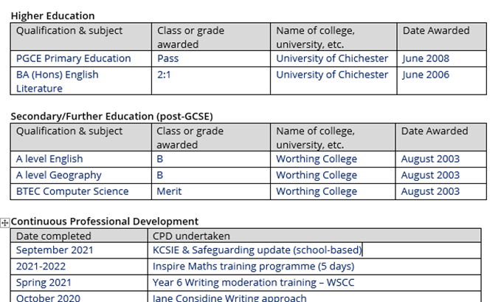
Section 3 – Experience
- When outlining your experience, please indicate which year groups have been taught in any employment or teaching practice placement. This should be in chronological order.
- It is important that the “Other Education and Employment” table is completed in full showing a full career history. If there are gaps for periods such as parental responsibilities or volunteer work, please include these with dates. An example table is shown:
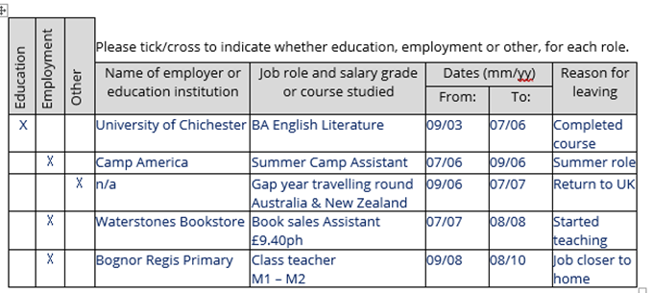
- For teachers completing their training, or with limited employment experience, teaching practices should be included to illustrate experience. An example table is shown:
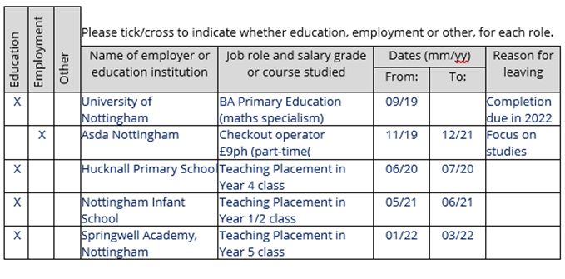
Supporting statement
Your supporting statement should be typed and submitted as a separate document, and should not exceed 1500 words. In writing it, you should pay close attention to the person specification provided with the post, and use examples of your experience to illustrate how you can meet the specification.

It is not necessary to repeat any of the information already included in your application form (such as listing school placements), but you may wish to draw attention to specific examples of your how your experience in different contexts shows how you meet the criteria.

Section 4 - References
Referees will be contacted before interview, so please ensure that you have discussed your application with your selected referees.
It is preferable for us to be able to email referees directly, so wherever possible please provide an email address.

Section 6 – Declaration
We prefer to receive applications submitted via email, along with supporting letters in a separate document. When sending an electronic file, candidates are asked to check the box to confirm their agreement with the declaration. If you are offered the post, you will be asked to check and sign your form in full to confirm that it is accurate.

Other questions
Our hope is to make the application process as clear as possible for all candidates, so that we ensure a fair field and are able to assess applications which show applicants strengths clearly.
If you have any queries about the supporting letter, the application form or any other part of the application process, please do not hesitate to contact the school office who will be glad to help, or will pass your request on to the headteacher for a response.

Thank you for taking the time to consider an application; we look forward to receiving it from you.

