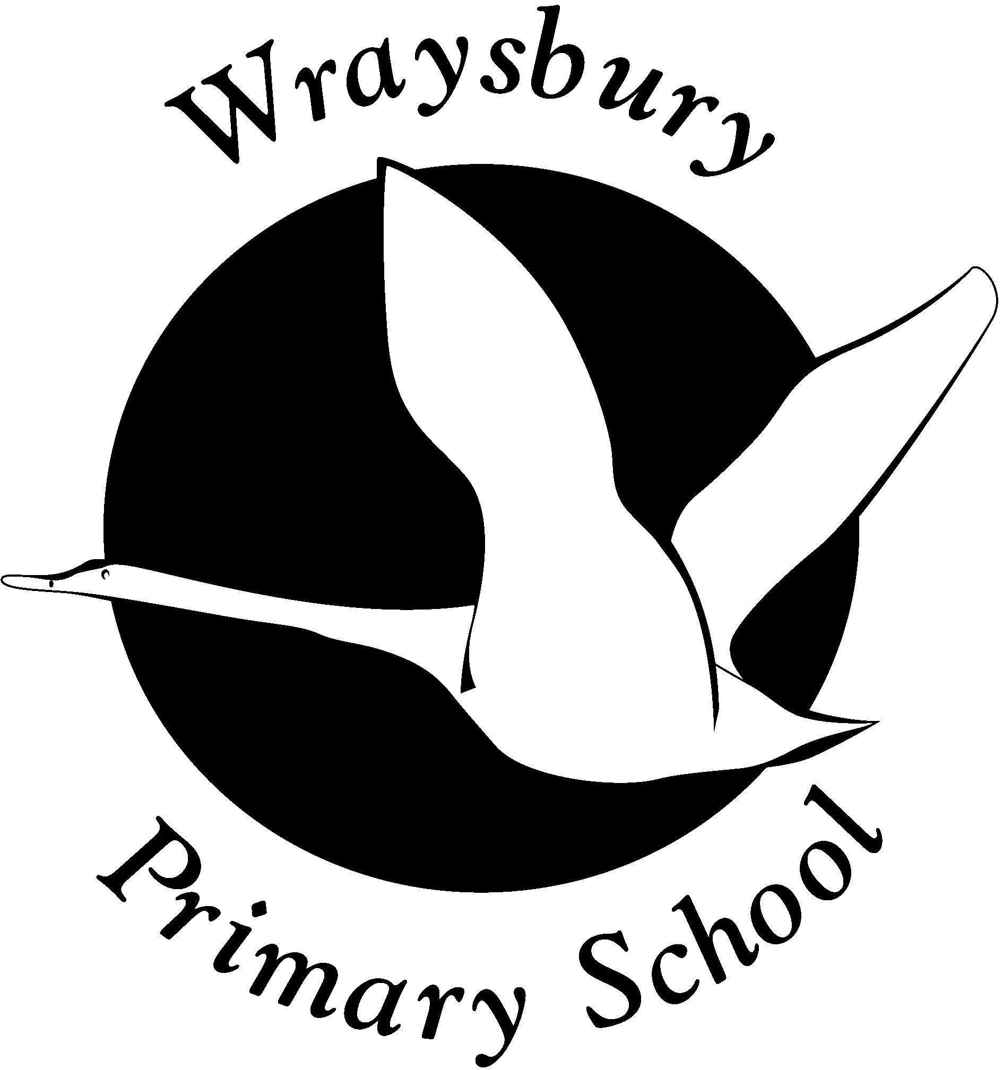

Wraysbury Primary School
Welley Road, Wraysbury, Staines TW19 5DJ
Phone: 01784 482603
E-mail: fin.wraysbury@rbwm.org.uk

Class Teacher for September 2021
(to start July 2021 would be an advantage)
MPS 1-6 (£25,543 - £37,152)

Are you looking for a supportive school to start your teaching career in or to develop your career further?
Wraysbury Primary School is a happy and fun place to work!

We are looking to appoint a class teacher in EYFS or KS1/2 for September 2021, however we are happy for a successful candidate to start in July 2021 and be paid through the summer holiday. Initially this will be a temporary one year appointment but with the possibility of becoming permanent.

We are looking for someone who:
- Is an excellent teacher
- Is passionate about children’s learning and every child achieving their potential
- Is innovative and creative in the indoor and outdoor learning environment
- Has a sense of humour

We can offer:
- Happy, friendly and hardworking children with high standards of behaviour
- A supportive mentor/phase leader and helpful teachers and teaching assistants to work alongside
- Very supportive parents and governors
- A very well equipped computing suite and outdoor swimming pool
- Refurbished classrooms
- A fabulous Eco-area
- A commitment to help you develop professionally (with lots of support in the first few months!)
- A school rated “Good” by Ofsted in September 2017.

To request an application pack please contact Mrs Saundh, School Bursar, on the above mailbox. Informal (socially distanced) visits are warmly welcomed, please contact the school to make an appointment with the Headteacher.

Closing date for applications is 12.00 midday, Monday 15th March 2021 however, applications will be considered upon receipt.

The school is committed to safeguarding and promoting the wellbeing of children. This post is subject to an Enhanced Criminal Records check for the successful candidate.

