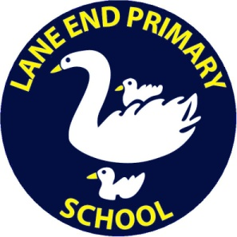
LANE END PRIMARY SCHOOL

PERSON SPECIFICATION: CLASS TEACHER

 | Essential |  | Desirable
Qualifications | - Must hold Qualified Teacher Status |  | - Evidence of continuous INSET and commitment to further professional development
Experience | - Successful primary school teaching experience or evidence of successful completion of primary school initial teacher training  - Experience of teaching within KS1 or KS2 |  | - Experience of teaching across the primary age range  - Experience of working in partnership with parents
Knowledge & Understanding | The applicant must have knowledge and understanding of:  - The theory and practice needed to provide effectively for the needs of all children  - A range of appropriate strategies for learning and teaching, including use of ICT and behaviour management  - Statutory National Curriculum requirements at the appropriate key stage including how to deliver the National Curriculum in a creative way, taking into account children’s interests and needs  - The monitoring, assessment, recording and reporting of pupil’s progress |  | In addition, the applicant might also have knowledge and understanding of:  - Preparation and administration of statutory National Curriculum tests
Skills & Abilities | The applicant will be able to:  - Commit to the school’s safeguarding procedures and policy  - Teach creatively to a high standard to inspire and challenge all pupils  - Relate to and motivate pupils well  - Demonstrate good classroom management  - Create a stimulating and effective learning environment  - Contribute positively to and promote the school’s mission statement, aims and ethos  - Work well within and contribute to team development  - Establish and develop good relationships with parents, governors and the wider community  - Seek advice and support where necessary  - Be supportive of and promote equality and diversity | - Offer an extracurricular activity  - Offer expertise, interest or have a specialism in Computing and/or D&T
Personal Characteristics | - Enthusiastic  - Works well in a team  - Has flexibility, sensitivity and understanding  - Organised

