[

# Geoffrey Field Infant School

Exbourne Road, Reading, RG2 8RH

Telephone: 0118 937 5473

Headteacher: Miss Z Dean

Email: [admin@geoffreyfieldinfant.reading.sch.uk](mailto:admin@geoffreyfieldinfant.reading.sch.uk)

[*www.geoffreyfieldinfant.co.uk*](http://www.geoffreyfieldinfant.co.uk)

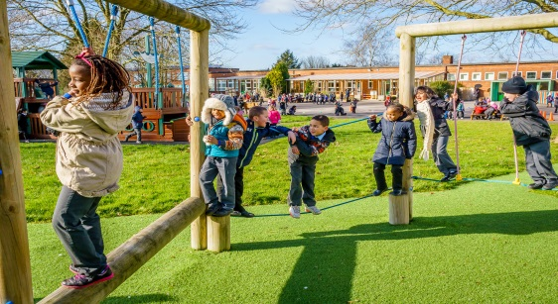 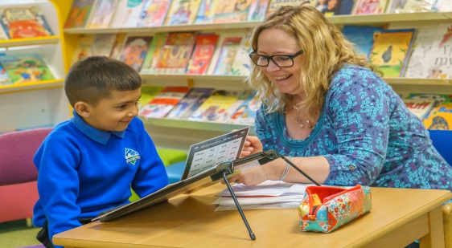

**CLASS TEACHER**

**Required for September 2021**

**Salary Scale: MPR/UPR**

Applications are invited from both NQT/ECTs and experienced teachers

**Are you interested in…?**

* friendly and enthusiastic children who are well behaved and ready to learn
* a well-resourced school with extremely attractive grounds
* key opportunities for professional/personal development including 1:1 coaching and mentoring
* working collaboratively with friendly and supportive colleagues
* adding to the further development of the school

We are a 3 form entry school with 10 classes, including a Nursery class, and 47 staff. Our current NOR is 320.

The school is organised into 3 teaching and learning teams – Foundation Stage, Year 1 and Year 2. Each team has at least 3 teachers plus a number of highly trained support staff.

The school is part of the extremely successful Whitley Excellence Cluster.

If you want to know more about our school please watch *our video* on the school website**: www.geoffreyfieldinfant.co.uk**

Visits to the school can be arranged.

*For an application pack please email* [*admin@geoffreyfieldinfant.reading.sch.uk*](mailto:admin@geoffreyfieldinfant.reading.sch.uk) *or phone 0118 9375473 or download via the school website* ***www.geoffreyfieldinfant.co.uk.***

**CLOSING DATE: Friday 14th May at 12 noon**

**SHORTLISTING: Monday 17th May**

**INTERVIEW DATE: Monday 24th May**

Please do not send a CV. For the purposes of Equal Opportunities we can only accept Reading Borough application forms.

This School is committed to safeguarding and promoting the welfare of children and young people and expects all staff and volunteers to share this commitment. An Enhanced DBS check will be sought from the successful candidates.