





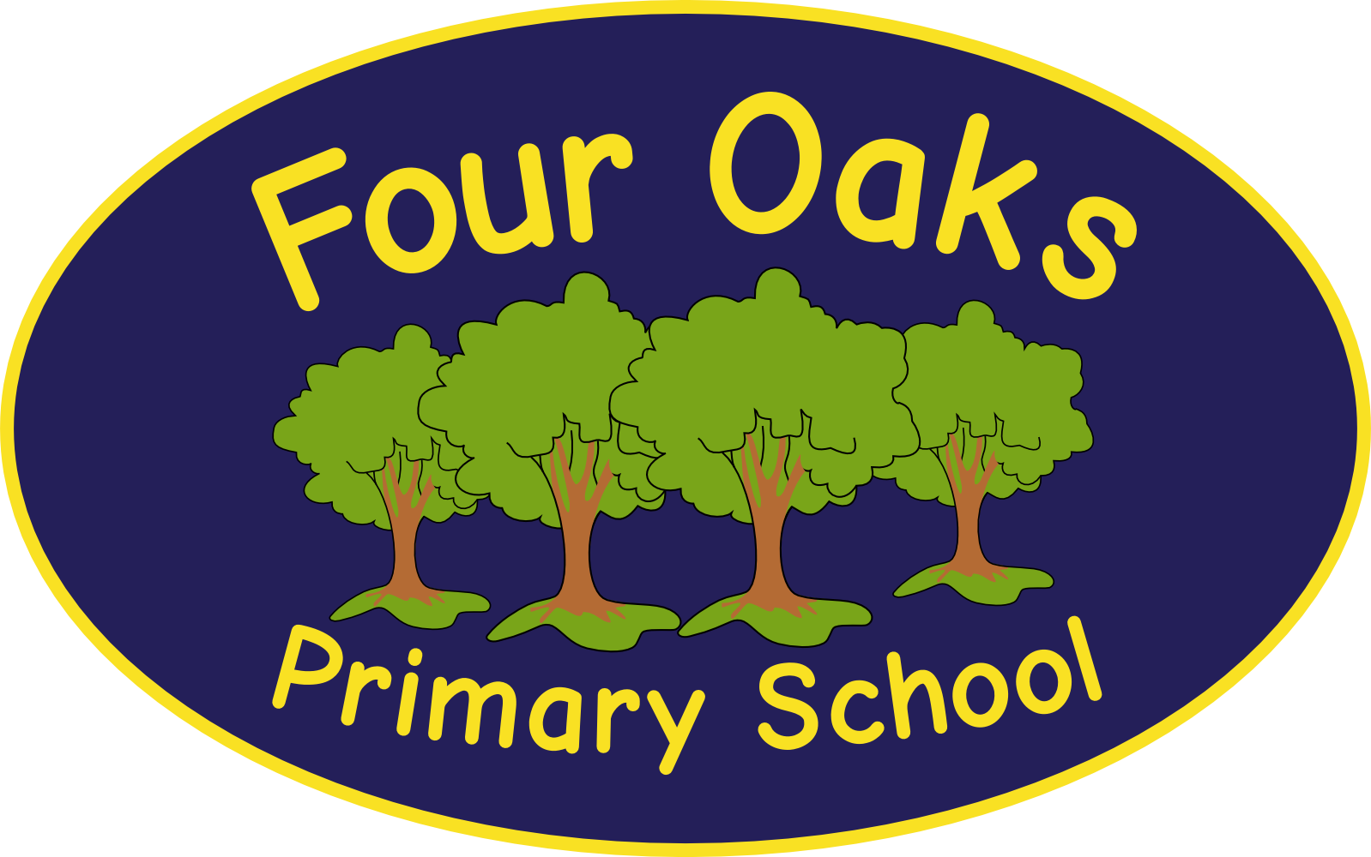

Headteacher: Mrs S Robinson B.A.(Ed) M.Ed. NPQH

39 Davy Street
Liverpool L5 1XP
Telephone: (0151) 263 4038
Fax: (0151) 260 7257
Email: office@fouroaksprimary.com
Website: www.fouroaksprimary.co.uk

4th May, 2022
Teacher

A range of posts available to include:
Full-time, permanent: EYFS, KS1, KS2.
Full-time, 1 year fixed term: EYFS, KS1, KS2.

Four Oaks is an inclusive primary school, with high aspirations for all. We have happy, extremely well-behaved children and supportive, dedicated staff and governors, catering for pupils from 1 to 11 years old.

Our school has received a prestigious SCALA architects’ award. It is a modern build with beautiful, well equipped classrooms and state of the art facilities including an interactive 4D classroom. It is surrounded by landscaped grounds with many facilities for the children. Visitors to our school always comment on the happy, enthusiastic children who demonstrate exceptional behaviour.

The Governors wish to appoint a teacher to join our team. We have flexibility regarding which year group you join. You should make it clear on your application form which Key Stage(s) or year group(s) you prefer. You must have consistently strong feedback on your teaching. You will be joining an EYFS, Key Stage One or Key Stage Two Phase team who work well together and who are dedicated to providing the very best education to our children. The governors invest in high levels of CPD for all teaching colleagues.

We have both permanent posts available and 1 year fixed term teaching posts. The temporary posts are to continue implementing the next phase of our recovery curriculum and may be extended.

Closing date: Monday 6th June

Application should be returned to applications@fouroaksprimary.com

Four Oaks Primary School is committed to safeguarding the welfare of young people and expects all staff and volunteers to share this commitment. All appointments are subject to enhanced DBS checks and excellent references.

NB Please only submit one application form even if you are applying for more than one Key Stage post. Please make it clear on the application form which is your preferred Key Stage(s).

NB This is a re-advertisement to extend the closing date, there is no need to reapply.

