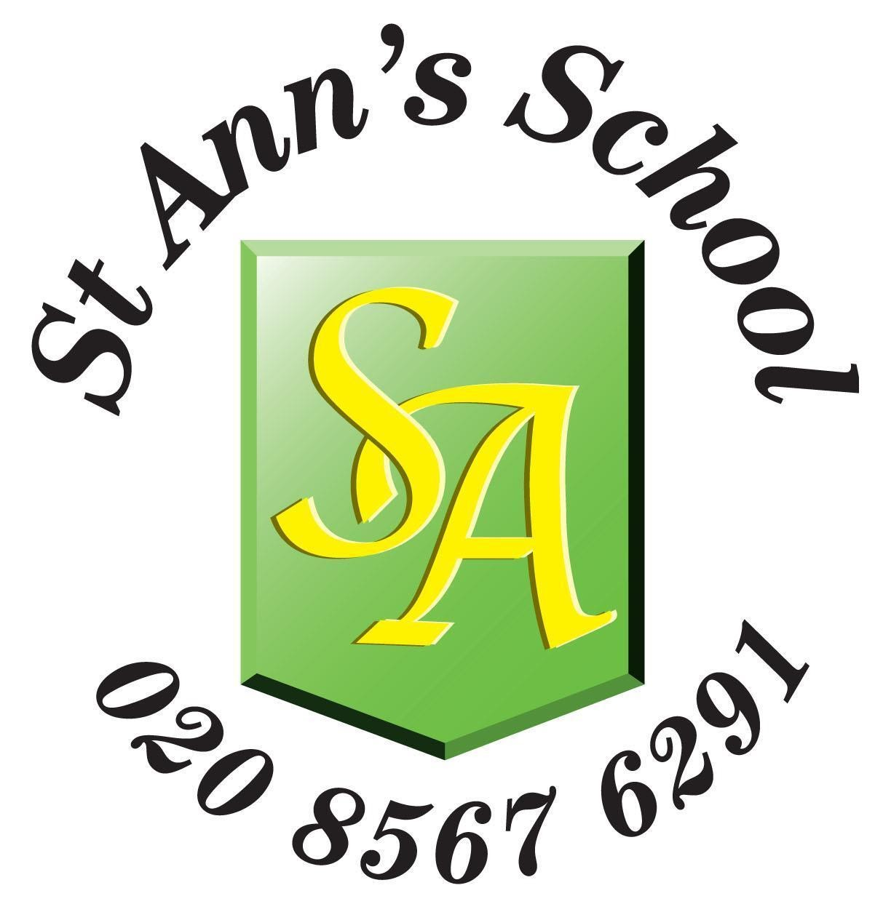 **St Ann’s School**

Springfield Rd

W73JP

020 8567 6291

*hr@st-anns.ealing.sch.uk*

*www.stannsschool.co.uk*

### **Head Teacher: Mr. Timmy Holdsworth**

OCTOBER 2024

Dear Applicant

Thank you for your interest and request for an application pack for the post of Class Teacher at St. Ann’s School.

I enclose an application form, a job description and a person specification.

**Please ensure that when writing your supporting statement you address all the Person Specification points individually:**

**Please make your responses very clear by numbering each point in line with the Person Specification.**

**Your statement will be used by the selection panel to compose the short list, and if you do not address each of the points on the person specification you will not be called for interview.**

Short listing will take place on or before Tuesday 5th November and applicants called for interview will be contacted on that date. If you have not heard from us by the end of Tuesday 5th November 2024, please assume that on this occasion you have not been successful.

A group visit for applicants has been organised on Thursday 24th October 2025, from 10.00 – 11.00am. Attending this visit is strongly recommended although it is not part of the interview process. Please email the school office to confirm that you would like to attend this visit:

hr@st-anns.ealing.sch.uk

Interviews will take place on Thursday 7th November 2024. The schedule for interviews is as follows and applicants must be available to take part all day on 07.11.2024.

**Schedule for interview day on Thursday 7th November:**

8.45am: arrival time / sign in at Reception

9.00 -10.00: Written task

10.15-11.15: Class based session – 20 minutes in class per candidate, which includes five minutes of preparation before.

11.30 onwards: Formal Interviews

Interview times will be advised to applicants who have been selected to take part in the formal interviews following the class based and written task sessions.

I look forward to receiving your completed application form, which must reach school by midday on Friday 1st November, 2024. Please email your completed application form to:

hr@st-anns.ealing.sch.uk.

Yours faithfully

Timmy Holdsworth

Head Teacher.

  