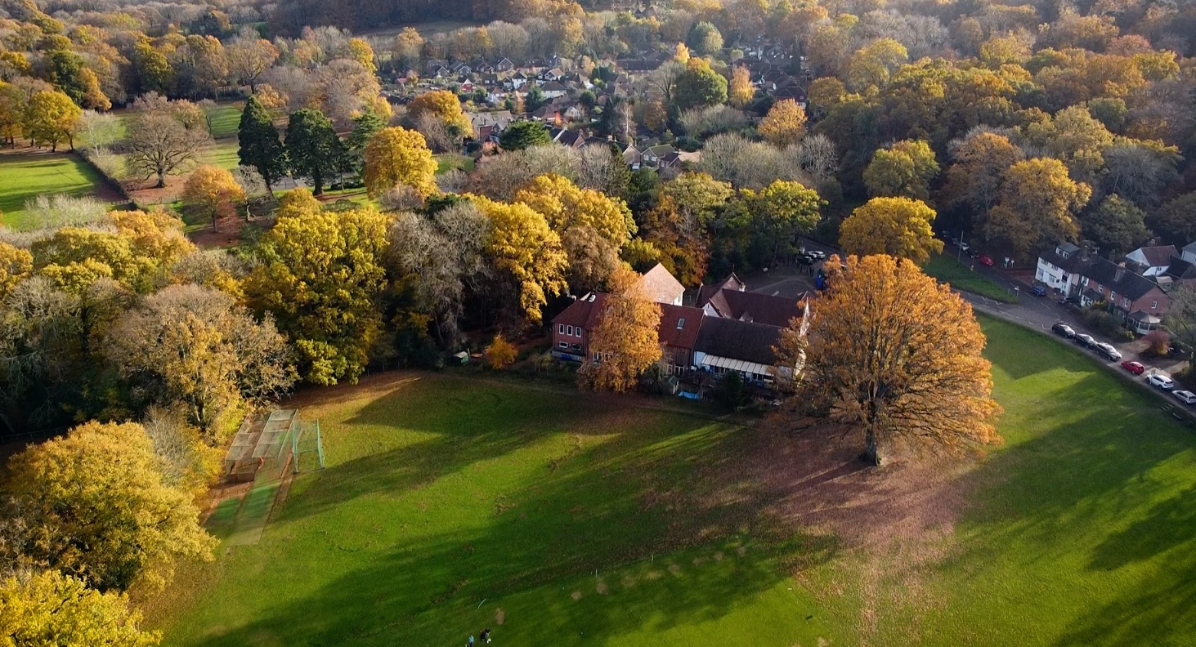

Email: [sbm@grayswood.surrey.sch.uk](mailto:sbm@grayswood.surrey.sch.uk)

**Class Teacher**

**Full time**

**September 2025**

**ECTs welcome to apply**

# **Class Teacher**

**Our vision:**

***'Love one another as I have loved you'***

***(John 15:12)***

*Everybody at Grayswood Church of England Primary School is nurtured and loved as a unique child of God. Growing together through* ***perseverance*** *and* ***teamwork****, we learn to* **love** *and* ***forgive*** *with* ***kindness*** *and* ***respect****. As we flourish, we embrace the future with hope, confidence and positivity.*

Welcome to Grayswood CofE Primary School!

We are fortunate to be situated in an idyllic rural setting and have strong links to the local church. Our school is at the heart of the community.

We are so proud of our school and have an excellent reputation in the local area. The children at Grayswood are friendly, engaged and well-behaved. They are keen to learn and have strong positive relationships with staff. Parents are supportive of the school and often come in to help in class, on trips and at Forest School.

Our dedicated staff team work collaboratively and creatively to provide exciting learning opportunities for all children. We have high aspirations and achieve very strong results across the school.

We are looking for an enthusiastic Class Teacher to join our staff team from September 2025; someone to inspire our children, an excellent communicator with good interpersonal skills and a sense of fun!

Please do take a moment to visit our website, where you will be able to view our welcome video under the admissions tab. We hope this will give you a good insight into our lovely village school, but we would also love to meet you so do phone the office to arrange a convenient time for you to visit.

**Our school is committed to safeguarding and promoting the welfare of children and young people and expects all staff and volunteers to share this commitment. The successful applicant will be required to undertake an Enhance Disclosure via a DSB check prior to appointment.**

**Recruitment process:**

* Your completed application form must be submitted online by **Thursday 27th March 2025.** In your supporting statement please tell us about your relevant experience and what you feel you can bring to Grayswood School.
* Shortlisting will be on Friday 28th March 2025.
* Interviews will be held on Wednesday 2nd and Thursday 3rd April 2025.
* References will be requested before the interview.



**Job Description – Class Teacher**

**Salary:** Main Pay Scale

**Hours:** Full time

**Contract type:** Permanent

**Reporting to:** Headteacher

**Responsible for:** Learning Support Assistant

**Main purpose**

**The teacher will:**

* Fulfil the professional responsibilities of a teacher, as set out in the School Teachers’ Pay and Conditions Document
* Meet the expectations set out in the Teachers’ Standards
* To coordinate a subject across the school (depending on experience)

# **Duties and responsibilities**

Teaching

* Plan and teach well-structured lessons to assigned classes, following the school’s plans, curriculum and schemes of work
* Assess, monitor, record and report on the learning needs, progress and achievements of assigned pupils, making accurate and productive use of assessment
* Adapt teaching to respond to the strengths and needs of pupils
* Set high expectations which inspire, motivate and challenge pupils
* Promote good progress and outcomes by pupils
* Demonstrate good subject and curriculum knowledge
* Participate in arrangements for preparing pupils for statutory assessments

**Whole-school organisation, strategy and development**

* Contribute to the development, implementation and evaluation of the school’s policies, practices and procedures, so as to support the school’s vision and values
* Make a positive contribution to the wider life and ethos of the school
* Work with others on curriculum and pupil development to secure co-ordinated outcomes
* Provide cover, in the unforeseen circumstance that another teacher is unable to teach

**Health, safety and discipline**

* Promote the safety and wellbeing of pupils
* Maintain good order and discipline among pupils, managing behaviour effectively to ensure a good and safe learning environment

**Professional development**

* Take part in the school’s appraisal procedures
* Take part in further training and development in order to improve own teaching
* Take part in the appraisal and professional development of others, where appropriate

**Communication**

* Communicate effectively with pupils, parents and carers and attend parents’ evenings

**Working with colleagues and other relevant professionals**

* Collaborate and work with colleagues and other relevant professionals within and beyond the school
* Develop effective professional relationships with colleagues

**Personal and professional conduct**

* Uphold public trust in the profession and maintain high standards of ethics and behaviour, within and outside school
* Have proper and professional regard for the ethos, policies and practices of the school, and maintain high standards of attendance and punctuality
* Understand and act within the statutory frameworks setting out their professional duties and responsibilities

**Management of staff and resources**

* Direct and supervise support staff assigned to them, and where appropriate, other teachers
* Contribute to the professional development of other teachers and support staff
* Deploy resources delegated to them

Safeguarding

* Work in line with statutory safeguarding guidance (e.g. Keeping Children Safe in Education, Prevent) and our safeguarding and child protection policies
* Work with the designated safeguarding lead (DSL) to promote the best interests of pupils, including sharing concerns where necessary
* Promote the safeguarding of all pupils in the school

**Other**

* To attend and lead assemblies
* To take a leadership role in the co-ordination and teaching of a subject area across the school

Please note that this is illustrative of the general nature and level of responsibility of the role. It is not a comprehensive list of all tasks that the teacher will carry out. The postholder may be required to do other duties appropriate to the level of the role, as directed by the headteacher or line manager.



**Person specification – Class Teacher**

The successful candidate will possess *most or all* of the following skills, attributes and knowledge. The school provides a supportive environment and our success is based upon the quality of teamwork and personnel already working here. Therefore, we are looking for someone with good personal skills and attributes to enhance our team.

|  |  |
| --- | --- |
| **Qualifications** | * Educated to a degree level * Qualified Teacher Status * Maths and English GCSE (or equivalent) - grade C/4 or above |
| **Experience** | * Evidence of effectiveness as a teacher within the primary age range * Evidence of good or outstanding lesson observations * Evidence of good behaviour management skills * Experience of teaching children with SEND * Expertise to use ICT to enhance and enrich the curriculum * Has worked as part of a staff team e.g. collaborative planning, leading curriculum area |
| **Knowledge** | * Sound understanding of the National and EYFS Curriculum * Knowledge of effective teaching and learning strategies which motivate children and promote purposeful learning and progress * A good understanding of how children learn * Ability to build effective working relationships with pupils * Knowledge of providing child-centred education and first-hand experiences to enthuse learners * Knowledge of how to establish a secure, stimulating learning environment * Knowledge of effective behaviour management strategies * Ability to adapt teaching and learning to meet all pupils’ needs * Clear understanding of safeguarding children in education |
| **Skills** | * Effective skills in planning, teaching, assessing and target setting * Ability to assess the rates of progress of individual pupils and maintain appropriate records * Ability to promote consistent positive behaviour management * Understanding of use of data analysis in ensuring children progress * Ability to work as a team, sharing ideas and expertise * Is well organised and committed to participation in all school activities * Has the ability to seek, listen to and act upon advice * Has well-developed oral and written communication skills * Ability to relate well to parents and encourage their participation in the education process * Good ICT skills |
| **Personal Attributes** | * High expectations for children’s attainment and progress * Able to make warm open relationships with children and adults * Is an enthusiastic and energetic teacher with a sense of fun * Has a good sense of humour and team spirit * Is adaptable and has a positive approach to change * Supportive to the ethos of a church school * Committed to providing equality of opportunity and inclusion * Committed to promoting the ethos and values of the school * Committed to personal professional development * Ability to work under pressure and prioritise effectively * Commitment to maintaining confidentiality at all times |
| **Leadership** | * Ability to lead the coordination and development of one subject area |