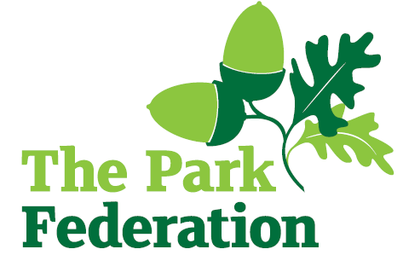
Class Teacher

Salary (actual): £30,000 - £46,525
Grade: MPS - UPS
Hours: Full time
Contract: Fixed Term – end date 30th April 2025
Start: October 2024

Hannah Ball School is a one form entry primary school in the heart of High Wycombe. Our small and friendly school serves a diverse community and offers a broad, balanced and evolving curriculum. We are a reflective and forward thinking school with a hardworking and dedicated team of staff, fantastic children and supportive governing body. We have close links with neighbouring primary schools and we actively encourage shared good practice, with an emphasis on high quality continuing professional development.

We are seeking to appoint enthusiastic professionals, who has high expectations of themselves and their pupils and is committed to improving the lives of our children to join our warm and welcoming team. Our partnership with The Park Federation Academy Trust means there are a host of professional development opportunities that will further your own skills, knowledge and expertise.

We are looking for an individual who:
● has experience of working within an all-through primary school
● is resilient, positive and have a good sense of humour
● is ambitious and determined to succeed and secure positive outcomes for our pupils
● makes a positive contribution to our school’s improvement
● has outstanding behaviour management skills
● has high levels of drive, energy and integrity
● put the children at the heart of all they do
● is highly motivated and able to demonstrate excellent classroom

For the right candidate, we will offer
- extensive support and CPD;
- the opportunity to work with other professional colleagues across the Multi-Academy Trust;
- a welcoming school, with friendly, enthusiastic and supportive staff team;
- an ambitious and dynamic Senior Leadership Team;
- a dedicated Governing Body;
- supportive parents and children who are keen to learn;
- an employee assistance programme (EAP).

We warmly welcome candidates coming to visit the school prior to application; please contact the school to arrange. Please visit the school website for an application pack. We do not accept CV’s.

Closing Date: As and when we receive successful applications.

The school is committed to safeguarding and promoting the welfare of children and young people and expect all staff and volunteers to share this commitment. The successful applicant will be required to undertake an Enhanced DBS Check with a check of the DBS Barred List.

