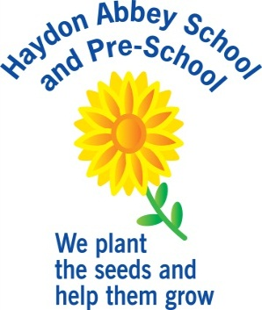

Class Teacher Haydon Abbey School and Pre-school

# Person specification

|  |  |
| --- | --- |
| Criteria | Qualities |
| **Qualifications and experience** | * Qualified teacher Degree * Evidence of outstanding primary teaching / Early Years practice depending on position * Evidence of ongoing professional development * Experience of teaching in KS2 |
| **Skills and knowledge** | * Knowledge of the National Curriculum / Early Years Foundation Stage * Knowledge of effective teaching and learning strategies * A good understanding of how children learn * Ability to adapt teaching to meet pupils’ needs * Ability to build effective working relationships with pupils * Knowledge of guidance and requirements around safeguarding children * Knowledge of effective behaviour management strategies * Good ICT skills, particularly using ICT to support learning |
| **Personal qualities** | * A commitment to getting the best outcomes for all pupils and promoting the ethos and values of the school * High expectations for children’s attainment and progress * Ability to work under pressure and prioritise effectively * Commitment to maintaining confidentiality at all times * Commitment to safeguarding and equality * Ability to work collaboratively |