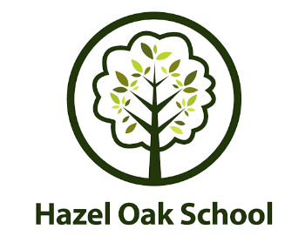 | 

Hazel Oak School - Class Teacher Vacancy

Full time, permanent - required for January 2021
MPS/UPS + SEN1
Community Respect Wellbeing Growth Creativity

- Are you ready for a new challenge?
- Are you passionate about supporting pupils who have Special Educational Needs?
- Can you bring innovation to special education?
- Do you thrive on bringing the curriculum to life with real experiences?
- Would you like to work where growth and opportunity are valued and supported?

We are seeking to appoint a full-time teacher at this popular and successful, all-age special school. This is a great opportunity to join this dynamic team of practitioners to deliver excellent teaching and learning in an environment where you can continue to grow professionally.

You will be required to deliver the full curriculum and adapt your teaching to suit the needs of our broad range of learners. The post is within our primary department with mixed age students. Over 50% learners at Hazel Oak have a diagnosis of Autism, so a working knowledge of how this impacts on teaching and learning would be a valuable asset.

Hazel Oak is a school for moderate learning difficulties with a diverse community of additional needs which also includes ADHD, Down Syndrome, social, emotional and mental health, speech, language and communication difficulties, plus more complex and medical needs. Communication, wellbeing, life skills and the functional use of core skills are central to our curriculum, which is delivered in a challenged based, blended approach.

The successful applicant will also have opportunities to develop their pedagogy through collaborative team working to create inspiring learning through bespoke experiences for all learners. The primary teaching model works across key stages 1 to 3 and the same collaborative approach is applied to accreditation teaching and learning in key stages 4 and 5. Whilst staff are based with a class group, they may be required to work across the age ranges.

We are an outstanding School, where staff are fully involved in the school’s development and have access to regular training, peer and wellbeing support. Teachers receive group planning time to support the delivery of our exciting, life-ready curriculum.

Our vision: Having fun, discovering our place in the world, building relationships and overcoming challenges. Learning about life beyond the classroom to shape a successful future.

This is your chance to be a part of something special.
Come and see what you’ve been missing.
Email the school office at office@hazel-oak.solihull.sch.uk for further details or to arrange a visit.
www.hazel-oak.co.uk “Reaching for the Stars”

Closing date for applications is 9am on Tuesday 5th October 2021
Interviews will take place on Thursday 14th & Friday 15th October 2021
Hazel Oak School is committed to safeguarding and promoting the welfare of children and expects all staff and volunteers to share this commitment. This post is subject to an enhanced DBS disclosure and Safer Recruitment checks.

