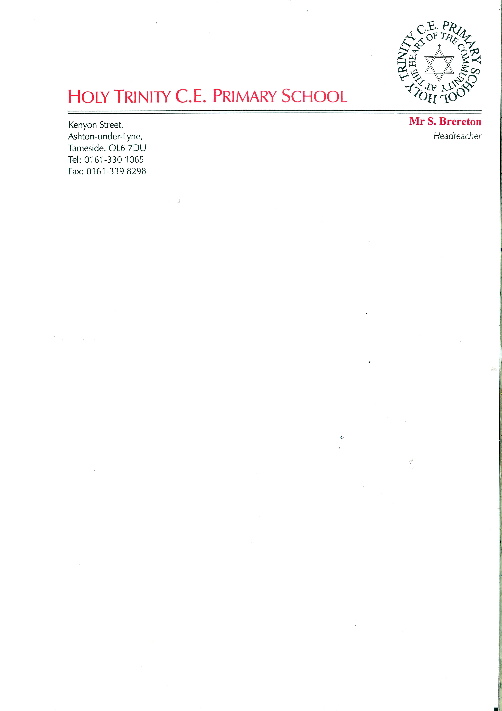
Email: simon.brereton@holytrinity.tameside.sch.uk

Year 2 Class teacher required for September 2022
Suitable for a ECT or recently qualified
Permanent and Full Time

“What does the Lord require of you but to do justice, to love kindness and to walk humbly with your God" Micah 6:8

The Governors are looking to appoint an excellent class teacher who wants the opportunity to develop their skills within a supportive environment.

The successful candidate will
- Be an effective communicator
- Be enthusiastic and ready to show initiative
- Be committed to supporting the schools vision, values and ethos
- Have an understanding of teaching children from a wide range of backgrounds and abilities

What we offer:
- A thorough and comprehensive induction process
- A caring and supportive whole staff team
- Happy and enthusiastic children who are ready to learn
- Parents who want to engage with the school
- A genuine and proven commitment to developing teachers

If you would like more details on this position please contact the Head Teacher on the above number.

Closing date for applications: Wednesday 15th June
Interviews and lesson observations: Friday 24th June

Forms are available from the school office or in the jobs section of the school website

The Governors and staff of Holy Trinity Primary are committed to safeguarding and promoting the welfare of our children. As such, this role is subject to an enhanced DBS check.

