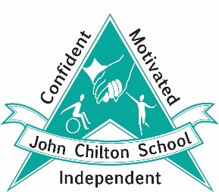
John Chilton School
Bengarth Road
Northolt
UB5 5LD

Tel 0208 289 4790

Class Teacher (Main Scale 1-6 dependant on experience £34,502 - £44,756 PA)
Plus, special needs allowance £2,384 PA
Start date: September 2023

John Chilton School is a special school judged as Good with Outstanding aspects (OFSTED November 2018) for pupils aged 4 to 19 years, with cognitive difficulties with or without a physical or medical need. Applications are invited from excellent teachers who have an interest in working with pupils with special needs; NQTs are welcome to apply.

John Chilton School is based across two sites The successful applicant must be able to commit to working at both sites as required.

Responsibilities include:
- teaching and having a pastoral responsibility for a small group of pupils with moderate to severe learning difficulties, physical or medical needs or SEMH difficulties;
Required:
- some experience of working with pupils with special educational needs;
- commitment to pupil learning and your own CPD;
- high expectations and determination to raise standards;
- excellent communication and team work skills;
- the ability to work closely with parents, outside agencies and the wider community.
We offer:
- a fantastic school where everyone is valued;
- the opportunity to develop skills and experience with personalised opportunities for continuing professional development;
- excellent facilities, resources and job satisfaction within a supportive environment;
- support from colleagues and a leadership team dedicated to success.

The school is committed to providing equal opportunities for all. Candidates are welcome to visit the school. Please contact Debbie Frailing, School Business Manager to arrange a suitable date and time.
We are committed to safer recruitment, safeguarding and promoting the welfare of children and young people and expect all staff and volunteers to share this commitment. The successful applicant will be required to apply for an Enhanced Disclosure from the Disclosure & Barring Service (DBS). Further information can be found at: https://www.gov.uk/government/collections/dbs-checking-service-guidance--2
Candidates who have lived or worked abroad may require an overseas police check and may be asked to provide a good conduct certificate. Further information can be found at www.gov.uk

Closing date: Applications to be submitted to the school by Monday 5 June 2023, noon
Interviews: week beginning Monday 12 June 2023

How to apply:
An application pack is available from the school website: www.john-chilton.ealing.sch.uk
Completed application forms to be returned to Debbie Frailing, School Business Manager finance@john-chilton.ealing.sch.uk

