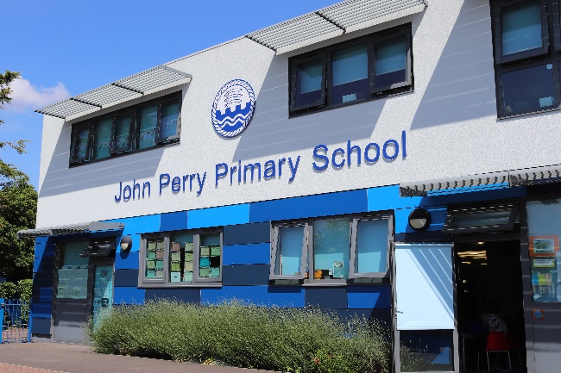
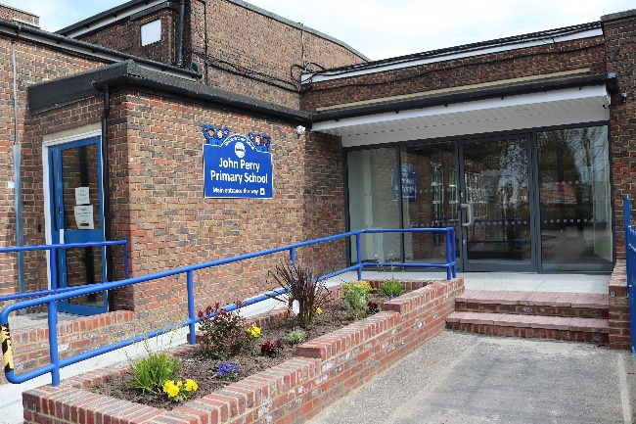
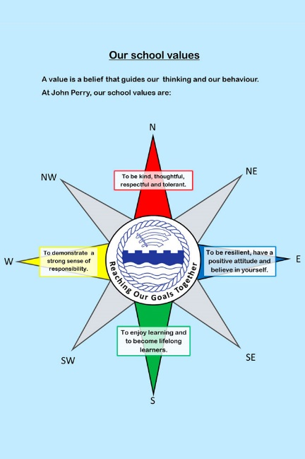
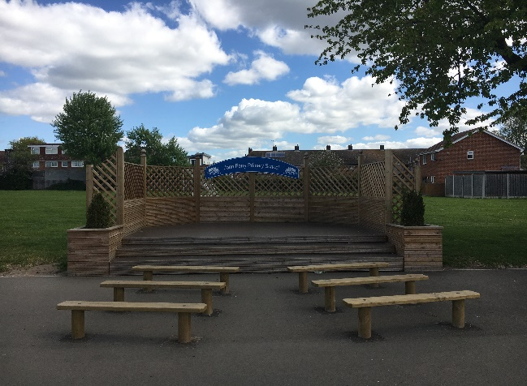
CONTENTS
- Welcome
- What we offer
- What we are looking for
- How to apply
- Job description & person specification
John Perry Primary School
Charles Road
Dagenham
Essex RM10 8UR
020 8270 4622
office@johnperry.bardaglea.org.uk
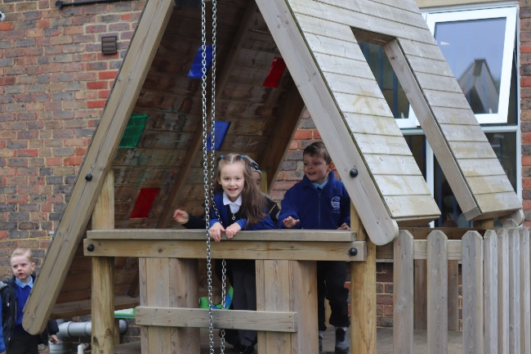
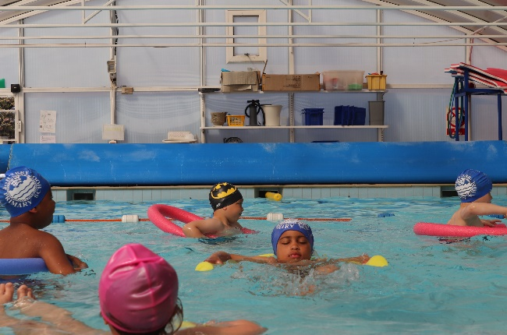
CLASS TEACHER APPLICATION PACK
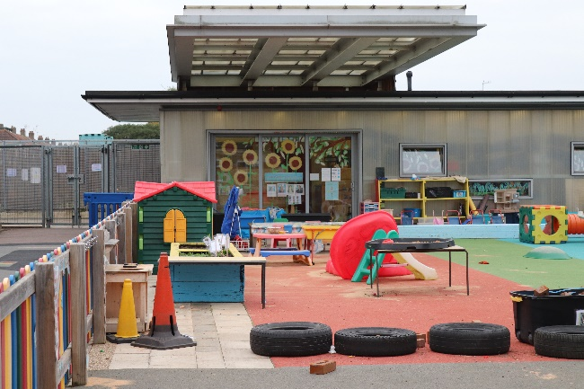
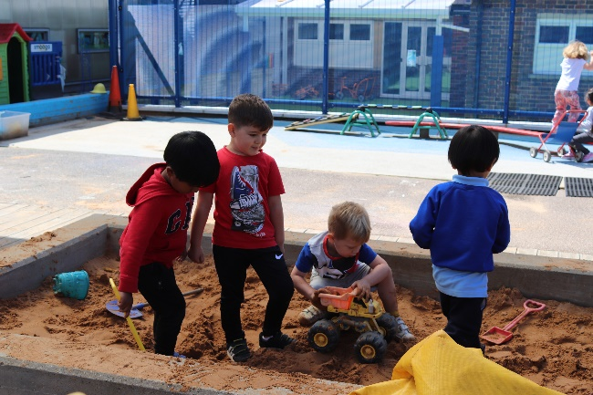
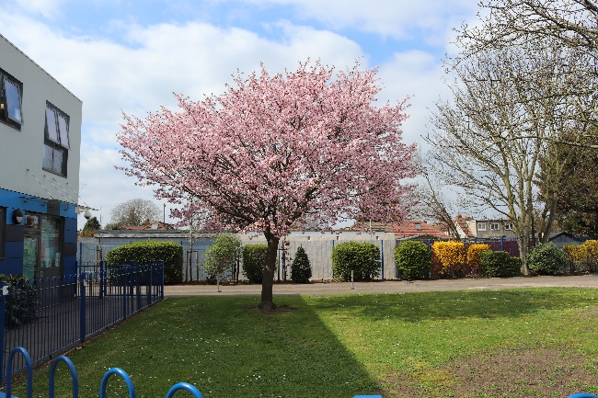
Dear Applicant,

Thank you for your interest for the position of Class Teacher at John Perry Primary School. I hope that you will find this information pack helpful. If after reading this you have any questions, we will be happy to answer these. Please visit our website for additional individual information. We also encourage visits to our school. Come and see our curriculum in action and meet our friendly, confident children and professional school staff.

You will find John Perry to be a vibrant and rewarding place to teach. Comments from our most recent Ofsted inspection (December 2018) show that:
- The school provides a safe and secure environment for pupils.
- Pupils are rightly proud of their school, enjoy positive relationships with their teachers and make good progress.
- Pupils are extremely welcoming to visitors to the school and are keen to talk about their learning.
- As response to feedback, one parent wrote, ‘I don’t have a single negative thing to say about this school. My children adore this school, as do I.’

We are a 3-form entry school. We have an Ofsted rating of ‘Good’ (December 2018) and have been praised for our inclusive work in our Additional Resource Provision (ARP).

Our school is situated in Dagenham, within easy transport links into and out of Central London. A five minute walk will get you to Dagenham East Tube station on the District Line. We offer free onsite parking for all our staff.

We aim to ensure that every child succeeds to the best of their ability and receives a broad and balanced education which fosters a love of learning for life. Creativity, inclusion and great learning are what we promote and deliver. We are committed to continuous improvement and developing a sense of shared purpose across our school community. We have achieved broader success including the Music Award, Healthy School Gold Status and National Primary Science Quality Mark Bronze certification. We also enjoy links with the Royal Ballet School. Our School is very well resourced with specialist music teachers, Smart boards in every classroom with iPads and laptops for every year group. We benefit from our onsite IT technician, so no time is wasted on troubleshooting. Children benefit from our heated swimming pool, two very large playgrounds, two large grass playing fields, as well as separate outdoor Nursery and Reception learning areas and raised vegetable gardens. Children enjoy freshly cooked lunches with a wide variety of healthy options, prepared by our highly trained catering staff.

We work in close partnership with primary and secondary schools in our immediate community of Dagenham. We provide training, support and career opportunities to teachers at all stages of career progression, from ECF teachers, to Subject Leads through to Middle and Senior Leaders. We are always looking to develop future leaders amongst our new recruits.

If you would like to be part of a diverse, creative and innovative staff team who is committed to make a difference to children’s lives, then our school is the place for you. We can offer you a career pathway with challenge and opportunity.
We look forward to hearing from you !
Wayne Pedro
Head Teacher
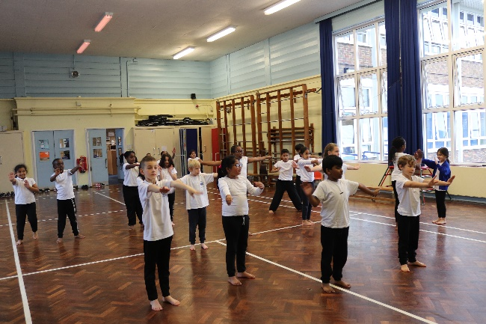
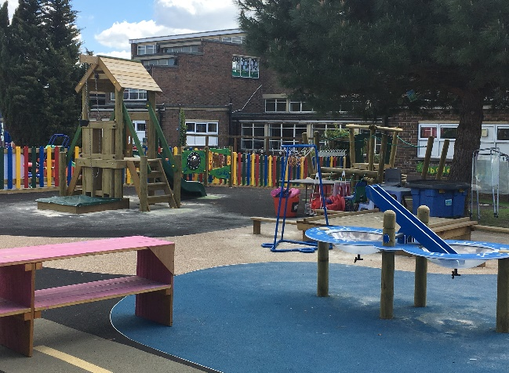

What we offer:

• A supportive, enthusiastic and inspiring team to grow and develop with.
• A vibrant, professional environment in which to work with a focus on the wellbeing of staff and children.
• Confident children with great attitudes to learning.
• Staff benefits such as high-quality professional development for all our staff, cycle to work scheme, childcare vouchers, partnership work with local schools and onsite parking facilities.
• Our dedicated support staff including Learning Support Assistants, IT Technician, Swimming Teacher, Business Manager, Administration, Premises and Catering Teams ensure that you are able to fully concentrate on teaching.
• Inner London weighting.
• A SLT who believes good staff wellbeing is essential for motivating staff and for promoting pupil wellbeing, progress and attainment.

We are looking for teachers who:

• Have excellent knowledge of the Primary National Curriculum.
• Can model exemplary practice and have a proven track record of impact on children’s achievement and wellbeing.
• Are self-reflective and have the desire to be the best they can be.
• Have a professional attitude, are great role models and really want to make a difference for children and families.
• Are great innovators who want to work with others to create exciting new learning opportunities for the children in their care.
• Are ambitious for themselves and their children and want to be school leaders of the future.

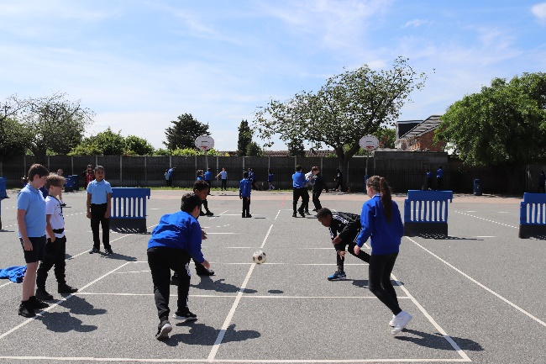
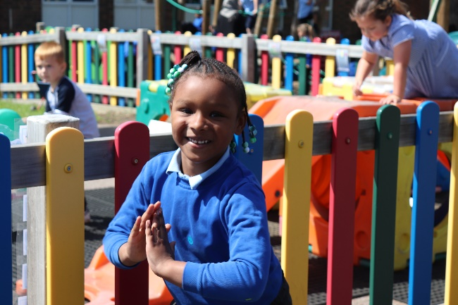
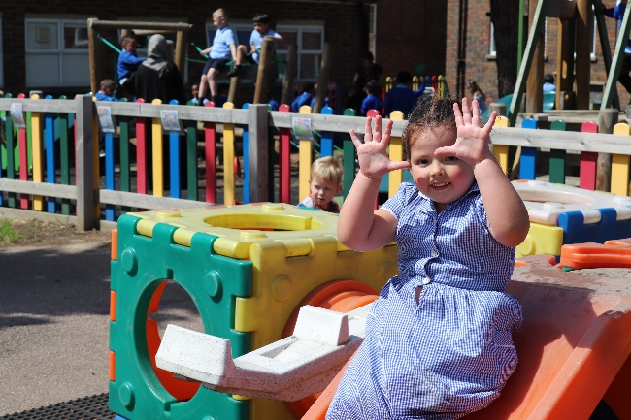
HOW TO APPLY
- Read the job description and person specification carefully.

- Complete the application form either electronically or print and complete by hand.

- Ensure supporting statement relates to the competencies outlined in the person specification.

- Email your completed application to: mhawkins@johnperry.bardaglea.org.uk or send it by post to:

Marc Hawkins
School Business Manager
John Perry Primary School
Charles Road
Dagenham
Essex RM10 8UR
Closing date for applications and shortlisting:
Wednesday 22nd March 2023 at 12:00 (midday)

Interview date: Tuesday 28th March 2023

We are committed to safeguarding and promoting the welfare of children and young people and expect all staff and volunteers to share this commitment. The successful candidate will be subject to clear reference checks and a DBS at enhanced level. We welcome applications from all sections of the community, regardless of gender, race, religion, disability, sexual orientation, or age.

Should you have any queries or would like to arrange to visit our school, please contact Marc Hawkins on 020 8270 4622 or email at mhawkins@johnperry.bardaglea.org.uk

We look forward to receiving your application.
CLASS TEACHER JOB DESCRIPTION

Grade: MPS
Main activities & responsibilities:
The current School Teachers’ Pay and Conditions document describes duties which are required to be undertaken by teachers in the course of their employment. In addition, certain particular duties are reasonably required to be exercised, and completed in a satisfactory manner. It is the contractual duty of the post holder to ensure that his/her professional duties are discharged effectively.

Essential Qualifications
- Educated to degree level
- Qualified Teacher Status

Experience
Will have had some experience of teaching in a multicultural inner city environment, ideally in more than one year group.

Particular Specific Responsibilities
- The post holder is responsible to their line manager for their duties, responsibilities and teaching tasks.
- The post holder will interact on a professional level with all colleagues and establish and maintain good working relationships which will promote the development and effective delivery of the school curriculum and maximise children’s achievement.
- The post holder will be responsible for the supervision of the work of support staff and any students who may be on teaching practice or work placement.
- The post holder undertakes the teaching of the pupils in their class and the associated pastoral and administrative duties in respect of those pupils as well as the general responsibilities in the school as agreed with the Head Teacher.

Other Responsibilities
Teachers will be expected to undertake duties of a similar nature as may be reasonably directed by the Head Teacher from time to time. The duties and responsibilities of the post may vary from time to time according to the changing needs of the school.

CLASS TEACHER PERSON SPECIFICATION

We expect all teachers to:
- Adhere to the school’s procedures and policies for the safeguarding of all children.
- Adhere to the Teaching Standards and our School Values.
- Ensure that the curriculum is adapted so that tasks and activities are matched to the ability of all children.
- Ensure careful and ongoing assessment of the pupils learning to inform further planning.
- Teach all pupils according to their educational needs and acknowledge that every lesson counts.
- Promote and encourage good behaviours for learning in line with the School’s Positive Behaviour Policy.
- Ensure that equal opportunities are implemented in the classroom and throughout the school.
- Have excellent organisational skills, ability to meet deadlines and ability to prioritise.
- Undertake continuous professional development.
- Be creative and use their own initiative.
- Develop interpersonal relationships with children and staff.
- Use praise and encouragement to create a well-ordered and secure environment that will ensure the educational wellbeing of all children.
- Make effective use of IT to enhance learning and teaching.
- Complete all assessments and records as determined by school policy in a timely fashion.
- Work with school leaders to track the progress of individual children and intervene where pupils are not making progress.
- Work with school leaders to complete and teach individual pupil plans where pupils have specific needs.
- Develop and maintain positive relationship with parents to involve them actively in their children’s education.
- Participate in planning and staff meetings.
- Contribute towards the development of the school and implementation of whole school policies.
- Contribute and co-operate with other staff and professional agencies as appropriate to the needs of the children.
- Undertake other duties which may be reasonably assigned by the Head Teacher to ensure the smooth running of the school.

