# **KS1 Class Teacher - Maternity Cover**

Candidate Information Pack

St Paul’s CE Primary



About Liverpool Diocesan Schools Trust

We believe

Jesus said, ‘Let the children come to me.’ (Mt 19).

We believe that we are fulfilling this command when we enable children of all faiths and none to flourish in our schools. The Liverpool Diocesan Schools Trust (LDST) has an important role to play in improving the attainment of pupils across the Diocesan region.

What is our Purpose?

**Working together with our school communities, providing an excellent education and life-enhancing relationships with the Christian faith and Jesus Christ.**

We do this through:

* Being a family of schools that is committed to well-being and supporting each other, so that all children, learners and staff across our Trust, flourish.
* Connecting with each other to share practice and provide an excellent education that is built on distinctly Christian values.
* A commitment to inclusion, ensuring that all learners thrive through an education that teaches wisdom, instils hope, nurtures community, and embeds dignity and respect.
* Strong bonds of collaboration, innovative approaches to education and a shared purpose amongst schools, families, and communities.

What is our vision?

As a Diocesan Trust, our Christian values are intrinsically linked to our commitment to provide an innovative, high quality education, so that children and learners make excellent progress and fulfil their academic potential, by ensuring that:

* We live out our **Christian values** to **develop future citizens** who can contribute positively to a caring, compassionate nation.
* We share a Trust-wide commitment to providing an **education** that enables children and learners to **flourish and achieve** - academically spiritually, morally, socially, culturally, physically.
* We celebrate **diversity**, **address inequality**, **overcome disadvantage** and **raise aspirations** so that learners can achieve their **highest academic potential**.
* Access to an **inspirational curriculum** and **excellent teaching** enables our children to acquire a **deep body of knowledge** and a zest for **life-long learning.**
* Our schools can thrive under outstanding **local leadership**, accountable to the Executive team and Board of Directors.
* We identify **talents** and provide opportunities for **staff** to develop, pursue career developments and contribute significantly to **wider improvements**
* We maintain a strong emphasis on **safeguarding** and the **mental health and well-being** of all our pupils and staff.
* Our schools are self-sustaining, **inclusive learning communities** of professionals who **connect and collaborate** to **share best practice** and **innovative approaches rooted in informed evidence.**

Our Core Values

**We value Difference**

We are respectful of the:

* **Uniqueness** of each individual school
* **Differences** within each school and community

**We value Local**

* Providing aligned support and central services to empower local leaders to make local decisions that meet the needs of the local communities

**We value Collaboration**

* We value the opportunities to **collaborate** and work as a **team** to improve outcomes across our Trust

**We value Inclusion**

* We welcome **all** and are committed to ensuring that **each pupil** receives an educational experience related to their **own** personal gifts or needs
* We celebrate **diversity** and the individual talents of our pupils and staff

We welcome pupils of all faiths and none

**We are a fully inclusive organisation and encourage applications from individuals from minority communities.**

About St Pauls’



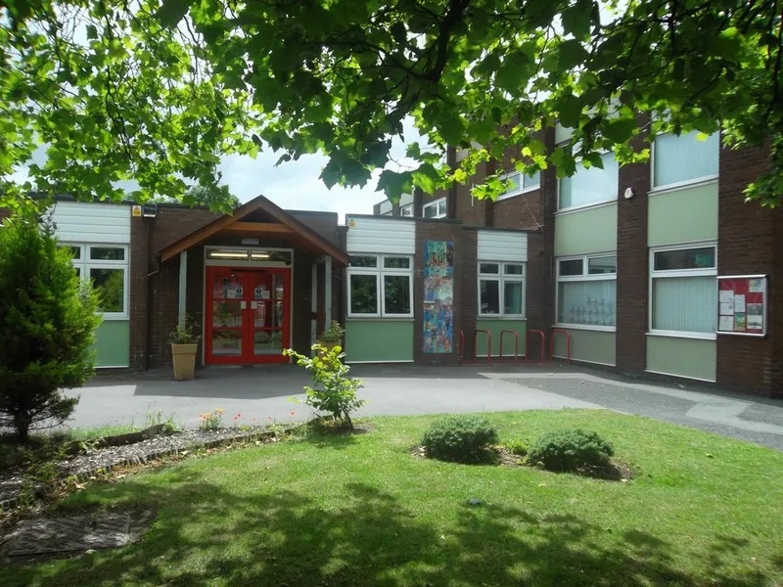

Our Mission statement is Learning and Living through Jesus Christ.  We live out this mission through a committed Christian leadership of the school and a close collaboration with St Paul's Church.  Our ethos is to welcome everybody of all faiths and beliefs and embrace diversity within a Christian setting.

As a faith school, our mission is to provide a Christian education for all children who attend our school.  Our curriculum allows children to explore their own faith and the faith of others in a safe and caring environment which promotes learning and living through Jesus Christ to allow children to explore the awe and wonder of the world that God has created for us.

Job Description

Title: KS1 Class Teacher – Fixed Term

Salary: MPR1-6 £31,650 to £43,607

Hours: Full time

Accountable to: Mr Adam Rigby – Head of School

Location: St Pauls CE Primary School – Warrington Road, Wigan, WN3

Main Purpose

Undertake all the duties of a qualified teacher as described in the School Teachers’ Pay and Conditions Document (STPCD).

Personal Attributes

Dedicated, reliable, understanding and caring. The child’s needs must come first.

Main duties/responsibilities

|  |
| --- |
| Be responsible for the learning and achievement of all pupils in the class/es ensuring equality of opportunity for all. |
| Be responsible and accountable for achieving the highest possible standards in work and conduct. |
| Treat pupils with dignity, building relationships rooted in mutual respect, and at all times observing proper boundaries appropriate to a teacher’s professional position. |
| Work proactively and effectively in collaboration and partnership with learners, parents/carers, governors, other staff and external agencies in the best interests of pupils. |
| Take responsibility for promoting and safeguarding the welfare of children and young people within the school. |

|  |
| --- |
| **Teaching and curriculum** |
| Deliver the curriculum as relevant to the age and ability group/subject/s that you teach. |
| Be responsible for the planning, preparation and development of teaching materials, teaching programmes and pastoral arrangements as appropriate. |
| Be accountable for the attainment, progress and outcomes of pupils. |
| Be aware of pupils’ capabilities, their prior knowledge and plan teaching and differentiate appropriately to build on these demonstrating knowledges and understanding of how pupils learn. |
| Have a clear understanding of the needs of **all** pupils, including those with special educational needs, disabilities and English as an Additional Language. |
| Review and update schemes of work in line with updates to the national curriculum. |
| Develop teaching materials and use resources and equipment effectively. |
| Set homework and plan other out-of-class activities to consolidate and extend the knowledge and understanding pupils have acquired as appropriate. |
| **Behaviour and Health and safety** |
| Implement appropriate health and safety policies and procedures in order to ensure a safe, effective and child friendly environment in all lessons and activities, raising any concerns following school protocol/procedures. |
| Actively seek out and implement best practice safety procedures. |
| Establish a safe, purposeful and stimulating environment for pupils, rooted in mutual respect and establish a framework for discipline with a range of strategies, using praise, sanctions and rewards consistently and fairly. |
| Manage classes effectively, using approaches which are appropriate to pupils’ needs in order to inspire, motivate and challenge pupils. |
| Maintain good relationships with pupils, exercise appropriate authority, and act decisively when necessary. |
| Be a positive role model and demonstrate consistently the positive attitudes, values and behaviour, which are expected of pupils. |
| Have high expectations of behaviour, promoting self-control and independence of all learners. |
| Carry out playground and other duties as directed and within the remit of the current *School Teachers’ Pay and Conditions Document*. |

|  |
| --- |
|  |
| **Record keeping** |
| Use an appropriate range of observation, assessment, monitoring and recording strategies as a basis for setting challenging learning objectives for pupils of all backgrounds, abilities and dispositions, monitoring learners’ progress and levels of attainment. |
| Monitor and assess pupils’ results and progress, ensuring appropriate records are kept, and use the data to inform targets, lesson plans and differentiated schemes of work. |
| Give pupils regular feedback, both orally and through accurate marking, and encourage pupils to respond to the feedback, reflect on progress, their emerging needs and to take a responsible and conscientious attitude to their own work and study. |
| Participate in arrangements for examinations and assessments within the remit of the *School Teachers’ Pay and Conditions Document*. |
| **Professional development** |
| Undertake appropriate and agreed continued professional development. |
| Participate in whole school and individual INSET programs as required. |
| Regularly review the effectiveness of your teaching and assessment procedures and its impact on pupils’ progress, attainment and wellbeing, refining your approaches where necessary responding to advice and feedback from colleagues. |
| Be responsible for improving your teaching through participating fully in training and development opportunities identified by the school or as developed as an outcome of your appraisal. |
| **Team working and collaboration** |
| Participate in any relevant meetings/professional development opportunities both at the school and across the Academy Trust, which relate to the learners, curriculum or organisation of the school / Academy including pastoral arrangements and assemblies. |
| To work in collaboration with others to develop effective professional relationships with partner schools in the Academy Trust. |
| Contribute to the selection and professional development of other teachers and support staff including the induction and assessment of new teachers. |
| To Cover for absent colleagues within the remit of the current *School Teachers’ Pay and Conditions* document. |
| To make a positive contributions to enhance teaching and learning with partner schools in the Academy Trust. |
| Deploy support staff effectively as appropriate |
| Communicate effectively with parents/carers with regard to pupils’ achievements and wellbeing using school systems/processes as appropriate. |
| To have professional regard for the ethos, policies and practices of the school in which you teach, and maintain high standards in your own attendance and punctuality. |
| Communicate and co-operate with relevant external bodies. |
| Make a positive contribution to the wider life and ethos of the school and The Levels Academy Trust. |
| **Administration** |
| Register the attendance of and supervise learners, before, during or after school sessions as appropriate. |
| Participate in and carry out any administrative and organisational tasks within the remit of the current *School Teachers’ Pay and Conditions Document*. |

This job description is intended to clarify the main duties and responsibilities of the post, but it is not intended to be an exhaustive list of all the tasks undertaken by the post. The jobholder will be expected to carry out such professional tasks as are commensurate with the duties and responsibilities of the post.

Liverpool Diocesan Schools Trust is committed to safeguarding and promoting the welfare of children and young people and expects all staff and volunteers to share this commitment. Further Safeguarding policies can be found www.standrewsmaghull.com  
Candidates should also refer to ‘Guidance for safer working practice for those working with children and young people in education settings’ which can be found by following the link - <https://www.saferrecruitmentconsortium.org/GSWP%20May%202019%20final.pdf>  
  
Appointment to this post is subject to a satisfactory enhanced DBS check, 2 satisfactory references, and verification of qualifications.

**Person Specification – KS1 Class Teacher**

|  |  |
| --- | --- |
| **St Pauls** | **Essential (E)**  **or**  **Desirable (D)** |
| **Skills**   * Promote the school’s aims positively and use effective strategies to motivate and inspire pupils. * Develop good personal relationships within a team. * Establish and develop close relationships with parents, governors and the community. * Communicate effectively (both orally and in writing) to a variety of audiences. * Create a challenging, effective and stimulating learning environment. * Able to use ICT effectively | **E**  **E**  **E**  **E**  **E**  **E** |
| **Experience**  The Class Teacher should have experience of:   * Successful teaching experience within Primary Education, including EYFS. * Proven track record in raising pupil attainment * Working in partnership with parents * Working with SEN | **E**  **E**  **E**  **E** |
| **Qualifications**   * Qualified Teacher status * degree   Evidence of a commitment to professional development | **E**  **E** |
|  |  |
| **Professional Values and Practice**   * Good team player * Shows willingness to contribute to the whole school community, in and out of the classroom * Flexible and adaptable * Organised and able to prioritise * Energetic and positive * Ambitious for self and pupils * Good sense of humour * Committed to improving own practice | **E**  **E**  **E**  **E**  **E**  **E**  **E**  **E** |

How to Apply

Application Process

The application process for this role is a 2-stage process:

* Application form
* Interview

To be considered for this role you must complete the LDST application form. We are unable to accept CV applications, or applications from agencies.

Once the closing date has been reached all applications will be reviewed. The candidates who best demonstrate the skills listed in the person specification in their application will be invited to interview.

To ask any questions, or to submit your completed application form, please email [Samantha.lowe@ldst.org.uk](mailto:Samantha.lowe@ldst.org.uk) call 01942 2430687.

LDST reserves the right not to progress candidates to the next stage of the process, or not to appoint to the role if candidates fail to demonstrate the essential criteria in the person specification.

Applicants from overseas are advised to obtain an overseas criminal check before they apply for a visa as the post is in the education sector.

**Closing Date: Friday 20th June 5pm**

**Shortlisting: Monday 23rd June**

**Interview Date: Thursday 26th June**

**Start Date of Post: 1st September 2025**

**School visit dates: Tuesday 17th June 10am & Wednesday 18th June 3.30pm.**

**Please contact the school office on 01942 243068 or email Samantha.lowe@ldst.org.uk to arrange a visit.**

**Our Trust Prayer**

Heavenly Father,

Let peace, friendship and love grow in our schools.

Send the Holy Spirit to give

excellence to our learning

love to our actions and

joy to our worship.

Guide us to help others,

so that we may all

Learn, Love and Achieve, Together with Jesus.

Amen