East Sussex County Council

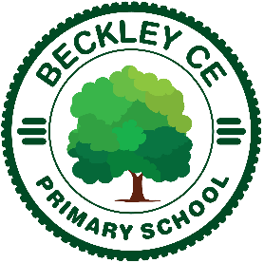
Beckley C.E. Primary School
Main Street,
Beckley, Rye
East Sussex TN31 6RN
Headteacher – Mr Simon Thurston

Tel: 01797 260324
email: office@beckley.e-sussex.sch.uk
web: www.beckley.e-sussex.sch.uk ‘Let your light shine.’ Matthew 5:16

10 May 2021

Re: Class Teacher – Key Stage 2

Thank you for your enquiry about the teaching vacancy in Key Stage 2, which will initially be for a 1 year fixed-term contract. This vacancy is for a mixed-age class in Key Stage 2, starting in September 2021. Although we are looking for a full-time appointment, arrangements for part-time hours may be considered also.

I hope that you have already taken time to look through our website and have been able to get just a small sense of our wonderful school. This really is a place where children love to learn and staff love to work.

We work very closely with our partner school – Peasmarsh CE Primary School and together we form The Genesis Federation. Our school is very well equipped and resourced, including extensive outdoor areas set in a beautiful rural landscape. Community engagement and support is very strong, and in 2018 the school celebrated its 200th birthday!

Although you will get some sense of our school community from the website, I strongly recommend that you arrange to come and visit us in person. Although any visit will currently be arranged under our COVID -19 procedures, I am still absolutely confident that you will see for yourself why we are proud of everything that makes this a special place.

I look forward to receiving your application and meeting you.

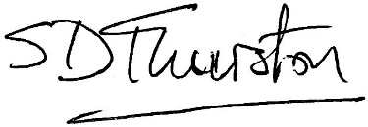

Simon Thurston
Headteacher

