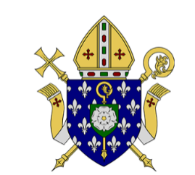**ST CLARE’S CATHOLIC PRIMARY SCHOOL**

**A Part of the Blessed Christopher Wharton Catholic Academy Trust**

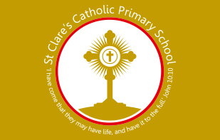

**FIXED TERM FULL TIME EARLY YEARS TEACHER**

**MAIN SCALE**

**Required for September 2025**

The Local Academy Council wish to appoint an enthusiastic, inspirational and committed Class Teacher to help us build on the school’s successes and to continue with us on our improvement agenda.

We offer:

* a supportive working environment where everyone is valued and respected
* the opportunity to join a happy, hardworking and dedicated team of staff and governors who strive to offer excellent learning opportunities for all children;
* friendly, well-behaved and motivated pupils who are fully engaged with their learning across the curriculum
* a well-structured programme for Professional Development, offered by the Blessed Christopher Wharton Catholic Academy Trust

We are looking for a Class Teacher who

* is a practising Catholic or feels fully able to support the Catholic ethos of our school;
* is a creative, effective and highly enthusiastic classroom practitioner;
* has knowledge and ability to foster good behaviour through positive strategies;
* is able to make a valuable contribution to the wider life of the school.

St. Clare’s is committed to providing a safe and secure environment for the children and expect all staff to share in this commitment. This post is subject to an enhanced D&BS check.

Please request an application pack by emailing the Business Manager, Lynne Davey, at [lynne.davey@cla.bcwcat.co.uk](mailto:lynne.davey@cla.bcwcat.co.uk)

**Applications should be returned to lynne.davey@cla.bcwcat.co.uk**

**Visits to school are very welcome on 17June 2025. Please telephone the School Office to arrange on 01274 637841**

**Closing date: Monday 23 June 2025 at 9am**

**Interviews: Thursday 26 June 2025**

If you have not heard from the school by Monday 23 June 2025, your application will not have been successful, on this occasion.