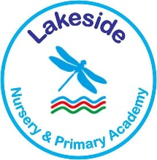
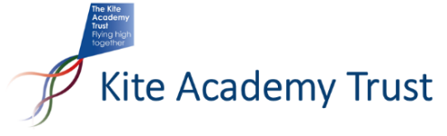

LAKESIDE PRIMARY ACADEMY
Key Stage 1 Teacher – Full Time/Part Time / Permanent
January 2023
MPS/UPS

Lakeside Primary Academy have an exciting opportunity for a full-time Teacher to join our KS1 team in supporting the learning and development of our pupils. This is a permanent contract starting in January 2023.

We are a Primary Academy with a warm, friendly atmosphere in Frimley, Surrey. We are within easy reach of towns in Surrey and Hampshire. We can offer you a dedicated and friendly staff team, training opportunities in Key skills and children who enjoy learning and are positive about their school.

We are a member of the Kite Academy Trust - a thriving Multi-Academy Trust with Academies in nearby locations; this brings tremendous professional development opportunities and exciting career pathways for committed and aspirational staff.

If you would like more information, please visit our website or contact us on O1276 469200 and ask to speak to Sam Armstrong, Academy Head Teacher.
Applications from NQTs welcome.
Closing date for applications: Midday Thursday 1st December
Interviews to be held: Week Beginning Monday 5th December

Suitable applicants may be interviewed sooner than the closing date, according to availability and the post being filled prior to this date. Applicants are encouraged to apply as soon as possible.

The Kite Academy Trust is committed to safeguarding and promoting the welfare of children and expects all staff and volunteers to share this commitment. The successful candidate will be expected to undertake an enhanced DBS check.

