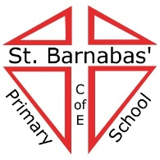**DIOCESE OF BRADFORD**

#### Heaton St. Barnabas’ Church of England (VA) Primary School

**Rossefield Road, Heaton, Bradford, BD9 4DA**

**Tel: 01274 545019 / Fax: 01274 487767**

Headteacher: Mrs D. Smith NPQH

[www.hstb.co.uk](http://www.hstb.co.uk)

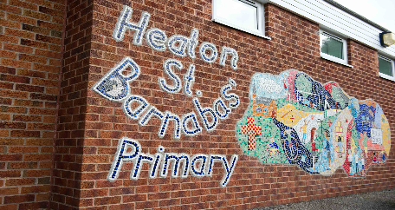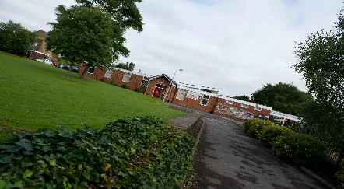*‘Unity in Diversity’*

**KS2 TEACHER**

Main Scale – NQT’s welcome

Permanent Position

Required for September 2021

Heaton St Barnabas is a two form entry primary school, situated in beautiful surroundings on the fringe of the city of Bradford. Our children are from a wide range of cultural and ethnic backgrounds and each child is very special to us. **Our most recent Ofsted in 2018 was judged as GOOD**

**The children, staff and governors are looking to appoint a highly motivated, experienced and inspirational teacher to join our KS2 team. The post-holder will work predominantly in Year 3 in order to accelerate learning, build on our school’s existing achievements and reach the best possible outcomes for the children.**

**The position is also suitable for a Newly Qualified Teacher wanting to expand their potential.**

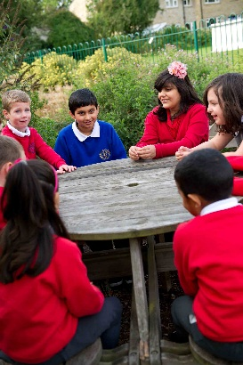

**We are looking for someone who will:**

* Value every child and the religious/cultural diversity of our school.
* Promote and develop the distinctive and inclusive religious character of the school.
* Have demonstrable evidence of good and outstanding practice
* Have consistently high expectations of the achievement and behaviour of every child
* Be committed to developing every child’s capacity to become an independent learner
* Have a keen interest in creative and innovative approaches
* Be someone who can share our sense of fun about learning

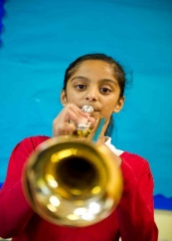

**We can offer you:**

* Children who are enthusiastic about their learning and whose behaviour is good.
* A committed and supportive SLT.
* A dedicated and enthusiastic staff team.
* A secure, caring and inclusive environment, where achievement is celebrated.
* Full support in your continuing professional development.

**You are warmly invited and strongly encouraged to visit the school. To arrange a visit or for further information, please contact our School office on 01274 545019**

Application Forms and full details of how to apply are available from the school and school website ([www.hstb.co.uk](http://www.hstb.co.uk))

**The closing date for this post is Friday 11th June 2021 at 12.00 noon**

**Shortlisting, interviews/assessments will take place w/c 14th June 2021**

*The school is committed to safeguarding and promoting the welfare of children and expects all staff and volunteers to share this commitment. Appointments are made subject to a full DBS check. We are an equal opportunities employer and all applications will be considered.*



#### http://www.youthsporttrust.org/downloads/cms/logos/PESSYP_KM_ACTIVE_4CP.jpgC:\Users\wsuleman\AppData\Local\Microsoft\Windows\Temporary Internet Files\Content.Outlook\C1BOKK5F\healthy schools.jpgC:\Users\wsuleman\AppData\Local\Microsoft\Windows\Temporary Internet Files\Content.Outlook\C1BOKK5F\fairtrade school.jpg