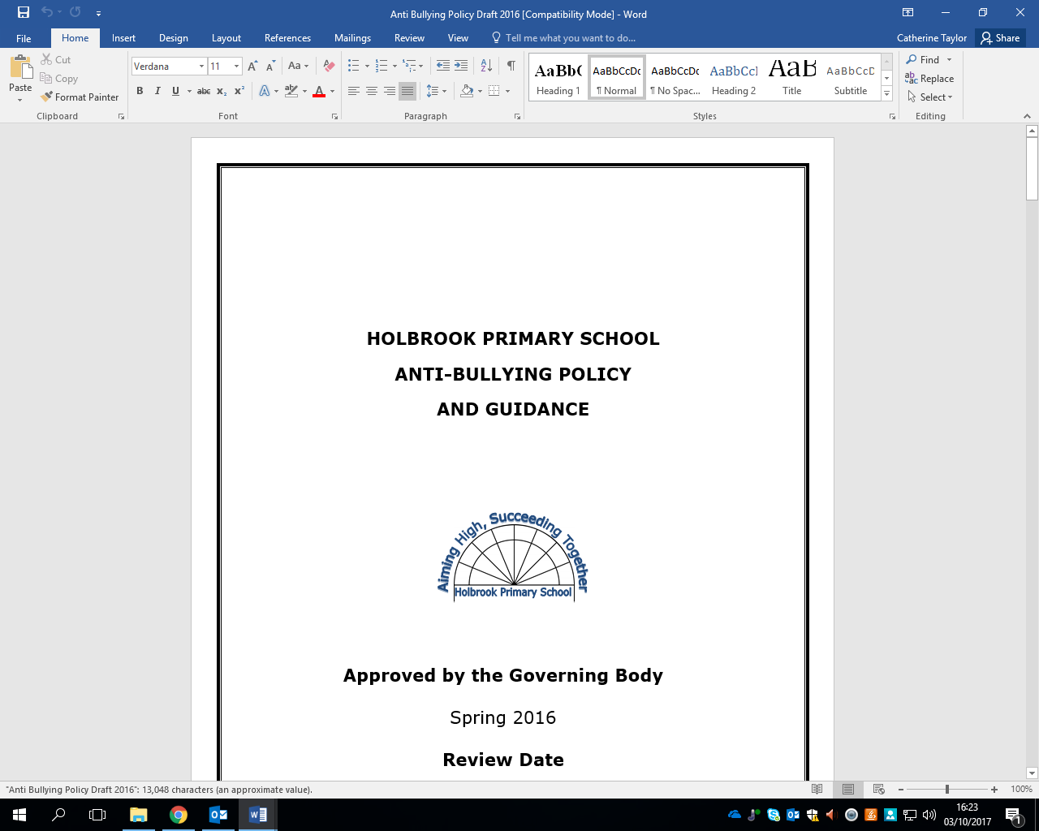Advert Holbrook Primary School
Classroom Teacher – KS2

Salary ECT – TMS 3
Required from September 2026
Contract Permanent, Full-time, 1FTE

We are seeking to appoint an enthusiastic and committed teacher to join our talented team. You may be currently training to be a teacher or an ECT looking for a new job and we welcome applications from both. We have a successful CPD programme providing support for ECTs, as well as those further on in their career.

At Holbrook, we have high aspirations for every child at the school and are committed to every child attaining their potential through experiencing a broad range of learning opportunities. We are dedicated to delivering a memorable and meaningful curriculum that will provide all children with valuable skills to go on to become successful life-long learners, confident individuals and responsible citizens.

We can offer you:
- A happy, caring and inclusive environment where staff and children learn alongside each other
- Enthusiastic and well-behaved children who are happy, responsive and keen to learn
- Experience of working in a supportive 2-form entry school with friendly, professional year group teams
- A school that invests in staff well-being and is committed to reducing workload
- A forward-looking school with high aspirations and standards (judged ‘Good’ by Ofsted June 2023)
- A well-resourced learning environment incl. modern computing suite, dedicated food tech room and attractive grounds for outdoor learning
- A wide range of professional development opportunities to begin or further your career

The successful candidate will be:
- A positive role model with a passion for teaching and learning
- Creative in their planning and delivery of lessons, able to engage and enthuse children
- A reflective and resilient practitioner with high expectations of all pupils
- Knowledgeable of the National Curriculum and the role of assessment in securing progress
- Able to establish positive working relationships with pupils, colleagues and parents
- Prepared to take an active part in all aspects of school life

Visits to the school are highly recommended and we would love to see you. To arrange a visit or ask questions prior to application, please contact the school on 01403 272500 or office@holbrookprimaryschool.com

Application packs can be obtained from the WSSfS website. Please apply addressing the person specification with your letter/application forms and email office@holbrookprimaryschool.com or post. We reserve the right to interview a suitable candidate before the closing date.

Closing date: Wednesday 22nd April 2026 Interviews: Monday 27th April 2026

Holbrook Primary School is committed to safeguarding and promoting the welfare of children and expects all its staff and volunteers to share this commitment. This post is subject to a full DBS check in line with the school’s policy towards safeguarding. We are committed to equal opportunities and welcome applications regardless of ability, age, gender, ethnicity religion or sexual orientation. We conduct online searches for shortlisted candidates. This check is undertaken based on the requirements set out in Keeping Children Safe in Education 2026. The check helps us to ensure safe and robust checks on the suitability of individuals to work within our school. To minimise unconscious bias or potential discrimination issues, a person who will not be on the appointed interview panel will conduct the search and will only share information when findings are of a concern. The appointed panel may explore any concerns passed to them as part of our due diligence process.

