Collaborate, Nurture, Achieve – We can do it!

Class Teacher (temporary to cover maternity leave)
Required for JANUARY 2021
Recruitment Information Pack
East Whitby Primary Academy
Stainsacre Lane, Whitby, YO22 4HU

Contents

Welcome from the Principal 3
Our aims and ethos 4
Our Trust 5
Application process and how to apply 6
Career pathways 7
Our coastal offer 8
Job Description and Person Specification 9-13

Dear applicant,

Allow me to extend a warm welcome from all governors, staff and children of East Whitby Primary Academy.

I am delighted you have shown interest in our Year 4 classroom Teacher post and I look forward to sharing with you what makes our school a very special place to work.

Our children are delightful, happy, confident and energetic!

They are passionate about their learning, be it in the classroom or through other areas of our developed curriculum such as dance, art, PE and music. Over many years together, we have built a learning community that puts the whole child and their development, along with harnessing the skills of our staff at our very heart.

You will be joining a school with low staff turnover and high staff retention and as Headteacher it is my job to make sure colleagues are supported and challenged to be life long learners.

We are looking for an experienced teacher who can take the love of learning that our children come to school with each day, and use it to inspire, awe and wonder; someone who can embrace all aspects of the curriculum.

Teaching at East Whitby is incredibly rewarding. Due to our well-deserved reputation across the area we place huge importance on developing talent – and in many ways our ‘project based ethos has resulted in many staff leading on whole school projects. I still get an incredible buzz from seeing our children reach their full potential through our staff training and development focus.

This is an exciting time to join us!

As a proud primary member of the Enquire Learning Trust (a specialist primary trust of 29 schools), our team are working in partnership with our sister school Stakesby Primary to share, learn and create a primary hub our area can be proud of. Through our Trust we are able to access the support and resources from the soon to launched Teaching School, which means as a staff member you have a wide range of colleagues, tools and resources to help you develop not just in the classroom but beyond.

I hope that you will take the time to come and see and experience for yourself the warm and welcoming atmosphere which makes our vision a reality.

Good luck with your application. I look forward to reading it.

Simon Smith
Principal

Our Aims and Ethos
It is our aim for all children to leave East Whitby as confident learners with self-belief and an abiding respect for others. We aim to instil a lifelong love for learning and a strong grounding for future success.

We promote achievement by:
- Holding the highest expectations for all
- Striving for every child to make the very best possible progress
- Being restless in our pursuit of excellence

We develop as confident and independent learners by:
- Providing learning which excites passion and curiosity.
- Embracing challenge and not giving up
- Trying our best without fear of failure
- Speaking knowledgeably about our strengths and areas of improvement

We value supportive and positive relationships by:
- Bringing out the best in each other
- Showing pride in one another’s achievements
- Creating strong partnerships between home, school and the wider community

We appreciate others by:
- Valuing and respecting the rights of others
- Making sure everybody feels listened to
- Promoting good manners and caring attitude

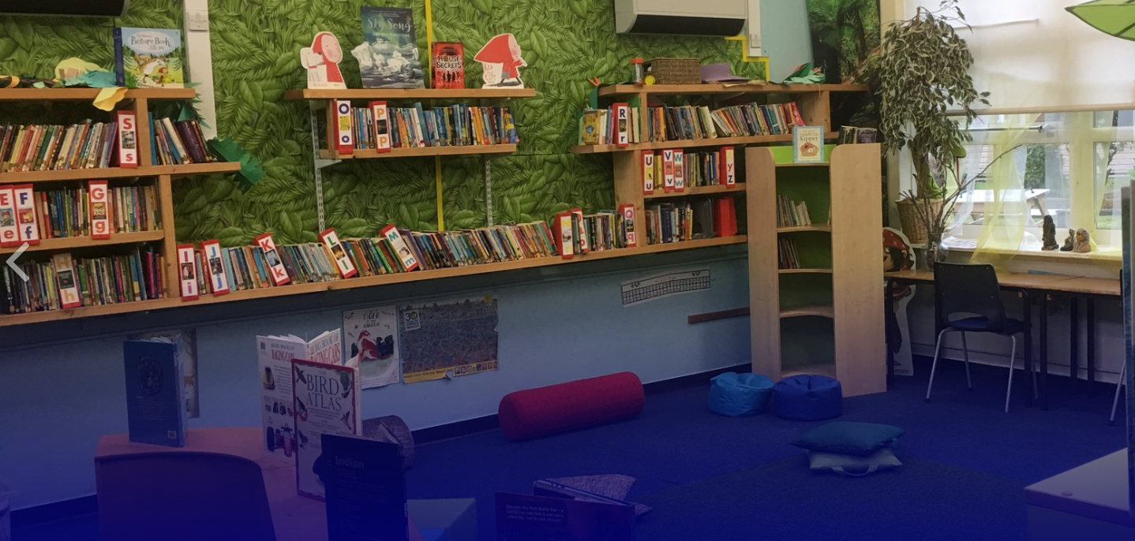

Our Trust

East Whitby Primary Academy is a proud member of the Enquire Learning Trust, a specialist Primary Trust of 29 schools across the North of England.

Believe, Persevere, Achieve

Our Academies are:
- Inclusive – provision should meet the needs of learners of all abilities, with aspirational targets set for every child
- Focused upon achievement – ensuring that opportunities are created for all children to reach their academic potential
- Meaningful and relevant – focused upon meeting children where they are and taking them to where they need to be
- Building confidence and self-esteem – so that all children believe they can be successful learners
- Developing habits for learning – habits which children will be able to draw upon throughout their education and beyond
- INSPIRATIONAL – through creative and imaginative teaching which inspires a love of learning in every child
This is what we see, hear and feel in every Enquire Learning Trust academy.
Our approaches to school improvement are built upon a number of key ingredients. These are expressed in the our quality keystones.
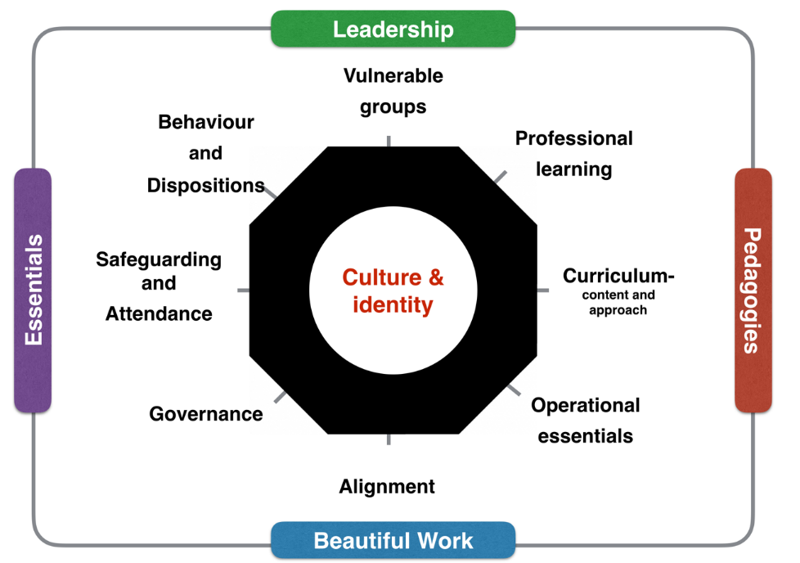

To learn more about us please visit us at www.enquirelearningtrust.org

Application Process
The closing date for all applications is Wednesday, 15th December 2021 at 9am

Interviews will be held on Tuesday, 4th January 2022

Completed applications must be returned to Garry Morrison at Garry.Morrison@northyorks.gov.uk

If you think you’re the person for the job, please complete the Enquire Learning Trust application form with your supporting statement addressed to Simon Smith (Principal), and send to the email address above by the closing date.

An email will be sent to shortlisted candidates with details of the interview process. If you have not heard from us within a week of the closing date please assume your application has been unsuccessful.

Queries

Visits are warmly welcome.

Please contact Garry to arrange.

We actively welcome you to contact Garry at North Yorkshire County Council to chat through the role and talk informally about how working here will make a real difference to the children and young people on the coast.

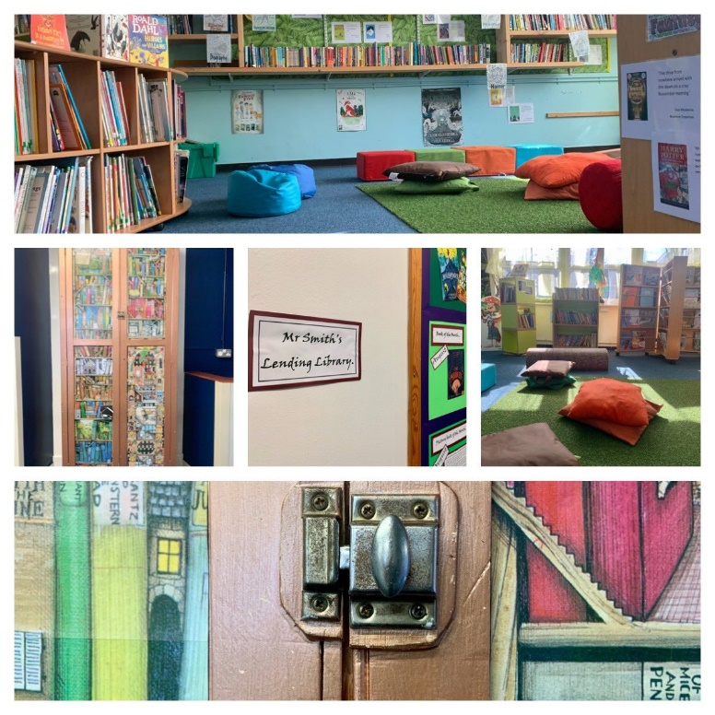

Our Coastal Offer

There are no great schools without great teachers - the key to education is the person at the front of the classroom.

This is an exciting time in which to join our professional body of teachers across the North Yorkshire Coast. Our schools are thriving and with such a sense of community and partnership, a modern way of working has allowed us to collaborate and work in partnership so that we can adapt and evolve.

We are part of the North Yorkshire Opportunity Area that is prioritising improvements to education and numeracy and literacy outcomes, alongside a drive to recruit and retain high-quality, motivated teachers to the area - what are you waiting for?

Teachers like you have the opportunity on the North Yorkshire Coast to be supported to have an enriched career that remains attractive to you as your career and life develops. We recognise and have developed a range of distinctive opportunities to give you the confidence to engage in additional professional and leadership development, as well as access to fully-funded national professional qualifications.

We value good teaching and great teachers on the Coast. That is why we have developed our ‘Coastal Offer’ - which is in addition to your existing pay and rewards package offered by your school, academy or multi-academy trust.

Visit us at www.teachyc.co.uk

Job Description

Job Title: Class Teacher

Major Areas of Responsibility and Key Tasks

• Consistently and effectively plan lessons in line with the national curriculum and sequences of lessons
to meet pupils’ differentiated needs by-
• Identifying clear learning challenges and specifying how they will be taught and assessed
• Planning learning activities that challenge pupils and ensure high levels of interest
• Setting appropriate and demanding expectations for achievement, learning and attitudes to learning
• Setting clear progress targets, building on prior attainment
• Providing clear structures for lessons maintaining pace, motivation and challenge
• Ensure effective teaching and best use of available time
• Monitor and intervene to ensure a positive climate for learning
• Follow school policy on cycle of learning in lessons
• Consistently and effectively use a range of appropriate strategies for teaching, learning and classroom management.
• To continually assess pupil’s learning to provide challenging targets and coherent teaching, reporting regularly to parents and SLT.
• Evaluate own teaching critically to improve effectiveness
• To maintain a learning environment that encourages independence.
• Encourage pupils to think and talk about their learning, develop self-control and independence, concentrate and persevere and listen attentively
• Use a variety of teaching strategies which involve planned adult intervention, first-hand experience, talk, problem solving as a vehicle for learning
• To take responsibility for leadership & development of curriculum areas where applicable.
• To promote positive behaviour in line with school policy.
• Mark and monitor pupils’ work and set targets for progress
• Assess and record pupils’ progress systematically and keep records to check work is understood and completed, monitor strengths and weaknesses, inform planning and recognise the level at which a pupil is achieving
• Prepare and present informative information and reports to parents

Other professional responsibilities

• Have a working knowledge of teachers’ professional duties and legal responsibilities
• Operate at all times within the stated policies and practices of the school
• Contribute to the life of the school through effective participation in meetings and management systems necessary to coordinate the management of the school
• Establish effective working relationships and set a good example through their presentation and professional conduct.
• Any additional responsibilities in line with Teachers’ Pay and Conditions as negotiated with the Headteacher.

Person Specification: Class Teacher – 0.6 FTE Maternity Cover

 | Essential | Desirable
Qualifications | Qualified Teacher status | Evidence of continuous INSET and commitment to further professional development
Experience | The Class Teacher should have experience of:  teaching at Key Stage 2  strategies for meeting in a mixed-ability class situation;  supporting the policy and practice of inclusion;  behaviour-management techniques for groups and individuals.  working in partnership with parents | In addition, the Class Teacher might have experience of:  teaching across the whole Primary age range;
Knowledge and understanding | The Class Teacher should have a comprehensive knowledge and understanding of:  statutory National Curriculum requirements at the appropriate key stage;  the theory and practice of providing effectively for the individual needs of all children (e.g. classroom organisation and learning strategies);  the monitoring, assessment, recording and reporting of pupils’ progress;  the statutory requirements of legislation concerning Equal Opportunities, Health & Safety, SEN and Child Protection;  the positive links necessary within school and with all its stakeholders;  effective teaching and learning styles. | In addition, the Class Teacher might also have knowledge and understanding of:  the preparation and administration of statutory National Curriculum tests;  the links between schools, especially partner schools.
Skills | The Class Teacher will be able to:  promote the school’s aims positively, and use effective strategies to monitor motivation and morale;  develop good personal relationships within a team;  establish and develop close relationships with parents, governors and the community;  communicate effectively (both orally and in writing) to a variety of audiences;  create a happy, challenging and effective learning environment.  manage the coordination of teaching assistants in support of SEN pupils; team… | In addition, the Class Teacher might also be able to:  develop strategies for creating community links.
Personal characteristics | Approachable  Committed  Empathetic  Enthusiastic  Organised  Patient  Resourceful  Good sense of humour  Resilience  Determined  The ability to work as part of a team

We are committed to safeguarding and promoting the welfare of children and young people and expects all staff and volunteers to share this commitment.
This post is exempt from the Rehabilitation of Offenders Act 1974 and the appointment is subject to a satisfactory enhanced level disclosure and S128 clearance from the Disclosure & Barring Service (DBS).

