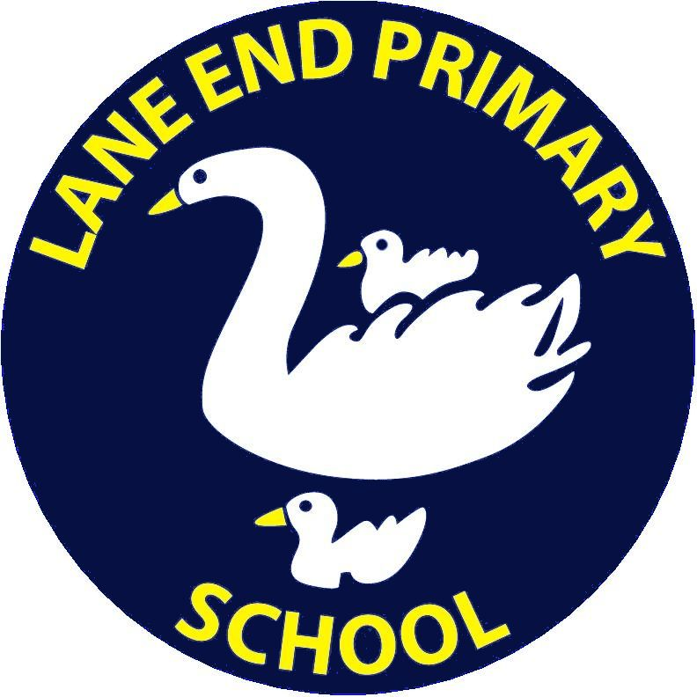
Lane End Primary School
Learn together, work together, grow together
______________________________________________________________________________________________________
Headteacher: Mrs D Williams
Edmonds Road, Lane End, Bucks. HP14 3EJ
E-mail: office@laneendprimary.co.uk
Website: www.laneendprimary.co.uk
Tel: 01494 881169
Fax: 01494 883640
2 Class Teachers Required
Full time/part time permanent

REQUIRED: September 2021

SALARY: MPS

Are you a forward thinking and dynamic teacher?
Are you interested in your own continuing professional development?
Would you like to work in a supportive school with great children?
Would you like to be part of our journey to Outstanding?

If so, we are looking for you to join our team which is committed to providing high quality education for all children. We are a rapidly growing primary school, taking children from 2-11 years. Our most recent Ofsted recognised that we are a consistently good school where teamwork is a strength:

‘A collaborative team spirit permeates all aspects of the school’s work. Staff are highly committed to improving pupils’ achievement…100% of staff agreed that the school is well led and managed, and that they are proud to be a member of Lane End Primary.’

‘Relationships between staff, pupils and parents are extremely positive. There is a clear commitment to ensuring that everyone is treated equally and that there is no discrimination. All pupils, whatever their ability or background, take a full part in all the school’s activities, where possible.’

(Ofsted, March 2018)
You will:

- Be committed to providing high quality learning experiences for all children
- Be able to work as part of a team

We will be able to offer you:

- A supportive team of staff and governors
- Excellent CPD opportunities

Job shares as well as full time positions will be considered.
Visits to the school are possible at the end of the school day. Please contact the school office to make an appointment or to find out further details. All applications should be emailed to: head@laneendprimary.co.uk
The closing date for receipt of applications is: Friday 16th April
Interviews will be held on: Week beginning 19th April
The successful applicant will have to meet the requirements of the person specification in order to be offered the post and will be subject to an enhanced DBS check. Lane End Primary School is committed to safeguarding and promoting the welfare of children and young people and expects all staff to share this commitment.

